SUBCOURSE EDITION
IT 0433 B

US ARMY INTELLIGENCE CENTER

RC - MIOAC

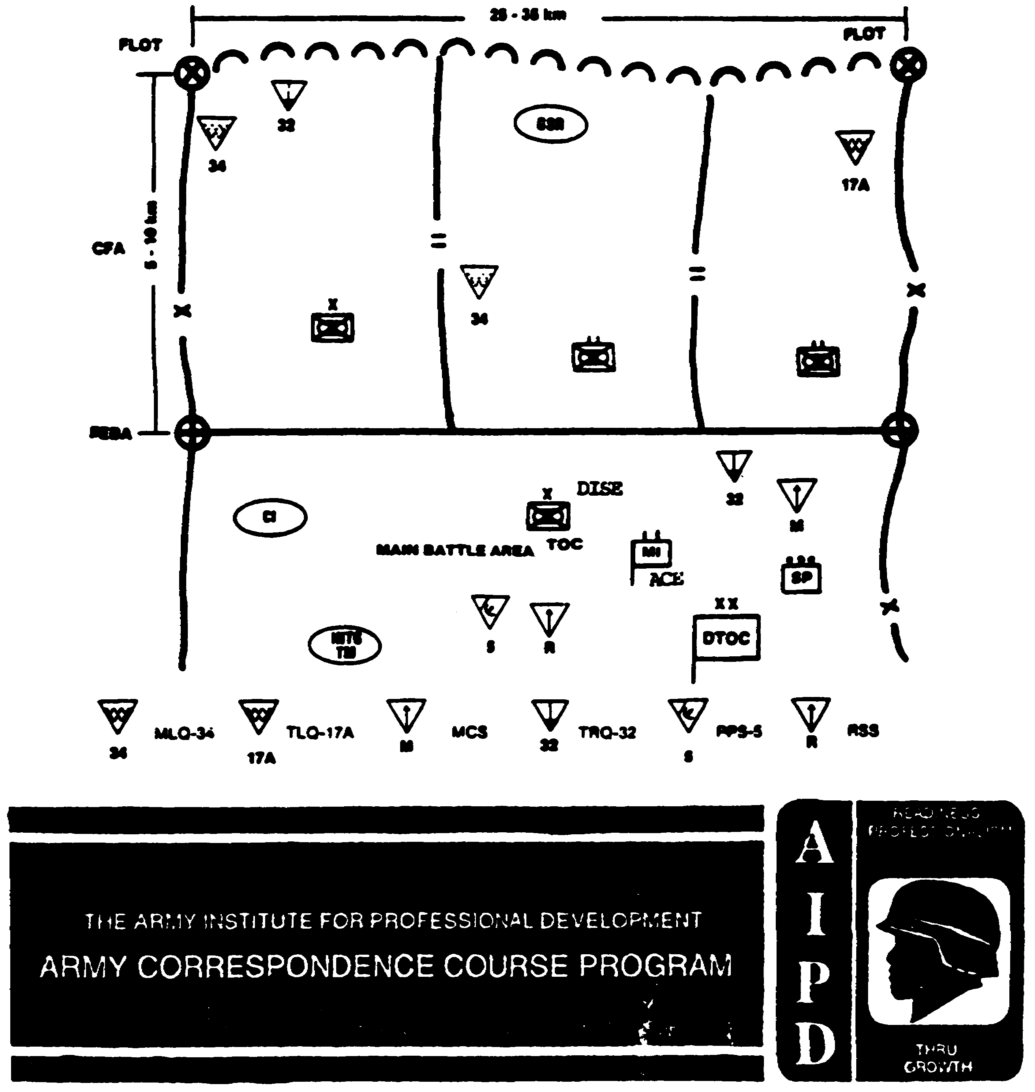

RC-MIOAC, IT 0433

EDITION B

United States Army Intelligence Center
Fort Huachuca, Arizona 85613-6000

Edition Date: June 1996

CREDIT HOURS: 8

SUBCOURSE OVERVIEW

This subcourse presents the basic procedures involved in directing intelligence and electronic warfare (IEW) asset management and the development of reconnaissance and surveillance (R&S) plans at battalion and brigade. It describes how to plan the employment of IEW assets and conduct deployable intelligence support element (DISE) operations. It further describes how to direct the processing and disseminating phases of the intelligence cycle and how to produce finished intelligence products form all-source information.

These lessons reflect doctrine which was current at the time they were prepared. In your own work situation, always refer to the latest official publications.

Unless this publication states otherwise, masculine nouns and pronouns do not refer exclusively to men.

TERMINAL LEARNING OBJECTIVE

ACTION: You will plan the employment of IEW assets, direct IEW asset management, and conduct DISE operations. Develop an R&S plan to support battalion and brigade operations. Direct the processing and disseminating phases of the intelligence cycle. Identify the procedures used to develop and produce all-source intelligence products.

i IT 0433

CONDITION: You will be given narrative information, illustrations, and sample formats from applicable field manuals. You will have access to extracts from field manual (FM) 34-35.

STANDARD: To demonstrate competency of this task, you must achieve a minimum of 70% on the examination.

IT 0433 ii

TABLE OF CONTENTS

SECTION Page

Subcourse Overview i

Table of Contents iv

Lesson 1: PLAN EMPLOYMENT OF INTELLIGENCE AND
ELECTRONIC WARFARE ASSETS 1-1

Part A: IPB Application 1-2

Part B: Operational Sites 1-7

Part C: Site Selection Checklist 1-9

Part D: Example - EW Application 1-12

Part E: Collection/Targeting 1-13

Part F: DISE Operations 1-21

Part G: Subunit/Coordinating Instructions 1-27

Part H: Example OPLAN 1-31

Practical Exercise 1-35

Answer Key and Feedback 1-36

Lesson 2: DIRECT ASSET MANAGEMENT 2-1

Part A: MI Battalion 2-2

Part B: Mission Planning and Asset Tasking 2-3

Part C: Evaluate Reporting 2-7

iv IT 0433

Part D: Analyze Information 2-8

Part E: Asset Status 2-10

Practical Exercise 2-12

Answer Key and Feedback 2-14

Lesson 3: PLAN RECONNAISSANCE OPERATIONS 3-1

Part A: Collection Management Process 3-2

Part B: R&S Terms/Principles 3-3

Part C: R&S Plan Development 3-4

Part D: R&S Planning Pitfalls 3-5

Part E: Assets and Equipment 3-9

Part F: R&S Planning 3-15

Part G: Tasking R&S Assets 3-18

Part H: R&S Overlay 3-25

Part I: Monitoring the R&S Effort 3-27

Practical Exercise 3-32

Answer Key and Feedback 3-34

Lesson 4: PROCESSING AND DISSEMINATING OF
INFORMATION/INTELLIGENCE 4-1

Part A: Processing 4-2

Part B: Recording Information 4-3

Part C: Evaluating Information 4-9

Part D: Analyzing Information 4-12

IT 0433 v

Part E: Determinations 4-14

Part F: Dissemination 4-14

Practical Exercise 4-17

Answer Key and Feedback 4-18

Lesson 5: PRODUCE FINISHED INTELLIGENCE PRODUCTS
FROM ALL-SOURCE INFORMATION 5-1

Part A: Intelligence Estimate 5-2

Part B: Intelligence Annex 5-10

Part C: Intelligence Summary 5-14

Practical Exercise 5-19

Answer Key and Feedback 5-20

APPENDIX A: Reconnaissance and Surveillance
Checklist A-1

APPENDIX B: Intelligence Files and Reports B-1

APPENDIX C: List of Common Acronyms C-1

APPENDIX D: Publication Extract D-1

FM 34-35 Armored Cavalry Regiment and Separate Brigade
Intelligence and Electronic Warfare Operations
December 1990

Use the above publication extracts to take this subcourse. At the time we wrote this subcourse, this was the current publication. In your own work situation, always refer to the latest official publications.

vi IT 0433

LESSON 1

PLAN EMPLOYMENT OF INTELLIGENCE AND
ELECTRONIC WARFARE ASSETS

Critical Tasks: 301-372-2000
301-372-2005
301-372-2006
301-372-2015
301-372-3006

OVERVIEW

LESSON DESCRIPTION:

In this lesson you will learn how to plan the employment of intelligence and electronic warfare (IEW) assets and how to conduct DISE operations.

TERMINAL LEARNING OBJECTIVE:

ACTIONS: Plan the employment of IEW assets. Ensure the application of the intelligence preparation of the battlefield (IPB) process is used. Identify line of sight (LOS) characteristics. Determine operational sites for each collection asset. Develop specific tasks and coordinating instructions for IEW assets. Conduct DISE operations.

CONDITIONS: You will be given narrative information and illustrations from applicable field manuals.

STANDARDS: Plan the employment of IEW assets. Conduct DISE operations. Prepare paragraph 3b of an operations order (OPORD) in accordance with FM 101-5.

REFERENCES: The material contained in this lesson was derived from the following publications:

FM 34-1 FM 34-35
FM 34-2 FM 34-80
FM 34-2-1 FM 34-130
FM 34-8 FM 101-5
FM 34-10

1-1 IT 0433

INTRODUCTION

Planning is critical to the success of IEW operations. The effectiveness of IEW is dependent upon the degree to which it is integrated with the commanders scheme of fire and maneuver. Full integration is best achieved by systematic planning and a full understanding of employment factors. IEW is a viable combat multiplier when used effectively. It has some inherent limitations that must be considered during IEW planning.

These include--

- Limited communications systems and architecture which, if not aggressively managed, can cause delays in the dissemination of information.

- Single-source collectors that can be susceptible to enemy deception. All-source collection management (CM) using collection assets employing multiple disciplines, is required to guard against enemy deception.

- Degraded communications intelligence (COMINT) and electronic intelligence (ELINT) collection if the enemy chooses not to use communications and non-communications systems. For example, in Desert Storm, Iraq did not employ their push-to-talk communications for fear of being intercepted and located by direction finding (DF) assets.

- Weather degradation on trafficability and the negative effects of high winds on antenna and aviation collection and jamming systems.

- Inability of ground-based systems to operate on the move. Positioning and integration of mutually supporting ground and airborne systems is critical to continuous support.

- Lack of sufficient organic intelligence assets to satisfy the commanders intelligence requirements.

PART A - IPB APPLICATION

IPB is used throughout the IEW planning process. IPB is the cornerstone to effective IEW operations and the commanders scheme of fire and maneuver. IPB predicts the allocation and employment of collection assets and is the basis for situation and target development. It also establishes the basis for target value analysis (TVA) which identifies high value targets (HVTs) and the selection of high payoff targets (HPTs) for fire support targeting by lethal and non-lethal means. Lesson 2, Module IT 0432 and

IT 0433 1-2

FM 34-130 provide detailed information on the IPB process. This lesson will address the application of IPB to support IEW planning and employment considerations.

Define the Battlefield Environment. As usual, the area of operations (AO) is assigned by the higher command. The area of interest (Al) must consider the electronic dimensions of the battlefield. Depending on echelon, it may include-

- Fixed electronic warfare support (ES) and electronic attack (EA) sites that support Threat operations.

- Airfields that support ES and EA aircraft.

Describe the Battlefield Effects.

Terrain. Evaluate the terrain from two perspectives:

- How it enhances and supports communications and target acquisition (TA).

- How it can be used to protect communications and TA systems from exploitation or disruption.

Evaluate the terrain's effects on both Threat and friendly systems. Consider-

- LOS characteristics of the terrain, including both communications and non-communications emitters.

- Vegetation and its effects on radio wave absorption and antenna height requirements.

- Locations of high power lines and their interference with radio waves.

- Large vertical objects, such as buildings or cliffs, that will influence radio waves.

- Effects of soil types on the electronic grounding of equipment.

- Areas best suited to deployment of your IEW systems, such as-

- Accessibility.
- Defilading and masking effects of terrain.
- Security from Levels I, II, and III rear area threats.

1-3 IT 0433

NOTE: Refer to FMs 71-100, 90-12, 90-14, and 90-23 for descriptions and detailed information on Level I, II, and Ill threats. These threats range from small group to tactical combined arms operations.

Evaluate the Threat. Use the standard order of battle (OB) factors to structure your analysis. Focus on how the Threat (targets) will appear to your collection systems. Focus on-

- Types of communications equipment and noncommunications emitters available.

- Surveillance and TA assets.

- Technological sophistication of the Threat.

- Command and control structure of the Threat.

- Tactics, from a communications perspective, such as-

- Deployment of threat command and control.
- Remoting of communication systems.
- Flexibility, or lack of, in procedures.
- Communications security (COMSEC) discipline.
- Operations Security (OPSEC) discipline.

- Reliance on active or passive surveillance systems.

- Electromagnetic signatures of each node. (Electronic preparation of the battlefield (EPB) doctrinal templates). Figure 1-1, depicts a simplified doctrinal template for a threat motorized rifle division (MRD) communications link.

- Unique electromagnetic signatures.

- Technical data base, such as

- Signal operating instructions (SOls).
- Communications net structure.
- Frequency allocation techniques.
- Operating schedules.
- Station identification methods.
- Measurable characteristics of communications and noncommunications equipment.

IT 0433 1-4

- Identify signature items of equipment that are easily identified by your collection assets.

- Identify the Threat's normal COMSEC and OPSEC procedures.

- Identify systems that are direct threats to your collectors.

- Describe the Threat's ability to locate and destroy your assets.

- Use techniques associated with the rear battle analysis to evaluate rear area threats (Level I, II, and III) to your assets.

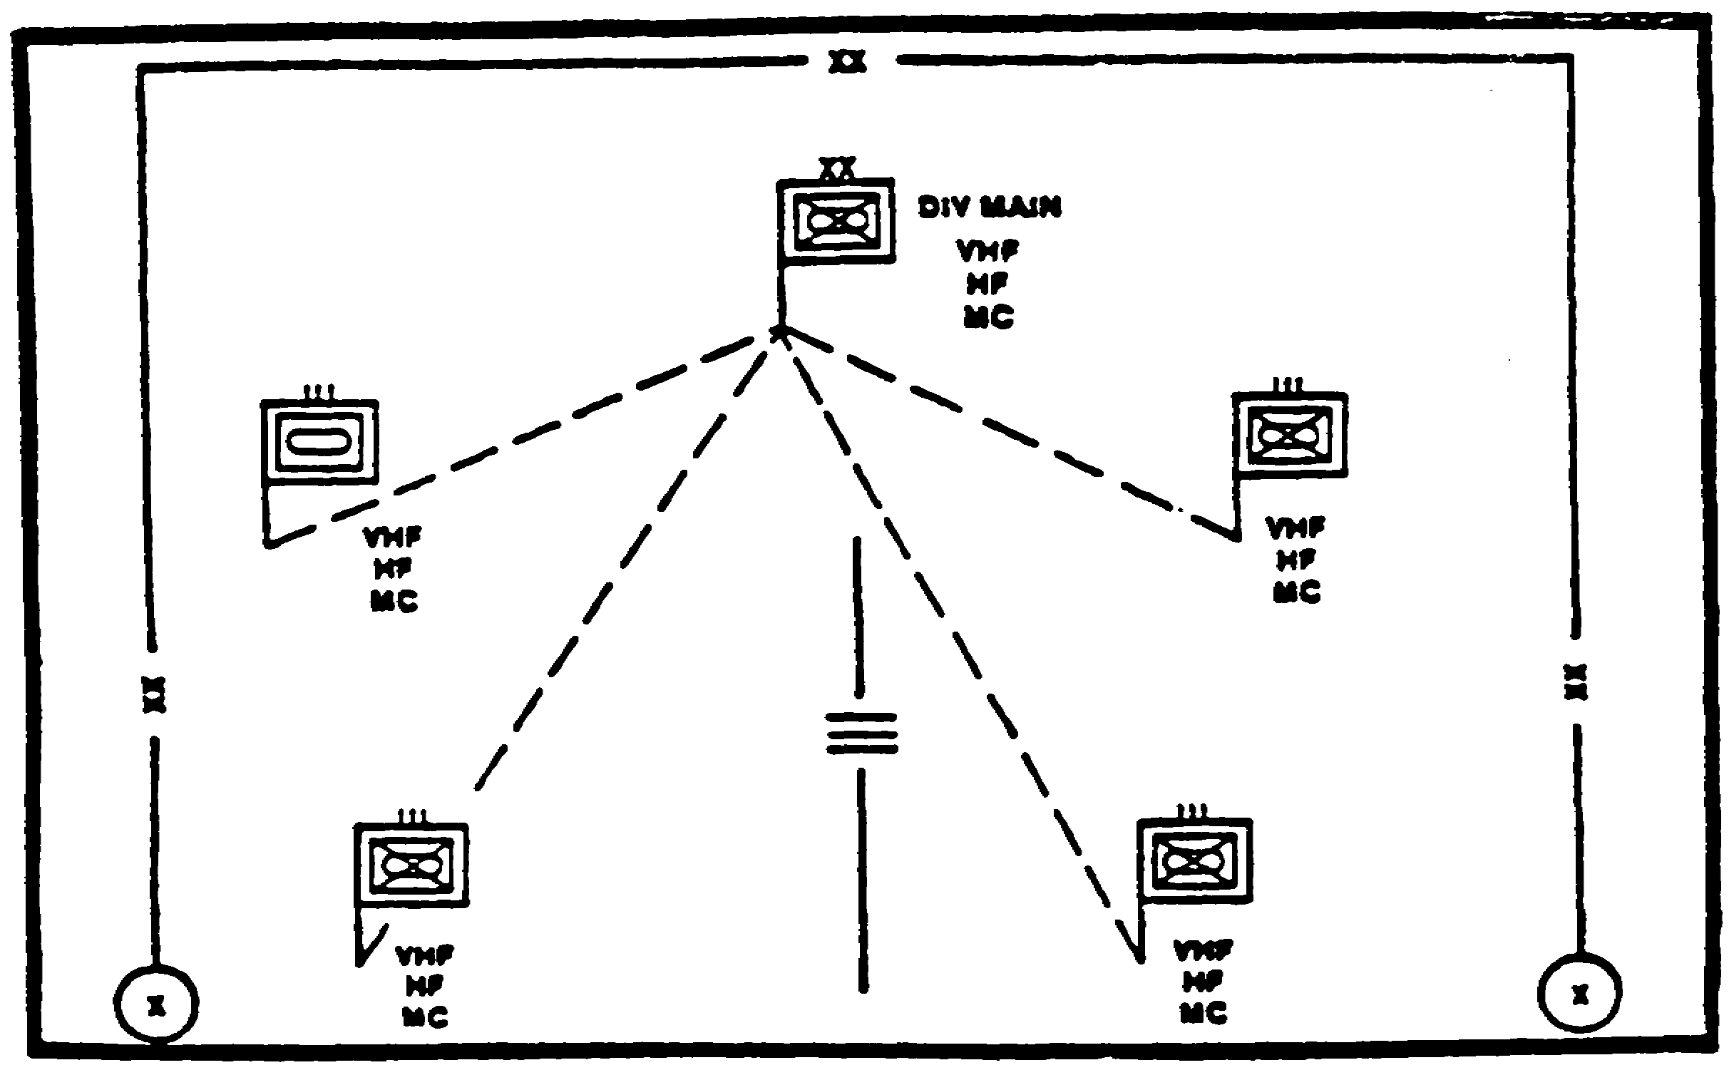

Figure 1-1. Simplified Doctrinal Template - MRD
Communications Link.

Determine Threat Courses of Action. Use the supported command's situation templates as a starting point for the development of your own situational templates. Figures 1-2 and 1-3 depict modified situational templates. Figure 1-2 shows the templated locations of threat IEW assets, and figure 1-3 shows the templated composition and locations of threat communication nodes.

Refine them to focus on--

1-5 IT 0433

- Electromagnetic signatures.

- Reactions to ES at critical junctions in the battle.

- Threat use of ES and EA to support their own operations.

- The targets of your collection operations.

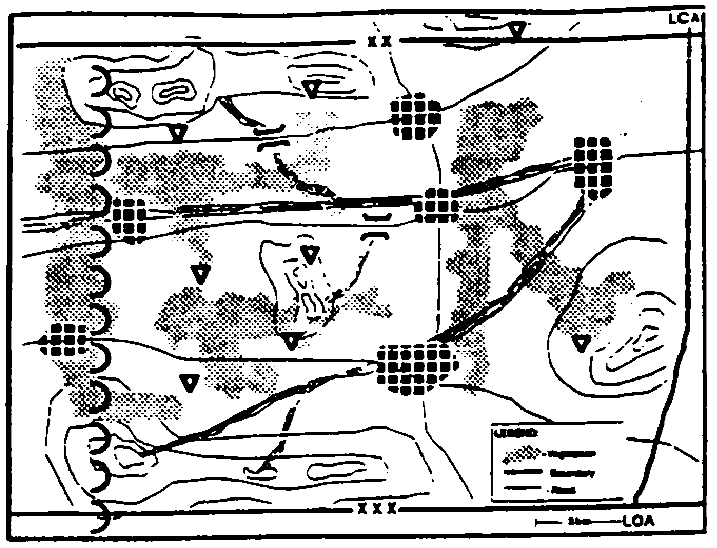

Figure 1-2. Templated locations of Threat IEW Assets.

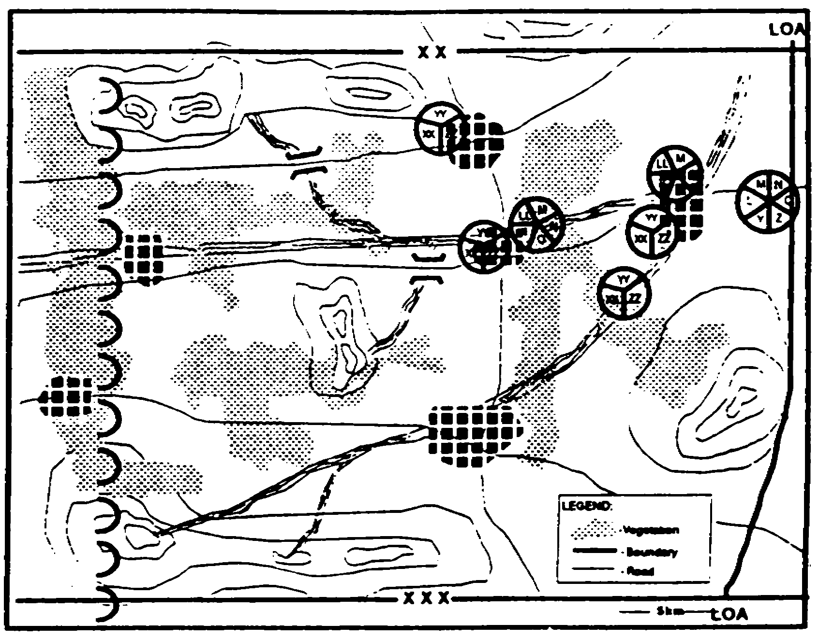

Figure 1-3. Templated Composition and Locations of
Threat Communication Nodes.

IT 0433 1-6

- Dispositions of threat target acquisition assets.

- Rear area threats to your units/assets.

Focus on threat courses of action (COAs) relevant to your commander, not the supported force commander. These COAS should deal primarily with collection operations, force preservation, and activities that will require your units/assets to displace. The supported command's intelligence officer (G2 or S2) develops COAs relevant to the needs of the supported force commander.

PART B - OPERATIONAL SITES

Most Military Intelligence (MI) systems need LOS to operate effectively. The need for high ground for operational sites usually exceeds availability. the maneuver unit commander or leader operating in the AO resolves conflicting requirements for the high ground. Consequently, it is imperative that the MI unit commander or representative coordinates with the maneuver commander for operational sites. He must inform the maneuver commander of how MI elements can support him from various sites and the relative impact of the terrain on the effectiveness of Ml systems in various potential sites.

There are three basic types of operational sites. the primary site is the principal position from which the IEW team will accomplish the assigned mission. An alternate position is another position where the same target can be covered. The supplementary position is used to cover a different target area. Figure 1-4 illustrates these positions. FMs 34-2-1 and 34-40-9 provide additional information on IEW site selection considerations.

All operational sites should-

- Permit coverage of the assigned area.

- Provide concealment and cover for the team, vehicles, and operational equipment.

- Facilitate communications and permit coordination with other MI and supported elements.

- Provide good ingress and egress.

- Take advantage of security provided by maneuver elements.

1-7 IT 0433

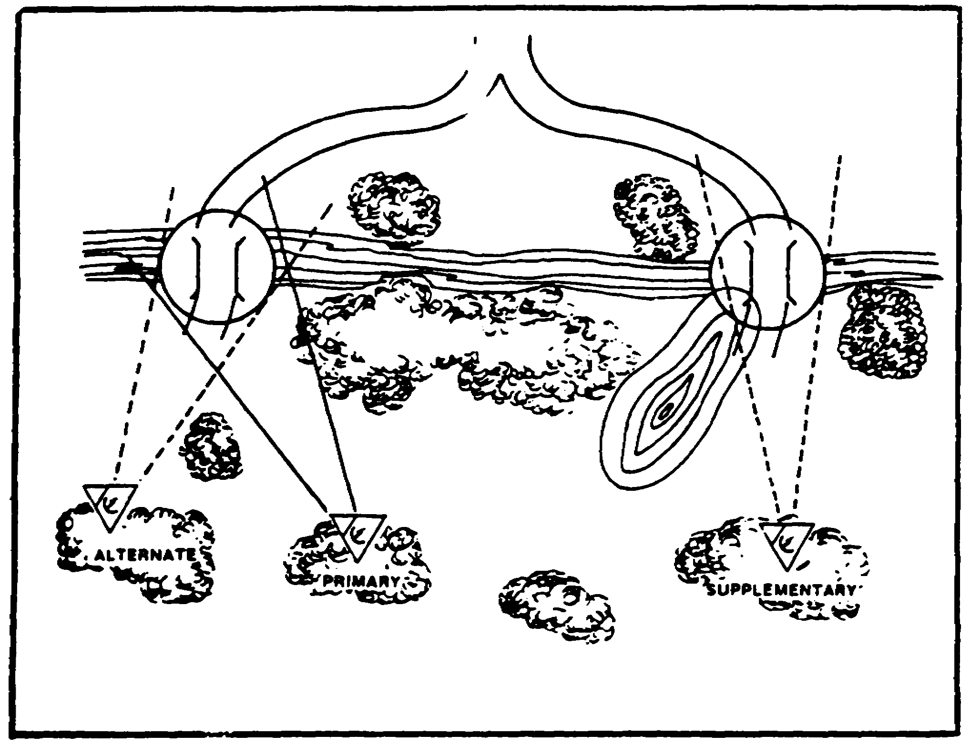

Figure 1-4. IEW Operational Sites.

- Provide LOS to the target area. Be relatively free of ground clutter.

Conducting map reconnaissance should be the first step in selecting operational sites for IEW assets. The advantage of a map recon is that it orients you to the terrain quickly. a disadvantage is that the map may be outdated. Using updated map references and IPB terrain overlays can overcome this potential shortcoming. The intent of map reconnaissance is to identify general operating sites for the ground deployment of IEW assets.

If time and the situation allow, a ground reconnaissance should be conducted. During a ground recon, collection/EA team leaders select specific operational sites within the general areas identified during map reconnaissance. During the reconnaissance operations they--

- Select routes to the AO.

- Identify and coordinate with friendly units in the area.

- Determine status of security.

The Ml collection/EA team leaders plan the organization and occupation of an operational site in detail. They should make detailed sketches to include--

- Primary, alternate, and supplementary positions.

IT 0433 1-8

- Exact positions of equipment and antennas at each site.

- Entry and withdrawal routes, and routes between positions.

- Directions and distances to Threat forces.

- Location of friendly forces.

- Friendly mine fields and planned barriers.

A typical organizational of an operational site is depicted at Figure 1-5. The electronic warfare (EW) platoon establishes a platoon headquarters in the brigade area from which the platoon leader directs and controls operations of subordinate elements. The transcription and analysis (T&A) team is also located here. This enables the T&A team to disseminate combat information rapidly to the brigade S2

PART C - SITE SELECTION CHECKLIST

Once a specific operational site is selected that offers good hearability and the fewest obstacles to interfere with IEW operations, it should be checked for survivability. The following checklist can be used to assist in determining site survivability--

- Camouflage

- Does the site blend into the terrain?
- Was effective use made of overhead cover?
- Do silhouetted antennas pinpoint the site?
- Does vehicle parking draw attention to the site?

- Security.

- Have guards been posted?
- Do the guards have the access rosters?
- Are sufficient guards posted to adequately protect the site?
- Is a challenge and password system in effect?
- Do personnel know emergency destruction procedures?

1-9 IT 0433

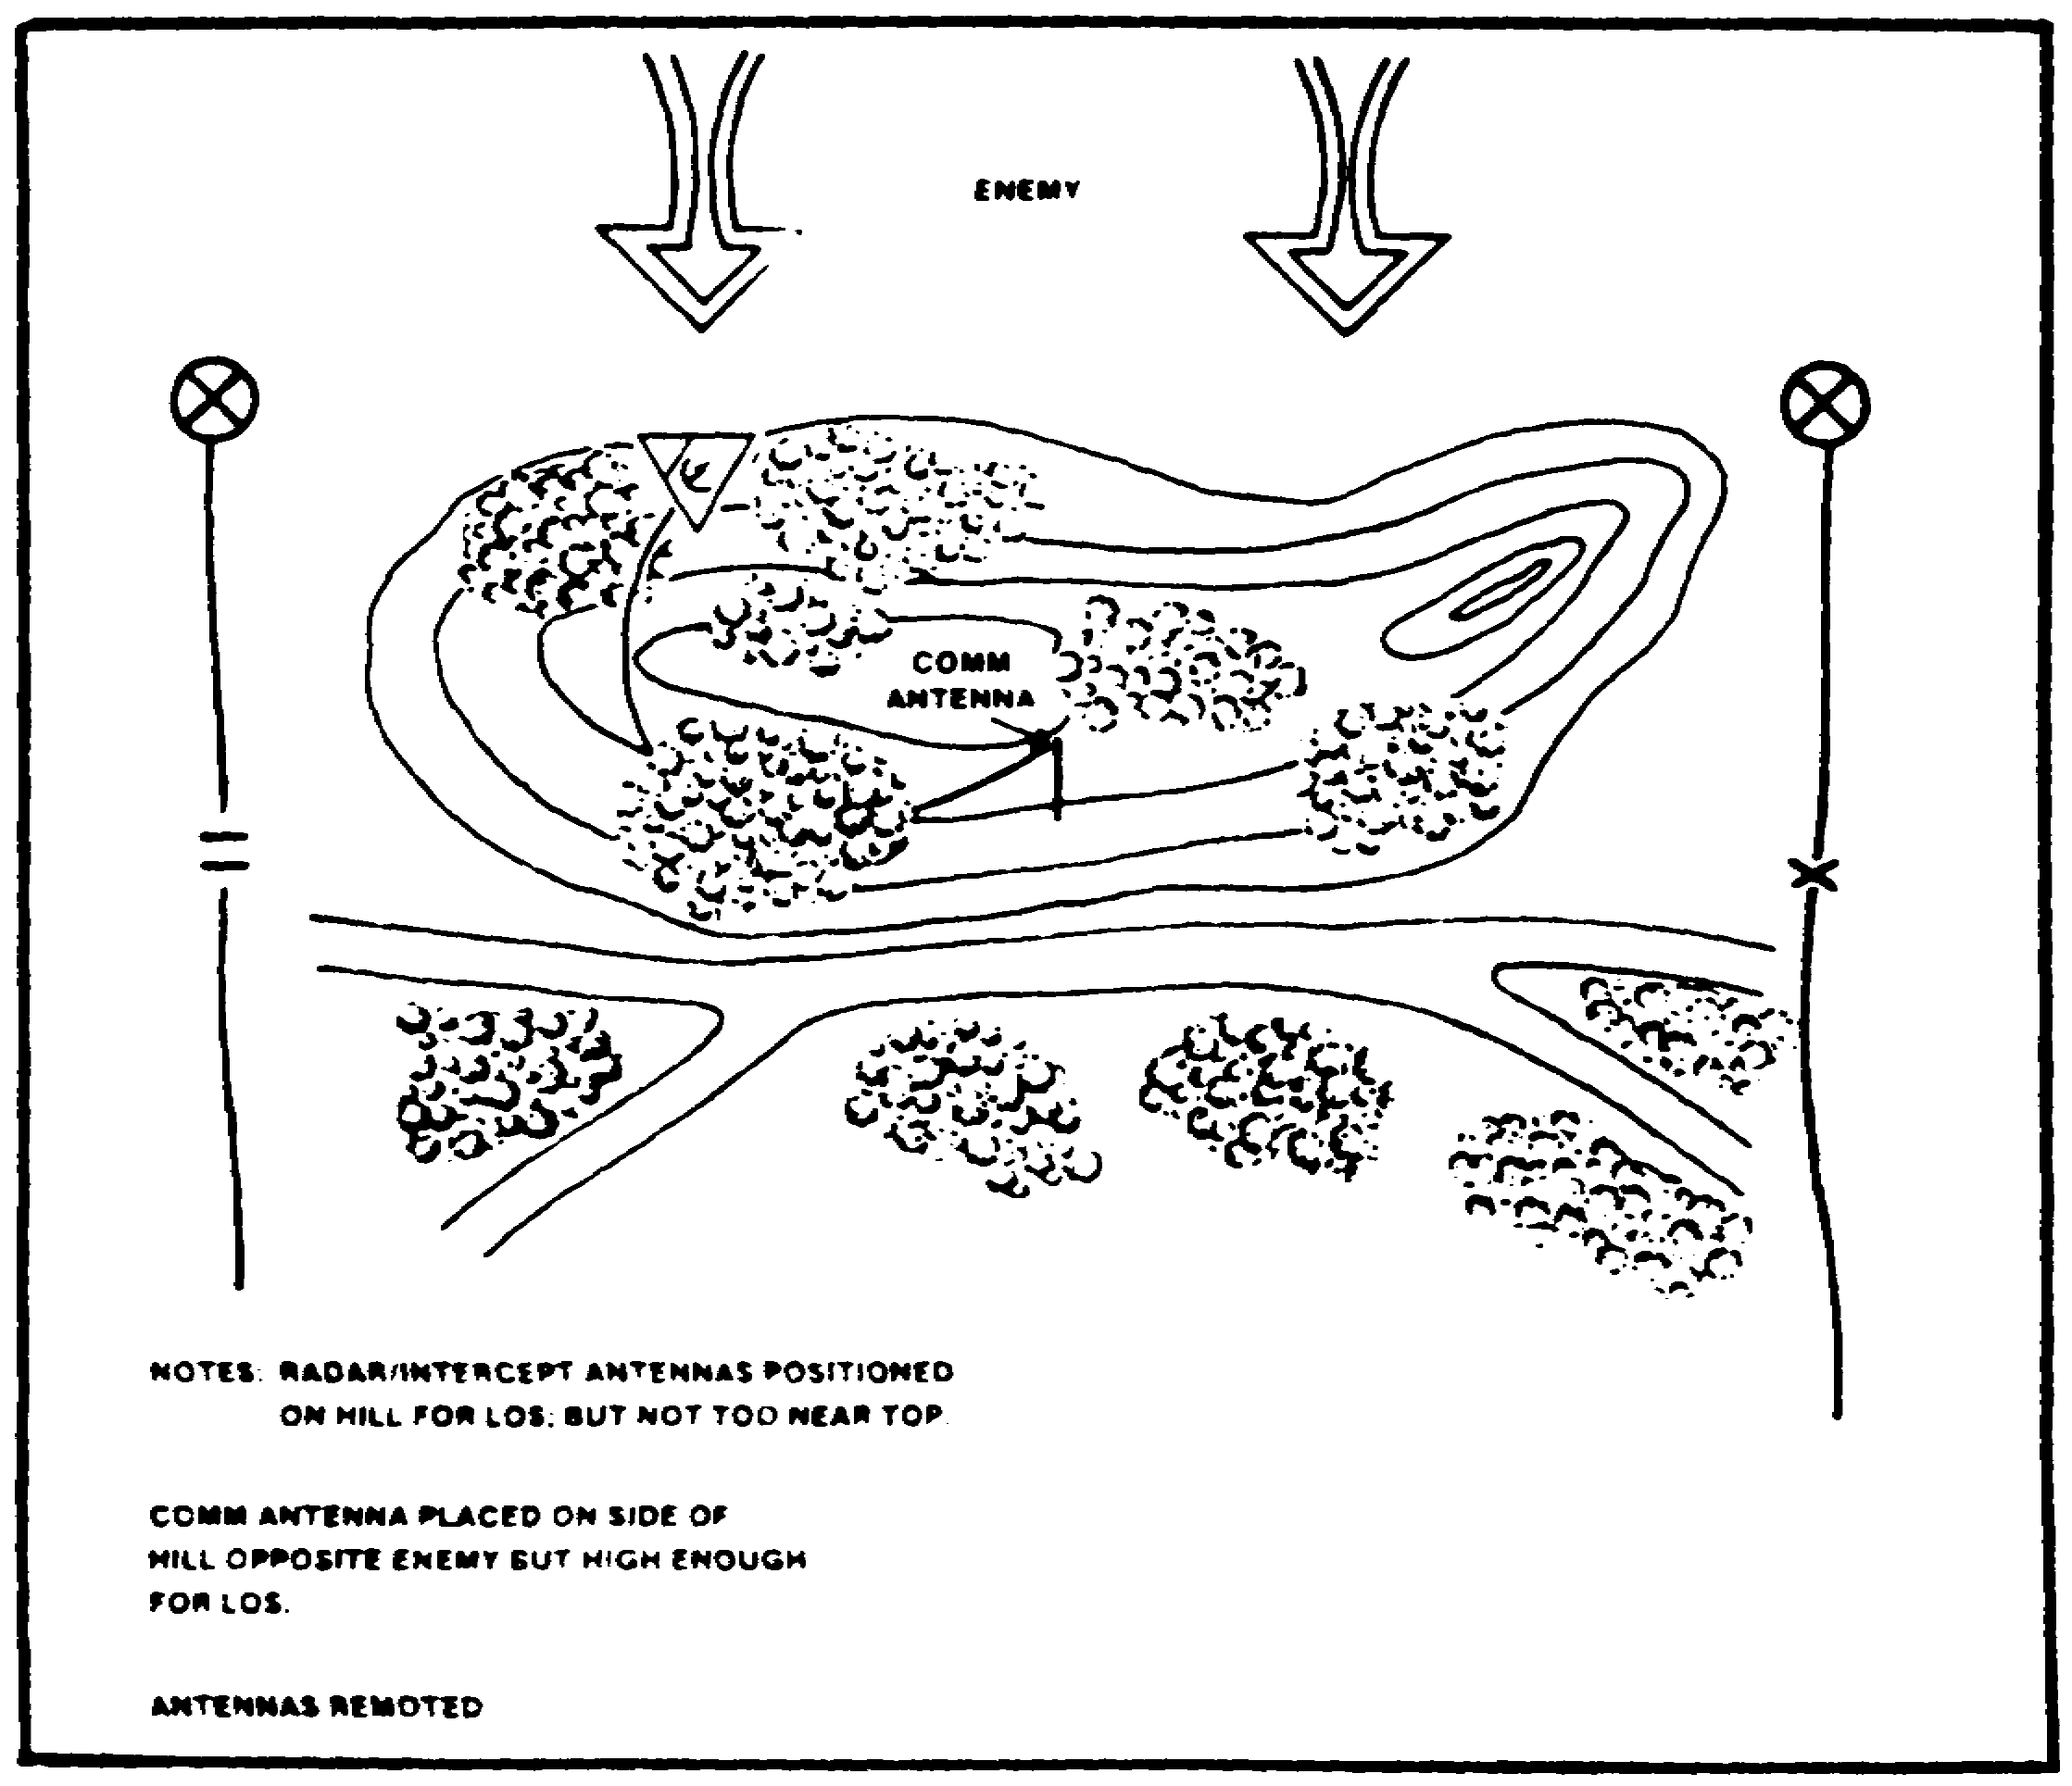

Figure 1-5. IEW Operational Site Organization.

- Defense Plan.

- Are positions properly prepared?
- Do fields of fire interlock?
- Are personnel aware of their responsibilities if attacked?
- Have secondary positions been prepared?

IT 0433 1-10

- Grounding equipment.

- Are the generators grounded?
- Are electrical (collection/jamming/analysis) shelters grounded?
- Does the soil provide adequate conductivity?

- Antennas.

- Are antennas property positioned to receive target signals?
- Are antennas properly positioned so that elements are not touching foliage?
- Are antennas properly grounded?
- Are antennas properly masked (terrain permitting) ?

NOTE: Collection antennas are not masked from enemy signals. Friendly reporting antennas are masked from enemy ES/EA systems.

- Equipment systems.

- Are electrical shelters/vehicles and generators on level or near level ground?
- Was maximum use made of available terrain?
- Are EA assets deployed away from ES assets?

- Communications.

- Can IEW elements communicate with higher, adjacent, and other required units?
- Are transmitting antennas remoted from site?
- Is current SOI on hand?
- Are land lines and alternate communications established?
- Is frequency modulation secure voice operational?
- Are authentication procedures known?
- Are proper radio teletypewriter operator (RTO) procedures being followed?

- Safety.

- Are generators and shelters level?
- Is a fire extinguisher located at the generator site?
- Are all items grounded that need to be grounded?
- Is a centralized fuel point established?
- Are sleeping areas located away from traffic flow?

1-11 IT 0433

PART D - EXAMPLE - EW APPLICATION

As stated earlier, IPB templates can aid in the selection and use of IEW assets. The following example shows how the application of IPB can be used for IEW asset planning and execution. The example is a simplified illustration of how templates may be used. Figure 1-1 depicted the doctrinal templates of a MRDs communication links to its subordinate regiments. The effects of terrain had not been considered. The communication links of very high frequency (VHF), high frequency (HF), and multichannel (MC) are the means through which the Threat commands and controls maneuver forces in the battle.

Figure 1-6 illustrates the doctrinal template superimposed over a combined obstacles overlay. It visualizes how terrain will affect Threat capabilities to communicate. The blocking terrain forces the Threat division commander to rely on HF (long distance) to communicate with two of his regiments. Figures 1-7 and 1-8 indicate, that there are at least two alternate solutions to the Threat's communications problems: the use of relays or the relocating of command posts (CPS) to facilitate communications.

Through situation templates, we identify viable solutions to the threat division commanders communication problems. Correlation between the event template, and the event analysis matrix on the communication situation templates provides clues concerning where to look and what to look for (frequency, modulation, and technical parameters). This will facilitate the locating of threat communication emitters.

Through LOS analysis, we determine where we can deploy sensors and determine their capabilities to see the Threat target emitters. This analysis assists in determining where ES assets can be deployed to intercept and locate emitters and where EA assets can be deployed to jam threat receivers.

As signal reports arrive, information is compared with data from other sources. The situation templates are then updated to reflect actual enemy dispositions. Once Threat emitters are identified and located, the commander decides on the appropriate COA. Options include disruption by jamming, destruction by fire, or relocation of friendly IEW assets.

The LOS terrain masking problems that affected the Threat commanders deployment will also affect IEW deployment. IPB of the entire Al will greatly assist in planning for deployment of friendly assets (figure 1-9). The effective deployment of IEW assets depends on a thorough knowledge of elevation and relief, obstacles, and mobility corridors (MC). Consequently, IPB techniques should be an integral part of IEW training.

IT 0433 1-12

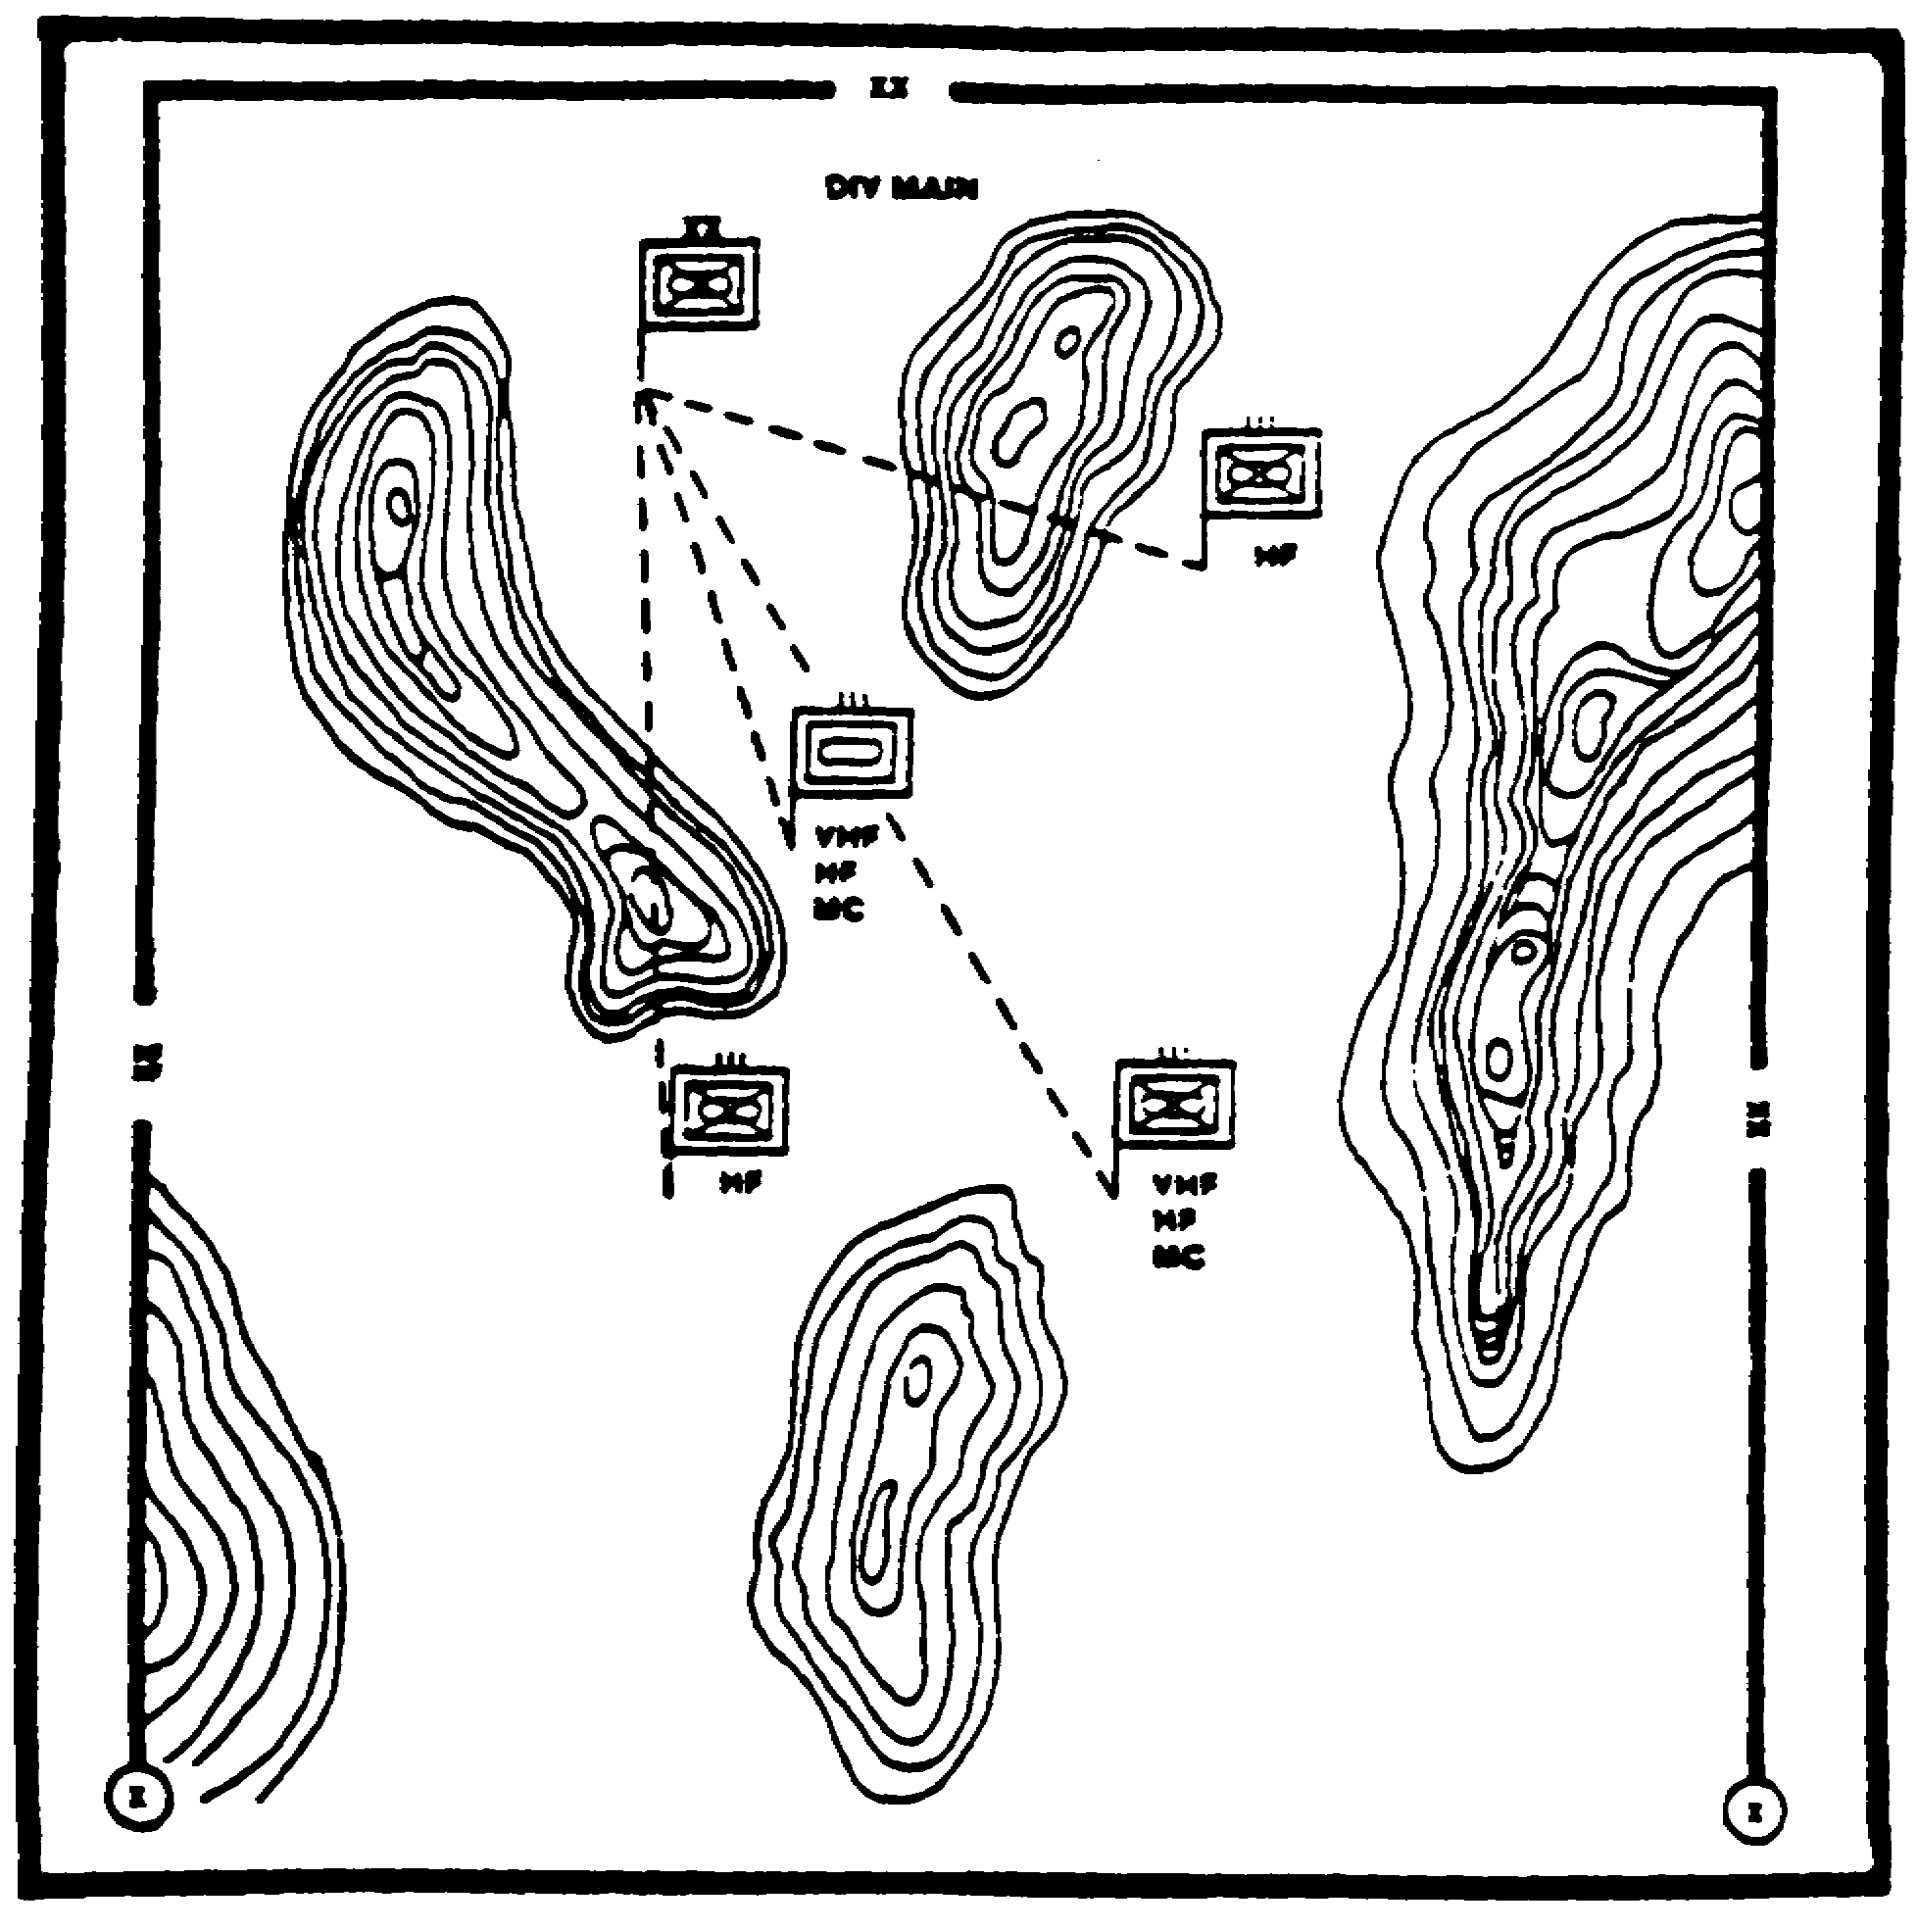

Figure 1-6. Terrain effects on MRD communications.

Aerial ES and EA resources should be used to overcome LOS and mobility limitations and fill gaps in coverage left by ground resources. Use of aerial resources is closely coordinated with ground resources. A major advantage of using aerial resources is their cuing capability of ground IEW assets.

PART E - COLLECTION/TARGETING

All IEW assets are assigned collection missions based on the commanders intelligence requirements. These requirements are expressed as priority intelligence requirements (PIRs) and information requirements (IRs). IEW collection assets are deployed to collect intelligence on Threat forces and assets operating within the AO and Al. They are tasked to conduct collection operations against specific named areas of interest (NAls).

1-13 IT 0433

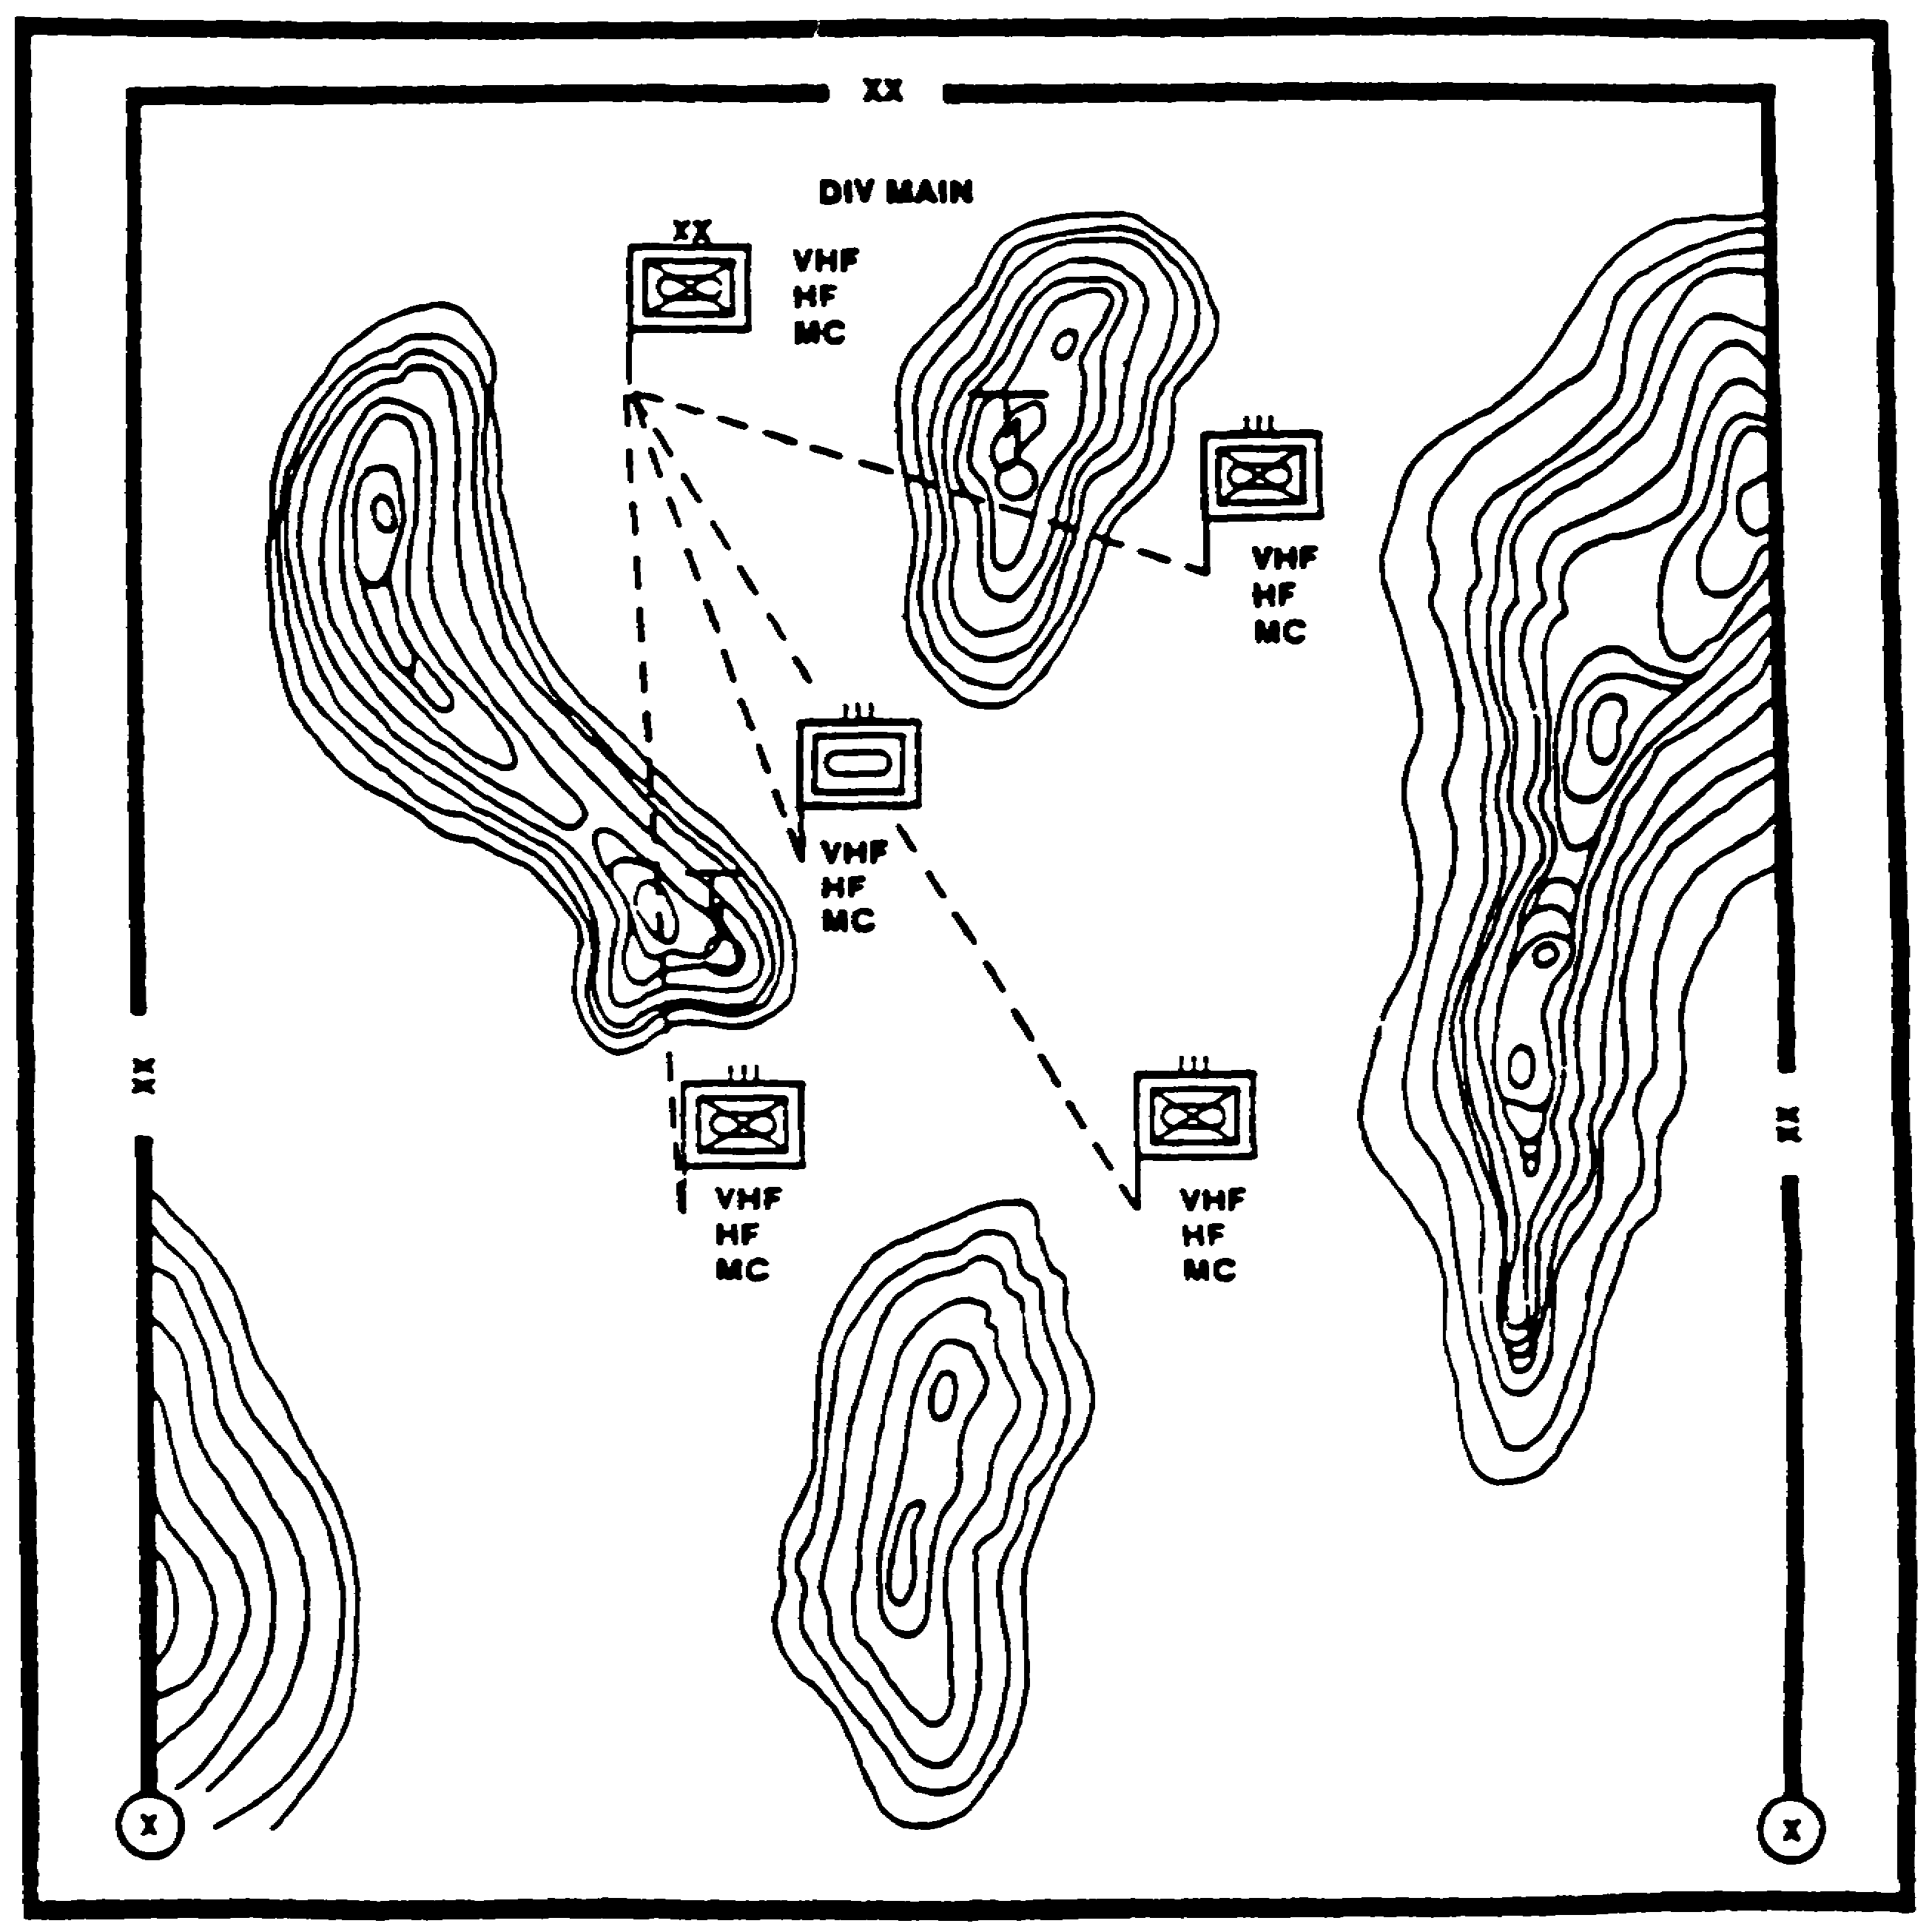

Figure 1-7. Situation Template - Radio Relay.

IT 0433 1-14

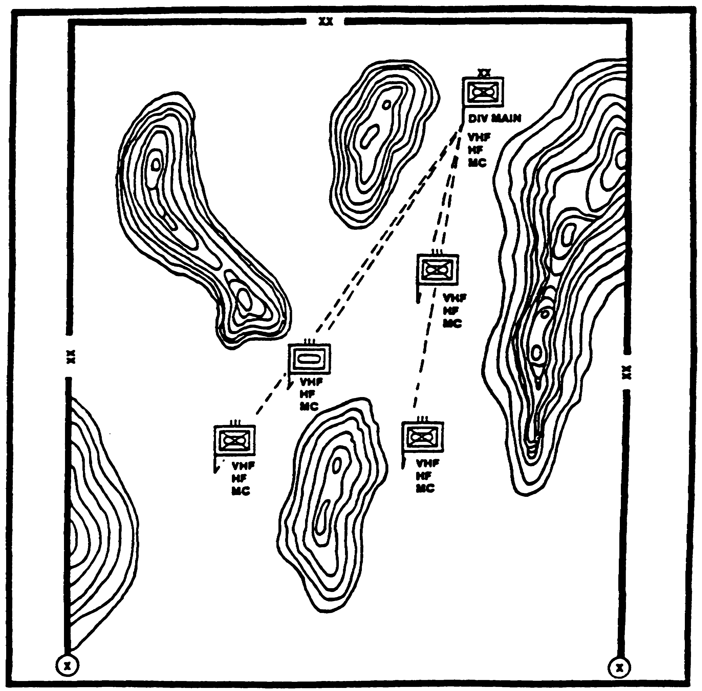

Figure 1-8. Situation Template - Relocated CPS.

1-15 IT 0433

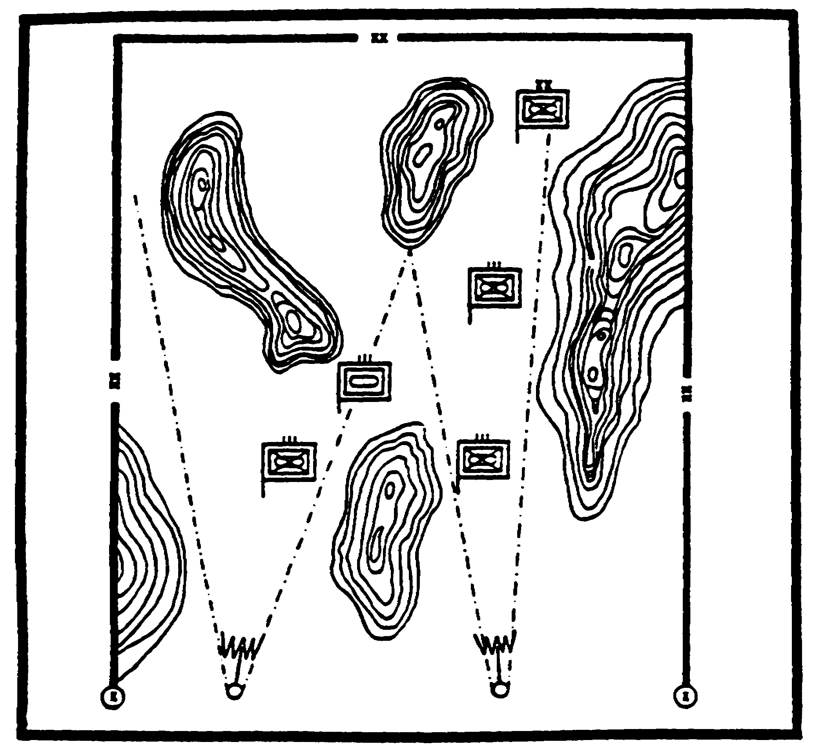

Figure 1-9. ESM Asset Deployment.

They are provided with specific orders and requests (SORs) to guide and direct their collection effort in support of the command's collection strategy. Lesson 4, module IT 0432, FMs 34-2 and 34-2-1 provide detailed information on PIRs, IRs, SORs and the development of a command's collection strategy.

Additionally, EW assets are involved in the target development process to include target value analysis and target acquisition. During the planning process, electronic HPTs are divided into four general categories for attack. These include--

- HPTs that will be located for destruction.

- HPTs that will be jammed.

- Threat emitters that will be intercepted for combat information or intelligence.

IT 0433 1-16

- Threat elements that will be deceived.

Planning is based on the following considerations--

- Priorities.

- Technical effectiveness.

- Jammer deployment.

- Communications.

- Jammer controls.

Priorities. The many HPTs anticipated on the battlefield will generate competing demands for EW support. These demands will always exceed the MI unit's capability to respond. Consequently, priorities must be established among the types of targets elected for attack. Guidelines for establishing initial priorities are--

- First Priority - Protect friendly C3 systems.

- Second Priority - Attack enemy artillery, rocket, and surface-to-surface missile (SSM) forces.

- Third Priority - Degrade or locate for destruction enemy air defense elements.

- Fourth Priority - Disrupt critical enemy C3 links.

Effectiveness. Jamming effectiveness is governed by the following technical factors--

- Target link distance. This is the distance between the enemy transmitter and receiver. For example, it is the distance between a regimental CP and a subordinate battalion CP.

- The distance between the jammer and enemy receiver.

- Radio LOS between the jammer and the target receiver.

- Antenna polarization.

- Effective radiated power of the jammer and the enemy transmitter.

1-17 IT 0433

- Compatible bandwidths between the jammer and enemy transceiver.

- Weather, terrain, and vegetation.

Deployment. Jammers are Threat HPTs for destruction. consequently, they have to move to survive and to maintain favorable transmission paths against enemy radios. Changes in battle lines will require frequent displacement. Operational sites are preselected for each phase of the battle. These sites must-

- Be accessible and concealed from enemy direct fire weapons.

- Provide for continuity of operations.

- Facilitate electronic massing of several jammers against single targets as shown in figure 1-10.

- Facilitate communications.

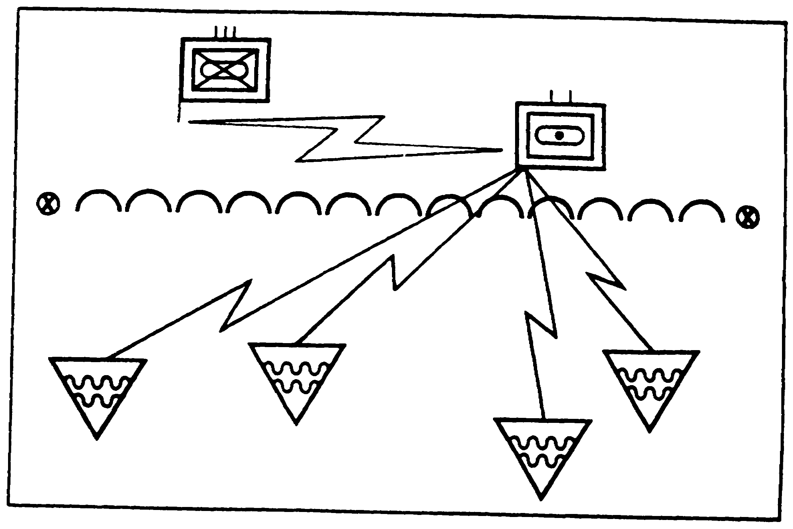

Figure 1-10. Dispersed EA Deployment.

IT 0433 1-18

Communications. Control and coordination are essential for effective EW operations. Communications is the key to effective control. Secure, reliable communications are required for--

- Tasking and technical support.

- Control of jamming operations.

- Tip-off and cuing between collectors and jammers (C&J), both air and ground, to include DF.

- Coordination between jammers.

- Dissemination of combat information.

- Resource status reporting.

- Mission status reporting.

Control Mechanisms. Control of jamming operations is essential to their success. Control keeps jamming directed at HPTs while minimizing its effects on friendly systems and operations. Either positive or negative control methods may be used. However, a combination of both is generally used for maximum coordination between the EA teams and the command they are supporting.

Positive controls methods include--

- Authorizing specific frequencies for jamming on an individual basis or by publishing a list of frequencies cleared for jamming. No other frequencies may be jammed without permission.

- On-off control allows for the immediate starting or stopping of jamming. Reliable communications are required and the command's ability to exercise this type of control must be verified prior to its implementation. On-off control is usually exercised by the Ml battalion/brigade analysis and control element (ACE) but may be held by the division G3 or delegated to lower echelons as circumstances dictate. It is the most centralized form of control.

Negative control is exercised through the publication of frequencies restricted from jamming. These lists coordinate the use of the electromagnetic spectrum to impose a minimum of restriction on jamming or frequency usage. They are grouped into TABOO, PROTECTED, arid GUARDED classifications. Conflicts in frequency groupings among

1-19 IT 0433

services, staffs, and agencies are resolved at command levels. Frequencies not on these lists may be jammed at will.

TABOO frequencies must never be deliberately jammed or interfered with by friendly forces. These frequencies are normally announced by higher headquarters such as the joint force or Army component commander. Examples include but are not limited to--

- Defense Communications System (DCS) rather frequencies used for friendly early warning air defense.

- Enemy frequencies being exploited by higher headquarters for intelligence purposes.

- Frequencies used for command and control of friendly forces and formations.

- Friendly missile control frequencies.

- Search and rescue nets.

TABOO frequencies also include internationally controlled or treaty-governed frequencies, such as broadcast emergency frequencies and commercial air and shipping traffic control frequencies. A TABOO frequency can be time-oriented, and the restriction may be removed as the situation develops. This decision is the responsibility of the originating headquarters. The G3, assisted by the Communications-Electronics (C-E) officer, is responsible for obtaining the TABOO list from higher headquarters.

PROTECTED frequencies are those used by tactical friendly forces for a particular operational requirement. They are designated by the senior tactical commander to control interference produced by friendly jamming and deception operations. Conflicts between frequency requirements for jamming and tactical command are resolved by the commander. The G3, assisted by the C-E officer, is responsible for obtaining the protected list of the next higher headquarters and adding local requirements.

GUARDED frequencies are those of the enemy's C-E systems from which signals intelligence (SIGINT) and ES information of technical and tactical information is derived. A GUARDED frequency may be jammed only after the commander has weighed the potential operational gain against the loss of information. The ACE recommends GUARDED frequencies for approval by the G3 in coordination with the G2. These frequencies are time-oriented in that the list may change as the enemy assumes different combat postures. FM 34-40 contains detailed information on EW operations.

IT 0433 1-20

Appendix D, provides a modified example of planning and execution for IEW asset employment. It is an extract from FM 34-35, Armored Cavalry Regiment (ACR) and Separate Brigade IEW Operations. It provides the tactics, techniques, and procedures for providing IEW support to the fictional 208th ACR. It addresses security (covering force area), offensive, and defensive operations.

PART F - DISE OPERATIONS

The DISE is the MI battalion commanders liaison to the maneuver brigade. It is under the operational control of the MI battalion S3 and consists of one officer and one noncommissioned officer. The DISE is assigned to the headquarters, headquarters and service company of the MI battalion, heavy division (Figure 1-11). The DISE deploys

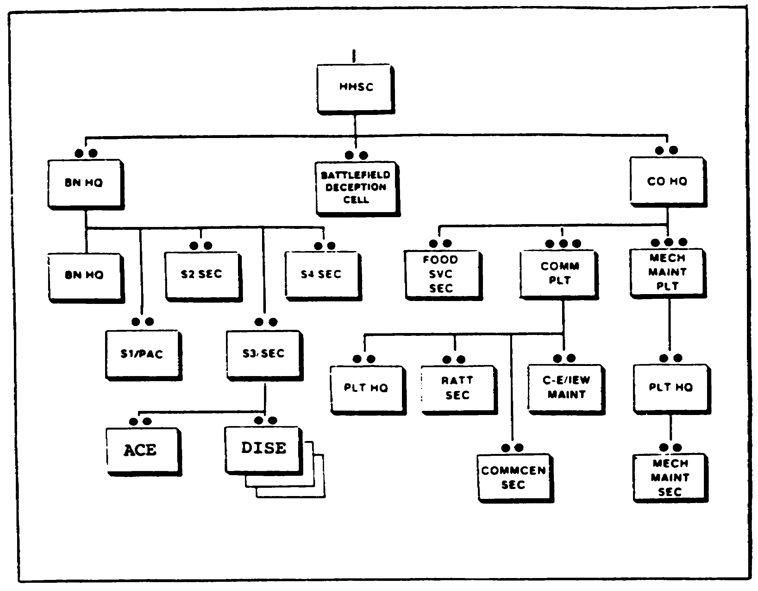

Figure 1-11. HHSC Organization.

1-21 IT 0433

with the brigade as an additional staff element. This element is vital to effective IEW support to the brigade. When an IEW company team is deployed into a brigade AO, the DISE is attached to the company team. It assists the team commander in coordinating IEW operations and support while in the brigade AO. It advises the brigade commander and staff on the integration and use of IEW assets to support the brigade's battles. The DISE-is dependent on the brigade for logistical support. It is responsive to requirements levied by both the supported brigade and supporting IEW company team. The DISE-

- Establishes liaison between the Ml Battalion (BN), IEW company team, and the Brigade Commander and his staff.

- Assists the Brigade S2 and S3 in planning the use of supporting IEW assets, preparing target lists, and preparing jamming schedules.

- Coordinates with the IEW company team commander to ensure rapid response to requirements.

- Ensures rapid dissemination of collected combat information from MI BN elements, as directed by the Brigade Commander.

- Coordinates with Ml BN Tactical Operations Center (TOC) on all matters concerning MI support to the Brigade.

- Monitors the SIGINT/EW tasking and reporting net for assets within the Brigade sector.

- Maintains communications with the MI BN TOC on the MI BN operations net.

- Ensures that deployed IEW elements are advised of friendly force maneuvers that will affect their own security.

- Coordinates with the Brigade staff to ensure availability of operational sites within the Brigade sector and necessary support for the IEW company team movement or routes within the Brigade sector.

- Requests additional IEW support when required.

As the Ml battalion commander's representative to the maneuver brigade commander on IEW matters, the DISE has certain responsibilities. These include the integration of IEW missions with brigade operations. In order to accomplish this, the DISE-

IT 0433 1-22

- Ensures collection and jamming missions support the commanders intent, concept of operations, scheme of maneuver, and fire support plan.

- Conducts LOS analysis for initial IEW company team deployment locations, specifically:

- High ground for collection and jamming (C&J).
- LOS from jammers and collectors to target.
- LOS between collectors for netting.
- LOS from jammers and collectors to C3 sites for reporting.

- Conducts LOS analysis for subsequent redeployment locations in accordance with the overall tactical scheme of maneuver.

- Studies the brigade OPORD with special attention to commander's intent, concept of operations, scheme of maneuver, fire support plan and unit boundaries and phase lines.

- Coordinates with the brigade S2 to identify specific priority intelligence requirements (PIRs), information requirements (IRs), and NAI to confirm or deny enemy COAs, with specific attention to-

- Development of enemy COAs.

- IPB application and development of threat templates.

- NAI development to include probable indicators and size enemy forces expected to deploy at each NAI.

- Associated enemy emitters and electronic clusters at each NAI.

- Probable time-lines.

- Types of nets and frequencies (obtained through coordination with Ml BN ACE).

- Location of specific collection assets to cover each identified NAI.

- Impact of weather on operations.

- Coordinates with the brigade S2 to ensure collection operations reflect the commander's specific PIR and IR and are synchronized with the overall reconnaissance and surveillance (R&S) plan with specific attention to-

1-23 IT 0433

- Unit scouts, patrols, observation posts (OPs/listing posts (LPs).

- Ground surveillance radars (GSRs).

- Remotely monitored battlefield sensor systems (REMBASS).

- Division long-range surveillance units.

- Cavalry operations.

- United States Air Force (USAF) reconnaissance operations.

- Interrogation of enemy prisoners of war and counterintelligence (CI) operations.

- Fire support.

- Coordinates with the brigade S2 and brigade communications-electronics staff officer (CESO) to ensure current brigade challenge and password(s) are passed to MI battalion S3 and IEW company team commander.

- Coordinates with brigade S3 to ensure IEW operations are synchronized with the brigade scheme of maneuver, with special attention to-

- Locating jamming assets to serve as an effective combat multiplier as part of the overall scheme of maneuver and fire support plan.

- Coordinating IEW operational sites and fall back positions with maneuver elements.

- Coordinating times and routes for IEW asset deployment or redeployment.

- Planning redeployment of Ml ground C&J assets by bounding as part of overall scheme of maneuver.

- Planning integration of airborne QUICKFIX to cover specific locations (NAls) not covered by ground assets. This includes coordination of specific time-lines.

- Coordinates with brigade S4 for logistic support, with special attention to-

- Attachment of IEW assets, as appropriate.

IT 0433 1-24

- Roll up of all MI battalion assets operating in brigade AO, from Ml battalion S3 and S4.

- Coordinates with brigade CESO for--

- Proper cryptographic (CRYPTO) fill and frequency for brigade operations and intelligence (O&I) net.

- Protected frequencies to prevent electronic fratricide.

- Deconfliction of IEW operational and C3 sites with signal units.

- Location of jammers (operational sites).

- Relays.

- Coordinates with brigade Fire Support Officer (FSO) for--

- Deconflication of IEW operational and C3 sites with fire support units.

- Fire support planning to avoid engagement areas.

- Family of scatterable mines (FASCAM) targets.

- Use of tactical fire direction computer system (TACFIRE) net to pass sanitized reports quickly.

- Fire support radar locations.

- Protective fires to cover withdrawal of IEW assets, as required.

- Coordinates with brigade engineer for-

- Location of current and planned mine fields and obstacles.

- Bridge classifications.

- Route reconnaissance.

- River-crossing sites and classification.

- Coordinates with brigade Air defense artillery (ADA) officer for--

1-25 IT 0433

- Deconfliction of IEW operational and C3 sites with ADA units.

- Forward area alerting radar (FAAR) locations.

- QUICKFIX air corridors, loiter times, and locations.

- Identification, friend or foe (IFF)(radar).

- Current ADA weapons control status and locations.

- Coordinates with brigade nuclear, biological, and chemical (NBC) officer for-

- Current contaminated areas.

- Planned NBC targets.

- Smoke and obscurant employment.

- Coordinates with brigade military police (MP) officer for current condition and status of routes and traffic control measures. Identifies MP support to the brigade's reconnaissance, intelligence, surveillance, and target acquisition (RISTA) effort.

- Coordinates with the brigade Air liaison officer (ALO) for--

- Timely in-flight reports.

- Latest weather updates.

- Current and planned air and ground engagement areas.

- Assists the brigade S3 in formulating the EW annex of the brigade operations plan (OPLAN) or operations order (OPORD).

- Serves as a critical liaison officer between Ml battalion and the maneuver brigade.

- Keeps the MI battalion S3 informed of coordination, requests, information, and intelligence from brigade staff.

- Serves as functionary member of brigade orders group.

IT 0433 1-26

- Provides copies of maps and overlays from brigade orders group to Ml battalion S3 and IEW company team commander.

- Monitors brigade O&l net and brigade command net for latest developments.

- Notifies Ml battalion S3, and IEW company team commander, in a timely manner of all brigade deployments and redeployments.

- Keeps brigade commander and staff informed of latest intelligence depicting the enemy situation--

- Monitors C&J tasking and reporting net for tactical reports. This includes platoon operations center (POC) and ACE FM communications.

- Selects pertinent tactical reports, from POC and ACE nets, that directly affect the maneuver brigade mission.

- Sanitizes these reports into size, activity, location, unit, time, and equipment (SALUTE) report format and passes combat information to the maneuver brigade S2. NOTE: Pertinent tactical intelligence should be passed in 15 minutes or less from time of receipt.

PART G - SUBUNIT/COORDINATING INSTRUCTIONS

The development of subunit and coordinating instructions for IEW units and assets is accomplished during the mission analysis phase of the command estimate process. subunit instructions are those specific or essential tasks that must be accomplished by each element of the command in order to accomplish the assigned tactical mission. Coordinating instructions are those details of coordination and control applicable to two or more elements of the command. the development of subunit and coordinating instructions begins with an analysis of the higher headquarters mission and intent.

The chief of staff or executive officer organizes the staff. His guidance includes the amount of time the staff with have for the analysis and where and when he will be briefed on the results of the analysis.

Each staff member has a role to play. All staff members continue situation updates focused on the new mission and simultaneously begin the analysis in their respective areas of responsibility. Each principle staff officer must understand what is essential to the commander and other principle staff officers. Once what is essential is known, the principle staff member has his staff section focus on that information and keep him apprised of changes so he can evaluate their impact and advise the commander and the rest of the staff.

1-27 IT 0433

Analysis of higher mission and intent includes the following--

- Purpose of the higher headquarters mission (including the WHY of the mission).

- Intent of the higher commander and the commander two levels up.

- A review of the AO to understand the higher headquarters mission and intent.

- A review of the higher commander's overall deception plan, the deception target, and the objective of the commander two levels up.

- Identification of tasks to be performed: specified and implied.

- Assets available (additions and/or deletions from current task organization).

- Acceptable levels of risk.

- Initial time analysis.

Information may be found in all portions of the higher order or plan. Much of this information is required in later steps of the decision-making process; however, it must be identified during mission analysis to determine its impact on the mission.

To plan properly, the staff must know the intent of the commanders two levels up. Therefore, the order must contain the intent of the issuing headquarters commander as well as that of the commander one level higher. Knowledge of the intent is necessary to allow commanders to develop plans that support the overall operation.

Area of Operations - That area identified in the higher order or plan, normally on the operations overlay, as the responsibility of the unit. The area might be further defined in paragraph 3 of the order. Personnel of the G3/S3 section identify and post it on the unit's operations map. For deduced missions, the area is determined based on the commander/G3/S3 estimate of the area necessary to accomplish the mission.

Deception - The deception objective and target of the commander two levels up and the overall deception program (objective, target, story, plan, and activities) of the next higher commander must be reviewed. This review ensures that none of the unit's planning compromises any higher deception efforts. When higher commands have not developed deception plans or have simple plans, greater planning flexibility is possible.

IT 0433 1-28

Tasks - Tasks that must be identified are specified and implied tasks.

- Specified Tasks - The tasks stated in the higher headquarters order or plan. They come primarily from paragraph 2 and 3 of the order or plan but may be found elsewhere, such as in the coordinating instructions or annexes. Any task that pertains to any element of the unit should be identified and recorded.

- Implied Tasks - those tasks not specifically stated in the order or plan which must be accomplished to satisfy the overall mission or to satisfy any of the specified tasks. Implied tasks come from further analysis of the order (reading between the lines) and analysis in conjunction with the known enemy situation and the terrain. Examples of implied tasks include river-crossing, passage of lines, and clear built-up area.

Inherent, routine, or standing operating procedure (SOP) tasks are not included in the list of tasks. Examples include establish liaison, maintain roads in sector, refuel, etc. Another planning consideration is the identification of limitations. Limitations are restrictions placed on a commander specifying things that cannot be done and/or things that must be done. Limitations, in most cases, prescribe some detail of force organization, maneuver, or rules of engagement. For example,… move not later than; ... retain two battalions in reserve; ... no unobserved indirect fire authorized, etc.

Assets Available - Assets allocated in the task organization or discussed in organizations for combat in paragraph 3 of the order or plan. More importantly, the relationship between mission and assets is critical. The folding together of time, space, and assets is critical to the success of a mission.

Risk - The higher headquarters might specify a risk the commander is willing to accept to accomplish the mission, for example, an economy of force in a certain area. It might also provide guidance pertaining to the use of friendly nuclear munitions, etc. The level of acceptable risk can be deduced from analysis of mission and intent.

Time Analysis - The element of time is not clearly identified for analysis in any of the staff estimates. However, time analysis must be an integral part of mission analysis, and must be conducted continuously until the mission is accomplished. The commander must balance detailed planning against attaining speed and surprise by immediate action. The commander can maximize planning time available by using timely warning orders, making sound assumptions, issuing complete guidance, and ensuring close coordination between units and staffs. Once the time is allocated, the commander must communicate his decision to the staff.

1-29 IT 0433

Throughout this analysis, the staff considers information that could affect the operation. Time is critical. During this step a lack of information might cause a poorly trained staff to delay and thus waste time. When information i snot available, the staff must develop assumptions to take the place of the missing information and clear them with the commander. Additionally, the staff must identify necessary information requirements and obtain the information. The important thing here is not to waste time waiting for unavailable information but to continue the process.

Although the commander is responsible for the identification of the essential tasks and the mission, the staff develops a tentative list of essential tasks and a preliminary restated mission statement.

Essential Tasks. From the list of specified and implied tasks identified earlier, those tasks that define the success of the mission are identified as essential. To properly identify the essential tasks, the staff and commander must be aware of the intent of the commander ordering the mission and that of his superior.

Restated Mission. The restated mission will be the mission statement for the unit conducting the analysis. It contains all the elements of a mission statement (WHO, WHAT, WHEN, WHERE, and WHY). The element of WHAT are the essential tasks, the accomplishment of which defines the mission success. If there are multiple tasks, they are listed in the sequence in which they are expected to occur. At this stage, the restated mission should not be changed. It may change, however, if an error in analysis is discovered or the mission is changed by higher authority.

The commander approves the results of the mission analysis. He makes the final decision on what tasks are essential and provides the restated mission. The mission statement provides the focus for subsequent staff planning.

Once the essential tasks have been approved by the commander they are listed in subparagraph 3b (Subunit instructions) of the OPLAN or OPORD. The following guidelines apply--

- Ensure that this is the last subparagraph of paragraph 3.

- List only instructions applicable to two or more units.

- Include any necessary descriptions of phase lines.

- Identify when OPLAN becomes OPORD (OPLAN only).

IT 0433 1-30

- Troop safety measures appropriate to the nuclear battlefield and the operation exposure guide may be included.

- Restrictions on the use of nuclear weapons may be included.

- Defense criteria for nuclear and chemical weapons should be stated if different from SOP.

- In a chemical environment, the level of mission-oriented protective posture (MOPP), when different from that in the SOP, must be stated.

- Priorities and necessary coordination procedures for use of the airspace are shown here if not specified in SOP or in an airspace management annex.

- Commander's PIR are stated in the subparagraph when an intelligence annex is not included in the plan or order.

- Annexes not listed elsewhere will be listed here.

- Time or conditions when a plan becomes effective.

- Antiterrorism actions (proactive).

PART H - EXAMPLE OPLAN

The OPLAN is for military operations. It can cover a single operation or a series of connected operations to be carried out at the same time or one after the other. It implements operations derived form the campaign plan. When it is time to put the plan into effect, the plan becomes an OPORD.

Paragraph 3b of the OPLAN or OPORD breaks down the mission into specific tasks. Ideally, paragraph 3b repeats any IEW-related mission tasking for combat units that also are identified in the intelligence annex to the OPLAN/OPORD.

Repeating the information in both the OPLAN/OPORD and the intelligence annex to the OPLAN/OPORD makes sure that both the G2/S2 and G3/S3 maintain the same priorities as they allocate their respective assets in support of the commander's concept of the operation. Cross referencing combat taskings in the OPORD, the intelligence annex to the OPORD, and the R&S plan (if applicable), helps to quickly identify and/or task all of the assets allocated to support the IEW mission.

1-31 IT 0433

NOTE: Figures 1-12 and figure 1-13 are extracts from FM 34-2. Figure 1-12 provides an example of a paragraph 3b of a battalion level OPLAN. Figure 1-13 show an example of an R&S graphic overlay with instructions. The two show examples of cross referencing combat taskings between two documents produced by the S3 and S2, respectively.

IT 0433 1-32

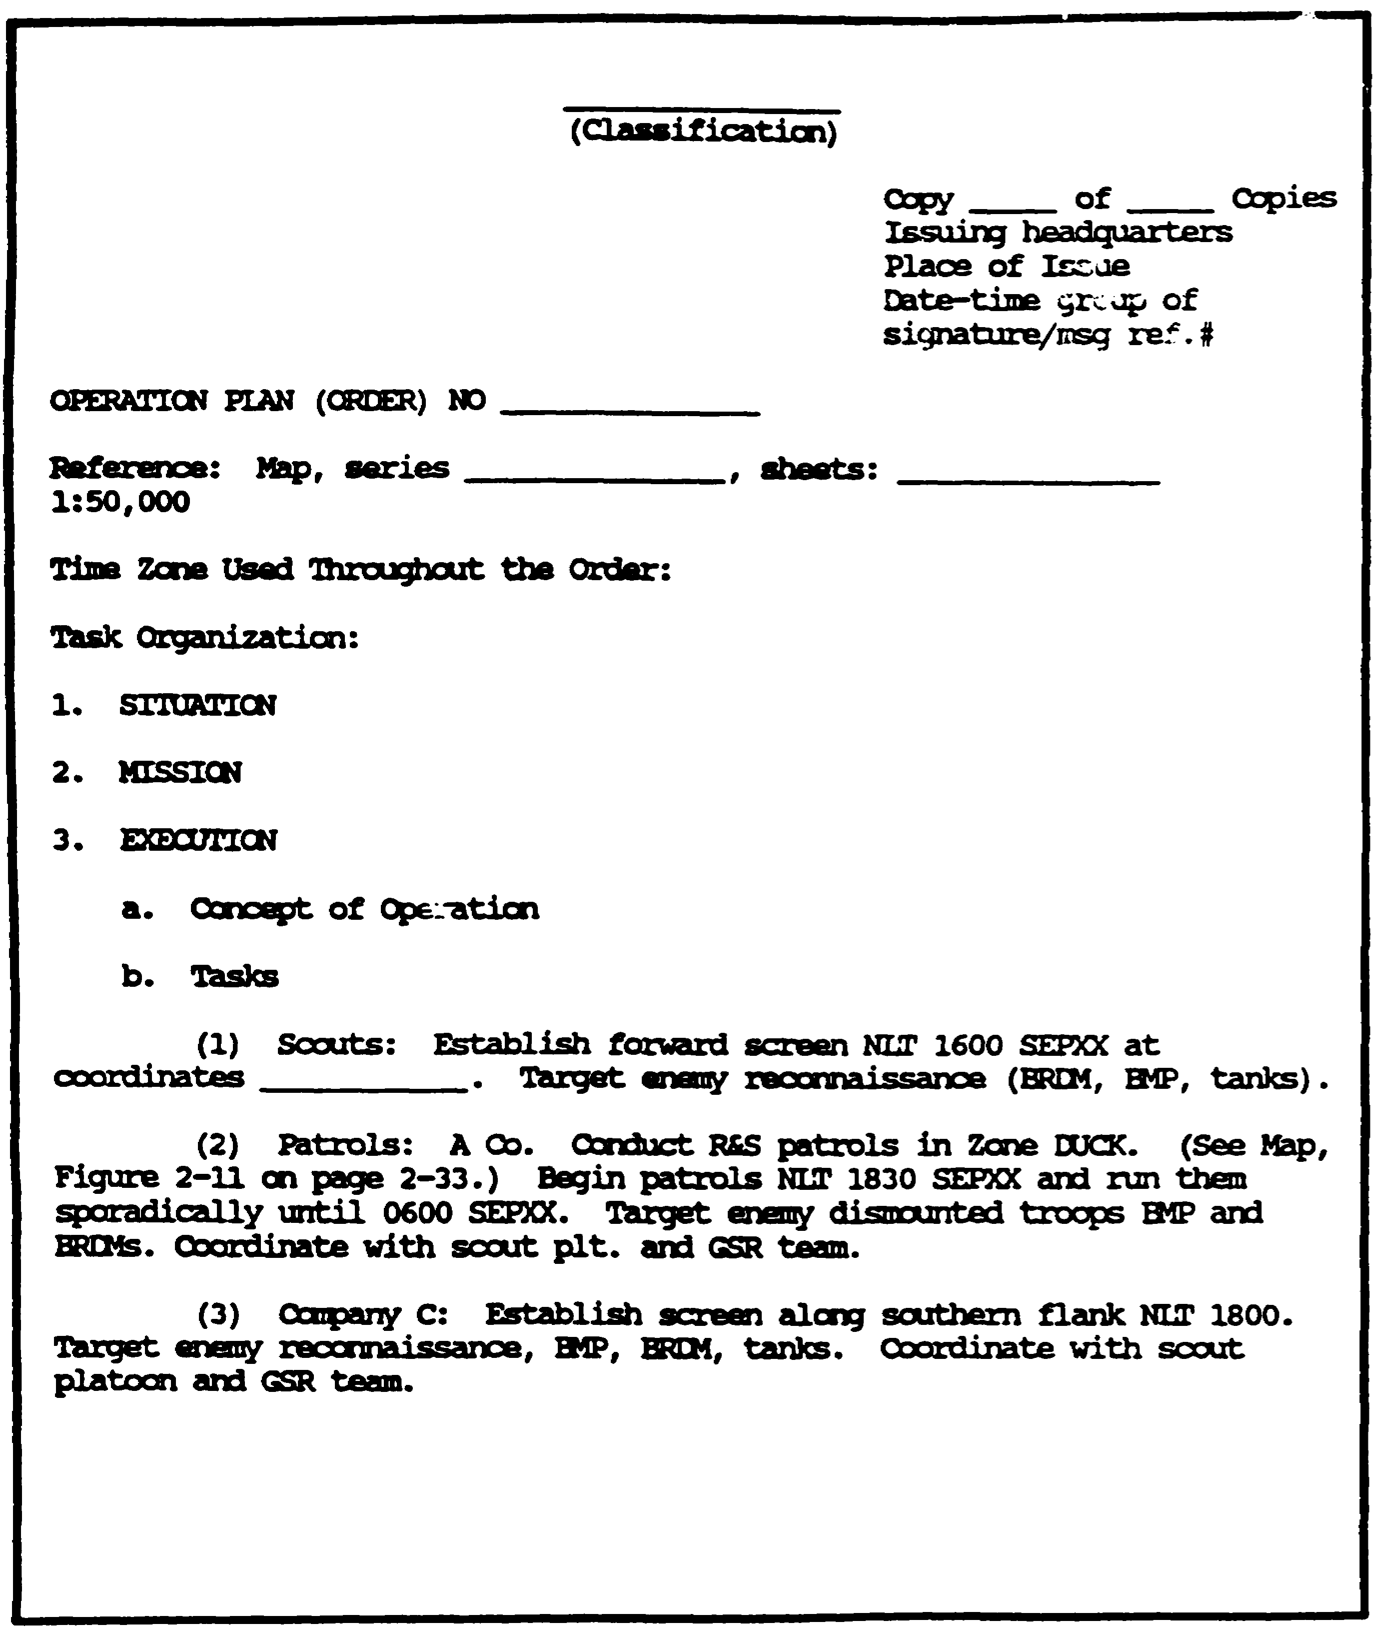

Figure 1-12. Example of paragraph 3b of an OPLAN.

1-33 IT 0433

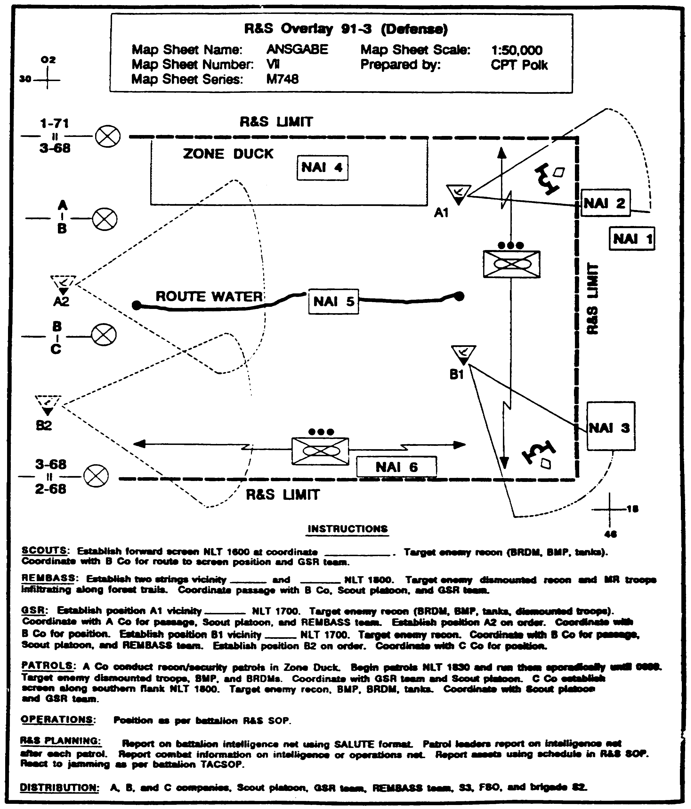

Figure 1-13. R&S Graphic Overlay with Instructions.

IT 0433 1-34

LESSON 1

PRACTICE EXERCISE

The following items will test your grasp of the material covered in this lesson. There is only one correct answer for each item. When you complete the exercise, check your answer with the answer key that follows. If you answer any item incorrectly, study that part of the lesson which contains the portion involved.

1. What is the first step in selecting operational sites for IEW assets?

A. Ground reconnaissance.

B. Aerial reconnaissance.

C. Site reconnaissance.

D. Map reconnaissance.

2. Which of the following is an example of a PROTECTED frequency?

A. Tactical friendly forces frequencies.

B. Friendly missile control frequencies.

C. Enemy's C-E systems frequencies.

D. Commercial air traffic control frequencies.

3. What are essential tasks?

A. Tasks stated in higher headquarters orders or plans.

B. Tasks that define the success of the mission.

C. Tasks not specifically stated in orders or plans.

D. Tasks listed in the unit standing operating procedure.

1-35 IT 0433

LESSON 1

PRACTICE EXERCISE

ANSWER KEY AND FEEDBACK

Item Correct Answer and Feedback

1. D. Map reconnaissance. Page 1-8.

2. A. Tactical friendly forces frequencies. Page 1-20.

3. B. Tasks that define the success of the mission. Page 1-30.

IT 0433 1-36

LESSON 2

DIRECT ASSET MANAGEMENT

Critical Tasks: 301-372-2056
301-372-2201
301-372-2202
301-372-3006
301-372-3007

OVERVIEW

LESSON DESCRIPTION:

In this lesson you will learn how to direct intelligence and electronic warfare (IEW) asset management.

TERMINAL LEARNING OBJECTIVE:

ACTIONS: Directions IEW assets. Evaluates incoming asset reports. Analyzes incoming information. Maintains appropriate IEW asset matrices and worksheets.

CONDITIONS: You will be given narrative information and illustrations from applicable field manuals.

STANDARDS: Direct IEW asset management in accordance with FMs 34-2 and 34-10.

REFERENCES: The material contained in this lesson was derived from the following publications:

FM 34-2
FM 34-2-1
FM 34-3
FM 34-10

INTRODUCTION

Asset management is the execution sub-function of the collection management process. Asset management is the specific planning, directing, and controlling of the individual collection and IEW resources necessary to accomplish the mission.

2-1 IT 0433

The asset managers (AMs) are the unit commanders with assigned resources capable of performing collection missions. The Military Intelligence (MI) unit commander performs IEW asset management.

There is a close relationship between mission management and asset management. The mission manager (MM) tasks the collection agency (for example, an MI unit). The collection agency tasks the specific collection assets. The Ml unit commander designates specific equipment or personnel needed to accomplish the collection mission. Then the S3 passes the identity of the specific assets and other pertinent information on to the MM.

NOTE: The emphasis in this lesson will be on the asset management of IEW assets of a divisional level MI battalion. It will explain the basic methodology for directing IEW assets. FMs 34-25, 34-35, 34-40, and 34-80 provide doctrine on directing the asset management process for other echelon IEW operations.

PART A - MI BATTALION

The tactical operations center (TOC) is the command and control center for the MI battalion. Under the direction of the battalion commander or battalion S3, it performs asset management of organic, attached, and supporting IEW resources. It provides the Ml battalion commander with the centralized management necessary to ensure rapid, efficient responses to mission requirements.

Battalion S2 assists the S3 in assessing counterintelligence (Cl) and enemy prisoner of war (EPW) interrogation mission priorities as received from the higher headquarters ACE. The S2 recommends to the S3 those specific tasks required by Cl and EPW elements in general support (GS) of the division to satisfy these missions.

Battalion S3 has staff responsibility for asset management for Ml battalion resources, to include supporting or reinforcing MI assets, and for supervising TOC operations.

The S3 section reviews missions received from the division ACE, develops specific tasks, and identifies the assets that can best accomplish these tasks. It prepares and transmits tasking instructions less signals intelligence (SIGINT) and electronic warfare (EW) taskings which are prepared by the ACE. Figure 2-1 depicts the S3 section responsibilities.

IT 0433 2-2

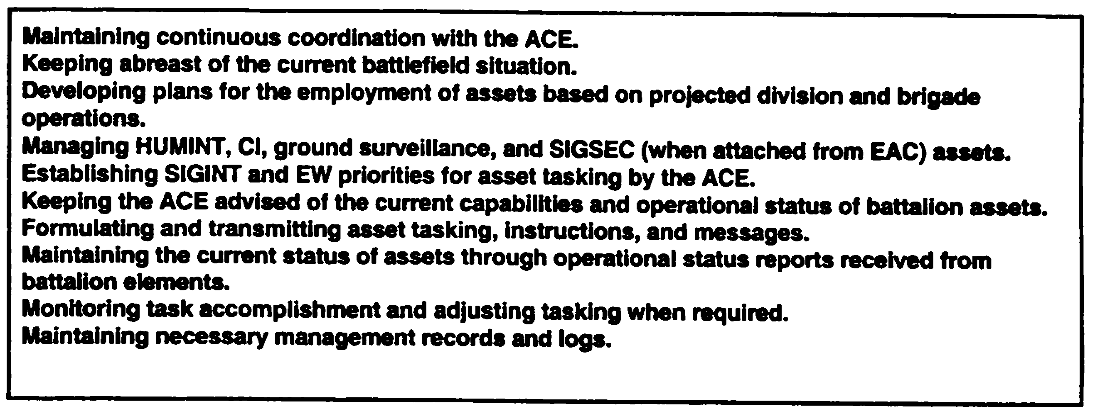

Figure 2-1. Responsibilities

The ACE manages SIGINT and EW assets for the commander and S3 by providing technical control and tasking according to established SIGINT and EW priorities directed by the S3. It recommends to the S3 the task organization and technical employment of SIGINT and EW assets.

PART B - MISSION PLANNING AND ASSET TASKING

Upon receipt of mission tasking from the ACE, the S3, as the battalion asset manager, evaluates the mission and assesses mission requirements. This is accomplished with the assistance of the ACE chief (for SIGINT and EW) and the S3 (for Cl and EPW).

The S3 performs some basic functions to include-

- Receives the specific orders and requests (SORs).

- Logs them in.

- Assigns an identification number.

- Notes the latest time information is of value (LTIOV) or suspense time.

The S3 then determines if assets are still available and capable of satisfying the requirements. Operations readiness, location, and schedule determine asset availability. To determine asset capability the following six factors are used-

2-3 IT 0433

- Range.

- Time-lines.

- Technical characteristics.

- Weather.

- Terrain.

- Threat.

Range is the distance at which a collection system can acquire a target. Target range is usually defined as the distance form the forward line of own troops (FLOT) to the target location (if known) or to the anticipated location. Range alone may not be the determining factor. For example, a SIGINT collector may technically have the range to cover a target area, but terrain and weather factors may block or degrade target coverage. The ACE operations section provides assistance in determining SIGINT and EW range capabilities.

Time-lines is the sum of the time required to-

- Evaluate the system.

- Transmit a collection request.

- Prepare mission.

- Conduct collection operations.

- Analyze or process the information.

- Provide results to requester.

Calculate or estimate the time needed to complete each of these events for each available IEW asset. This is based on the tactical situation and local standing operating procedure (SOP). Time will vary depending on-

- Mission priority.

- Sensor tasking control authorities.

IT 0433 2-4

- Specific system availability.

- Related exploitation and dissemination procedures.

Time must be allowed to transmit a request and receive an answer. This factor is based on experience, the current status of communications, and the tactical situation. The time-line estimating process is essential in determining an asset capability to meet the commander's requirements on time.

Technical Characteristics of each asset must be examined in detail to ensure that the platform and/or sensor can perform the mission. Location accuracy is a critical technical characteristics. For example, SIGINT systems -- the location accuracies of detected emitters must be enhanced through multiple intercepts and lines of bearing (LOB) on the target transmitters. Accuracy is enhanced through multiple use of the same sensor or by a group of sensors working together.

Weather is particularly important in the asset evaluation process. It can affect both the sensor and the platform, as well as the exploitation of the data collected. Heavy rain, fog, or cloud cover can directly affect the collection of some systems.

Terrain. Line of sight (LOS) and terrain masking of sensors are important considerations. Most ground based SIGINT and HUMINT observation requires LOS to accomplish their collection missions. Hills. mountains, large urban areas, and dense forests hinder LOA.

Threat. Collection assets are vulnerable to enemy action. The S3 must anticipate the Threat to both platforms and sensors in sensor evaluation. Penetration assets are the most vulnerable, while stand-off assets are less so. Generally, threat considerations must be weighed with other factors such as timeliness, availability, and capability of the collection system(s).

To assist the S3, an asset scoring procedure can be used to determine whether or not an asset is capable of satisfying information needs. This correlation process (Figure 2-2) provides a list of organic and attached assets capable of satisfying that particular requirement. The list is then reviewed to determine which of the capable assets are available for tasking. The procedure is similar to the one used by the higher headquarters mission manager in correlating specific information requirements (SIRs) with potential collection assets.

2-5 IT 0433

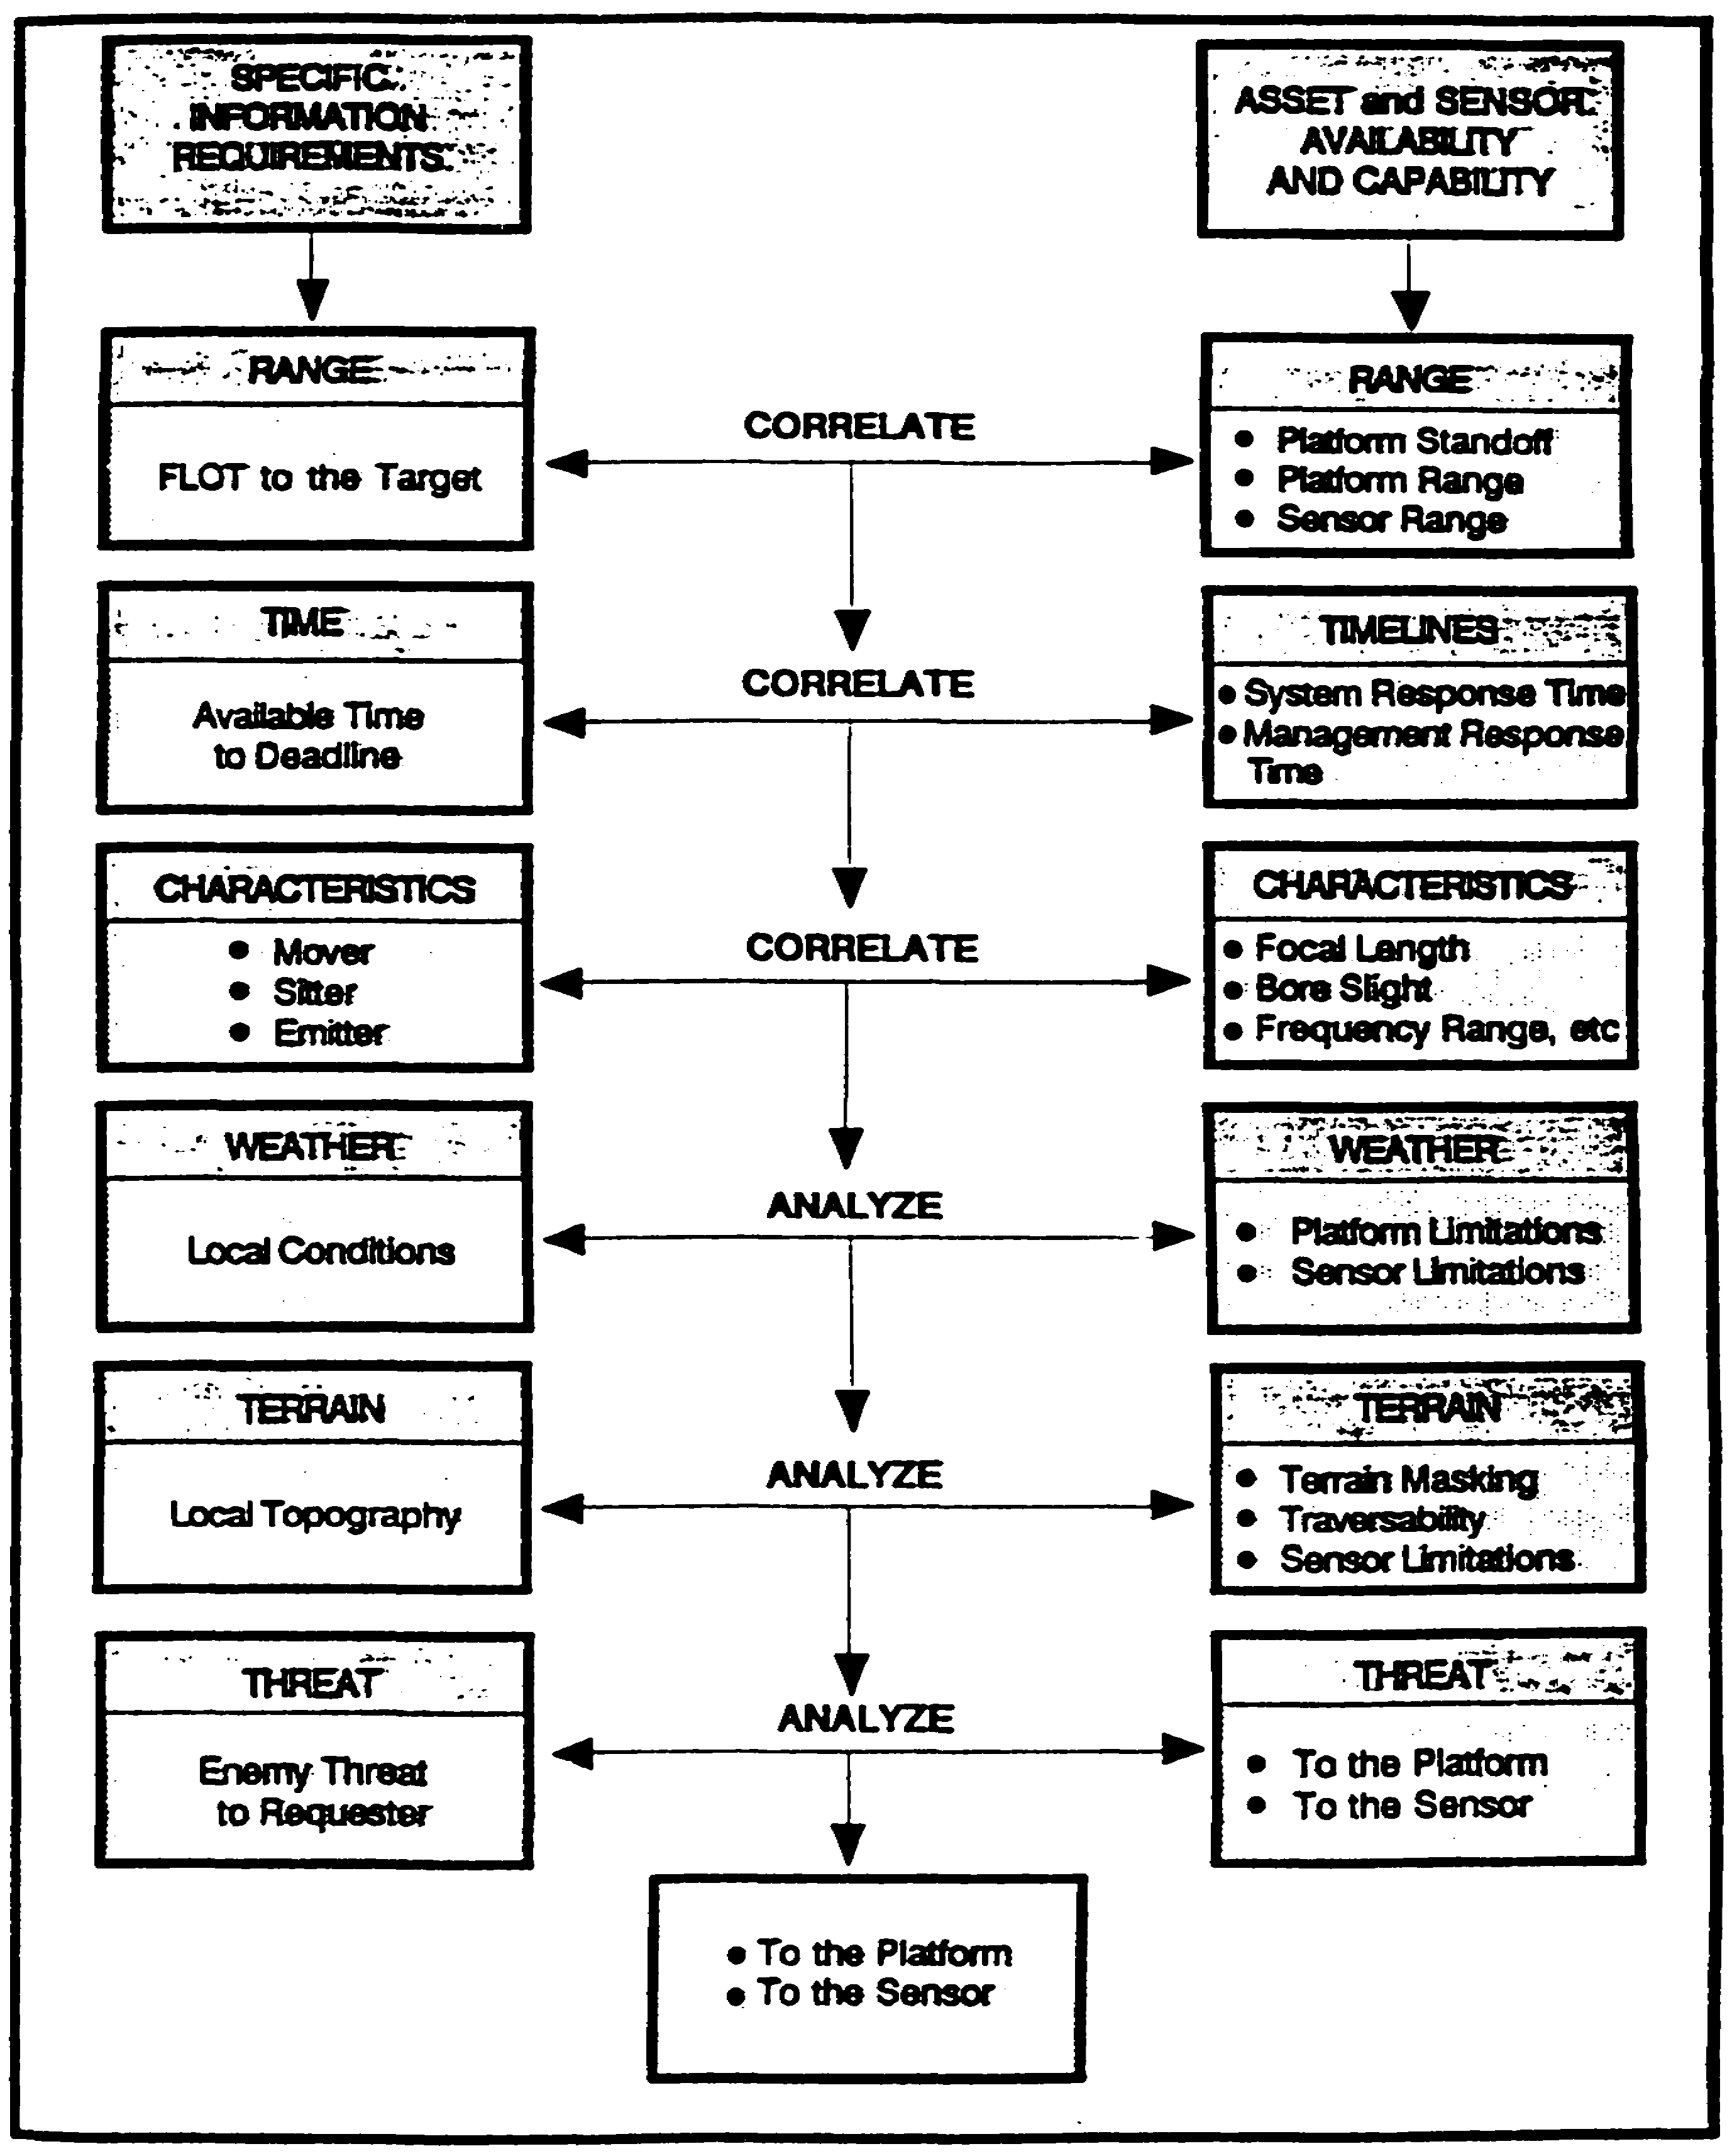

Figure 2-2. Correlation Process

IT 0433 2-6

The next step is for the S3 to plan the collection mission. this is the actual employment of one or more of the IEW collection systems to gather the required information. This planning is supported by the ACE and the S3 section. Lesson 1 of this module provides detailed information on planning the employment of IEW assets.

The IEW assets can receive mission tasking through the use of a fragmentary order (FRAGO), intelligence annex to the operations order, a reconnaissance and surveillance (R&S) matrix, or by using the appropriate United States Signals Intelligence Directives (USSID) messages.

Finally, the S3 monitors the mission unit it is over. For SIGINT and EW, the S3 is supported by the ACE operations section. The S3--

- Modifies the mission, if necessary.

- Informs the MM of its ongoing status.

- Makes sure collected information is processed and reported in a timely manner.

NOTE: Lesson 4, module IT 0432, FMs 34-2 and 34-2-1 provide detailed information on collection management operations and procedures.

PART C - EVALUATE REPORTING

Reporting evaluation is the determination of the value of the collected information relative to the established intelligence requirements. The desired end effect is that all SORs are fully satisfied in a timely manner, keeping the intelligence system fully synchronized. The S3, with the support of the ACE, needs to compare and review incoming reports for--

- Time-lines.

- Format.

- Responsiveness.

Time-lines. The time the event took place needs to be compared with the time the event was reported. This comparison can reveal delays and possible problems with reporting collected information. Does the reported information meet the LTIOV established in the original SORs?

2-7 IT 0433

Format. The reports are checked to ensure that they contain proper addresses and data elements. Are essential elements of information missing?

Responsiveness. The reports are also checked to ensure the information being reported satisfied the commander's requirements. Does the information actually address the tasked SORs?

If any of the above areas need clarification or correction, the S3 has the opportunity to rectify them during this evaluation phase. This can be accomplished by direct communications or through the ACE for SIGINT and EW related information and reports.

Incoming reports need to be corrected with existing requirements to determine if the reported information satisfies any existing SORs. This will assist in determining which SORs have been satisfied and which require continued collection. Note: It may take several reports from different assets, spread over a period of time, to completely satisfy a requirement. The report is forwarded to the ACE. The report is annotated or tagged with the number of the SOR(s) it answers or satisfied.

PART D - ANALYZE INFORMATION

While the report is being evaluated, the information is analyzed by the S3 section and the ACE. Analysis consists of three steps-

- Assessment.

- Integration.

- Deduction.

Assessment is the shifting and sorting of evaluated information to update significant elements with respect to the mission and operations of the command. The first and most important step towards proper assessment is a clear understanding of the unit's mission and the commander's intent. All information gathered is viewed in relation to what the commander wants to accomplish. Assessment also requires judgement and a thorough knowledge of military principles, the characteristics of the area of operations (AO), AND THE ENEMY SITUATION. This includes understanding enemy doctrine, tactics, and past practices. Regardless of the level of command, individuals who assess information must relate their efforts to the unit's mission to avoid wasted time and effort.

IT 0433 2-8

Integration is the process of combining significant elements of information (assessment) with other known information. It forms a logical picture or hypotheses of enemy activities or the influence of the operational area characteristics on friendly courses of action (COAs). In the process, more than one hypotheses may be formulated based on, existing intelligence.

Integration, particularly the development of hypotheses, requires the same good judgement and thorough knowledge essential to making a good assessment. In formulating hypotheses, the intelligence officer needs to avoid preconceived opinions and hypotheses based solely on personal experience, preference, or biases. Attempt to adopt the role of the enemy commander in the development of these hypotheses.

All hypotheses are analyzed and tested. Analysis includes determining the indications that should exist if the hypotheses are valid. Testing includes verifying the existence or nonexistence of these indications within the limitations of available time and means. Testing can be accomplished by comparing the hypotheses with a list of enemy indicators similar to those outlined in Appendix C, FM 34-3.

Deduction is the last step in the analysis of information. Deducing the enemy's actions will be a direct result of the integration process and is designed to answer the question: “What does this information mean in relation to the AO, enemy situation, and commander's intent?” The resulting answer provides a useful conclusion which can serve as a basis for determining future enemy COAs and for keeping the intelligence estimate current. Deduction should also answer the question: “What does this information mean in relation to the enemy's use of tactical deception or counter deception?" the resulting answer reduces friendly vulnerabilities to being deceived and the false belief that battlefield deceptions operations are being believed by the enemy.

Analyzing incoming asset reports will also assist in determining which assets are successful in answering the tasks and which are not. This will assist in making the following determinations-

- If asset is successful, it can be retasked to answer another SIR/SOR.

- If asset is unsuccessful then its location, tasking, maintenance status, and Threat activity or inactivity need to be reevaluated. This evaluation may dictate retasking, relocation, or tasking of another IEW asset.

2-9 IT 0433

PART E - ASSET STATUS

The following Matrix and worksheet will assist the S3 and ACE chief in maintaining the redeployment and equipment status of IEW assets.

IEW Redeployment Matrix (Figure 2-3). This matrix can be used to maintain a ready reference of the location of IEW assets. It has the capability of identifying the locations for each IEW asset's primary, alternate, and supplementary operational site. It can also be used by the supporting brigade DISE.

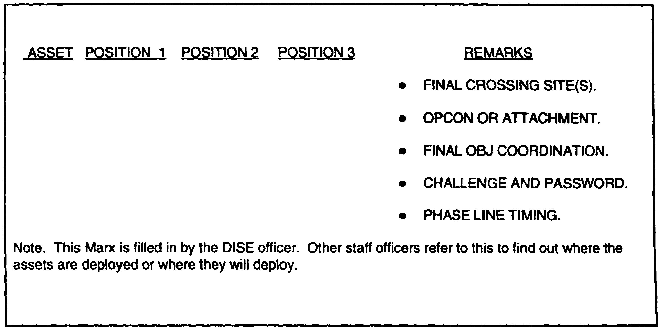

Figure 2-3. IEW Asset Redeployment Matrix.

Resource Status Report (RSR). The RSR is used by the ACE and its subordinate platoon operations centers (POCs) to maintain an accurate and up-to-date listing of all assets available for tasking and retasking. Tactical MI units do not possess enough IEW assets to accomplish the taskings that could be generated in a target rich environment. Therefore, every available asset must be used at all times. The RSR is an invaluable tool to accomplish this.

IT 0433 2-10

There is no standard format for the RSR worksheet; however, all will have the following minimum entries--

- Equipment. List all equipment either organic, attached, or under operational control (OPCON). It is best to list the equipment according to the task organization dictated by the S3.

- Platoon. To whom is the equipment assigned? Again, list according to the task organization.

- Location. Self-explanatory.

- EW System. The actual intercept/jamming position equipment. Indicate its status by stating either GREEN for fully mission capable, AMBER for reduced mission capable, or RED for non-mission capable. Local SOP will provide guidance on how to determine the status of systems.

- Command System. The frequency modulation communications. Indicate status as GREEN, AMBER, or RED.

- Power Source. This includes the status of the generators as well as the prime mover's power source.

- Prime Mover. Self-explanatory.

- Remarks. List as a minimum-

- overall system status.

- date time group of any system component that is rated either AMBER or RED.

- exact system malfunction.

- any other pertinent data.

2-11 IT 0433

LESSON 2

PRACTICE EXERCISE

The following items will test your grasp of the material covered in this lesson. There is only one correct answer for each item. When you complete the exercise, check your answer with the answer key that follows. If you answer any item incorrectly, study that part of the lesson which contains the portion involved.

1. Which of the following ACE assets provides assistance in determining SIGINT and EW range capabilities?

A. Traffic analysis team.

B. Operations section.

C. Cryptanalysis team.

D. Headquarters section.

2. Which of the following is the last step in the analysis process?

A. Deduction.

B. Assessment.

C. Integration.

D. Evaluation.

3. Who has overall responsibility for IEW asset management?

A. Battalion Operations Officer.

B. Battalion Communications Officer.

C. Battalion Intelligence Officer.

D. Battalion Commander.

IT 0433 2-12

LESSON 2

PRACTICE EXERCISE

ANSWER KEY AND FEEDBACK

Item Correct Answer and Feedback

1. B. Operations section. Page 2-4.

2. A. Deduction. Page 2-9.

3. D. Battalion Commander. Page 2-1.

IT 0433 2-14

LESSON 3

PLAN RECONNAISSANCE OPERATIONS

Critical Tasks: 301-372-2008
301-372-2300
301-372-2301
301-372-2302
301-372-3019

OVERVIEW

LESSON DESCRIPTION:

In this lesson you will learn how to direct the development of the Reconnaissance and Surveillance (R&S) plan at battalion and brigade.

TERMINAL LEARNING OBJECTIVE:

ACTIONS Develop a R&S plan. Evaluate assets availability, determine assets collection responsibilities, and prioritize collection requirements. Integrate tasking requirements into all operations orders (OPORDs) and fragmentary orders (FRAGOs). Maintain collection asset status reports.

CONDITIONS: You will be given narrative information and illustrations from applicable field manuals.

STANDARDS: Direct the development of the S2's R&S plan and task organic and assigned assets in accordance with FM 34-2-1.

REFERENCES: The material contained in this lesson was derived from the following publications:

FM 34-2
FM 34-2-1
FM 34-80

INTRODUCTION

Throughout history, military leaders have recognized the important contribution good R&S plays in winning the battle. Our own military history contains many examples

3-1 IT 0433

where our knowledge of the enemy, or lack of knowledge, directly led to victory or defeat.

The role of R&S has not changed on the modem battlefield. If anything, it has become even more important. Battles at the combat training centers prove that a good R&S effort is critical to success. On the other hand, a poor R&S effort almost guarantees defeat for the commander. Our success in Desert Storm reinforces the effects of good R&S planning and execution.

The message is clear: Success on the battlefield begins with R&S and R&S begins with the intelligence officer. As the S2, you play a big role in the success or failure of your unit. This lesson will provide you with the knowledge necessary to effectively direct the planning and execution of R&S operations.

PART A - COLLECTION MANAGEMENT PROCESS

To successfully plan and execute the R&S effort, you need a basic understanding of the five phases of the collection management process and the relationship of R&S to collection management process and the relationship of R&S to collection management. See lesson 4, module IT 0432 for a detailed discussion of the collection management process. Regardless of the echelon, you will go through the following five steps or phases to develop a collection plan and, ultimately, an R&S plan:

- Receive and Analyze Requirements (Develop Requirements).

- Determine Resource Availability and Capability (Develop Collection Plan).

- Task or Request Tasking of Resources.

- Evaluate Reporting.

- Update Collection Planning.

Receive and Analyze Requirements (Develop Requirements).

Receiving and analyzing requirements means identifying what the commander must know about the enemy, weather, and terrain to accomplish the mission. Normally, the command's concerns are expressed as questions, termed priority intelligence requirements (PIR) or information requirements (IR).

PIR and IR are either stated by the commander or recommended by you and approved by the commander. This is normally accomplished during the wargaming phase of the

IT 0433 3-2

command estimate process. You may also have requirements from higher or subordinate units. These you will prioritize and consolidate with the commander's PIR. Once you have identified all requirements you will eventually convert them into specific items to look for.

Determine Resource Availability and Capability (Develop Collection Plan). In simplest terms, determining resource availability and capability means assessing what assets you have to look for the specific items you have developed in the first step.

Task or Request Tasking of Resources. When tasking resources, you must tell a specific resource what it should look for and how to report the information.

Evaluate Reporting. Is the asset accurately reporting what it sees based on its capabilities? Does the report answer the original question?

Update Collection Planning. Do you need more information to answer the question, or is it time to shift focus and begin answering another question?

PART B - R&S TERMS/PRINCIPLES

Reconnaissance is concerned with three components: enemy, weather, and terrain. you should understand that reconnaissance is active. It seeks out enemy positions, obstacles, and routes. Since movement draws attention, good reconnaissance uses stealth to avoid detection.

Surveillance is passive. Surveillance implies observing a specified area or areas systematically from a fixed, concealed position. A good R&S plan contains the best mix of R&S based on requirements, assets available, and the Threat.

Counterreconnaissance (CR) essentially means blinding the enemy's eyes so they cannot detect our attack, or cannot locate our defensive positions. CR missions require you to-

- Know something about how the enemy reconnoiters.

- Be able to locate, target, destroy, or suppress enemy reconnaissance assets.

Defining R&S and CR in isolation may suggest that they occur in a vacuum. Nothing could be farther from the truth. R&S is a crucial phase of the intelligence cycle and a key part of your continuing collection process.

3-3 IT 0433

Principles: Now that we have defined R&S terms, we will address the two principles of R&S. They are--

- Tell commanders what they need to know in time for them to act.

- Do as much as possible ahead of time.

The first principle is of paramount importance. You must develop the R&S plan so that it directly addresses what the commander wants to know. In essence, the R&S effort is commander-oriented and commander-directed. Therefore, you cannot develop a successful plan until you know exactly what the commander needs to know.

The commander's questions which positively must be answered in order to accomplish the mission are PIR. They are the start point for the R&S plan. The clearer and more precise the commander's PIR, the better you will be able to develop the R&S plan to answer them. Remember, PIR drive your R&S efforts, so it is critical that you understand exactly what your commander needs to know in order to fight and win the battle.

The second principle involves the use of the IPB process. You need to build a data base on terrain, weather conditions, and enemy order of battle (OB) prior to hostilities. IPB is people intensive and time consuming. Consequently, the majority of the IPB effort needs to be accomplished during contingency planning prior to hostilities. You simply will not have the time during combat to establish a data base or conduct any in-depth analysis of the enemy, weather, or terrain. To successfully plan and execute the R&S operation, you must have this detailed analysis. IPB gives you a way to synchronize your R&S plan with the general battle plan. Lesson 2, module IT 0432 provides detailed information on the IPB process.

PART C - R&S PLAN DEVELOPMENT

There are many things you must consider when developing the R&S plan. You will probably have to consider fire support, maneuver, engineer augmentation, and command and control. You will need to ensure that the R&S plan fits into your commander's overall scheme of maneuver. You will also want to make sure that the R&S plan is closely tied to fire support and maneuver for CR missions as well.

Do not delay your planning awaiting copies of subordinate unit's R&S PLANS. If the situation warrants, give your R&S assets an initial mission and update the mission when you have the time for more detailed planning. All units, to include subordinate and higher, should be conducting simultaneous R&S planning. The technique that allows this simultaneous planning is the use of limits of responsibility. A limit of responsibility is a boundary defining where a particular unit should concentrate its R&S efforts.

IT 0433 3-4

In essence, a limit of responsibility is a “no further than” line. It tells the unit, “your R&S responsibilities stop here.” Figure 3-1 is an example of limits of responsibility for battalions, brigades, and divisions. They may be tied to a unit's area of interest (Al) or may depend entirely on mission, enemy, terrain, time, and troops available (METT-T).

The key is that limits of responsibility allow each echelon to formulate its R&S plan independently. It is important to note that an R&S plan is never a finished product. Because the situation and operational plan will most likely change, the R&S plan must be flexible enough to change to fit any contingency.

PART D - R&S PLANNING PITFALLS

Many common mistakes made by S2s in the planning stage result in unproductive R&S operations. These mistakes were noted during numerous observations at the training centers and occur regularly. To avoid errors in R&S plans, use the guidelines discussed below.

Use IPB Products. Use situation templates and event templates to identify areas on the battlefield where and when you expect significant events or targets to appear. These IPB products will save many hours of analysis by pinpointing specific areas on which to focus your R&S effort.

Know Your Assets. Know the capabilities and limitations of the R&S assets available to you. This should ensure that assets are not sent on missions they are not capable of conducting nor trained to conduct.

Provide Details. When you develop your R&S plan, provide details. Generic R&S plans do not provide the amount of information required in the time allocated.

Understand Scheme of Maneuver. It is imperative that you understand your unit's scheme of maneuver before you begin to formulate the R&S plan. A well thought out R&S plan that does not support the scheme of maneuver is a useless effort.

Provide Guidance. Provide detailed guidance to the company and teams as they plan their patrol missions: Patrols also need to coordinate with battalion before, during, and after all missions. This should preclude useless missions and wasted lives. You should also make sure patrols have enough time to plan and execute their missions.

Know Locations of Assets. You need to continuously monitor and disseminate the current locations of friendly R&S assets. This should minimize the incidents of fratricide.

3-5 IT 0433

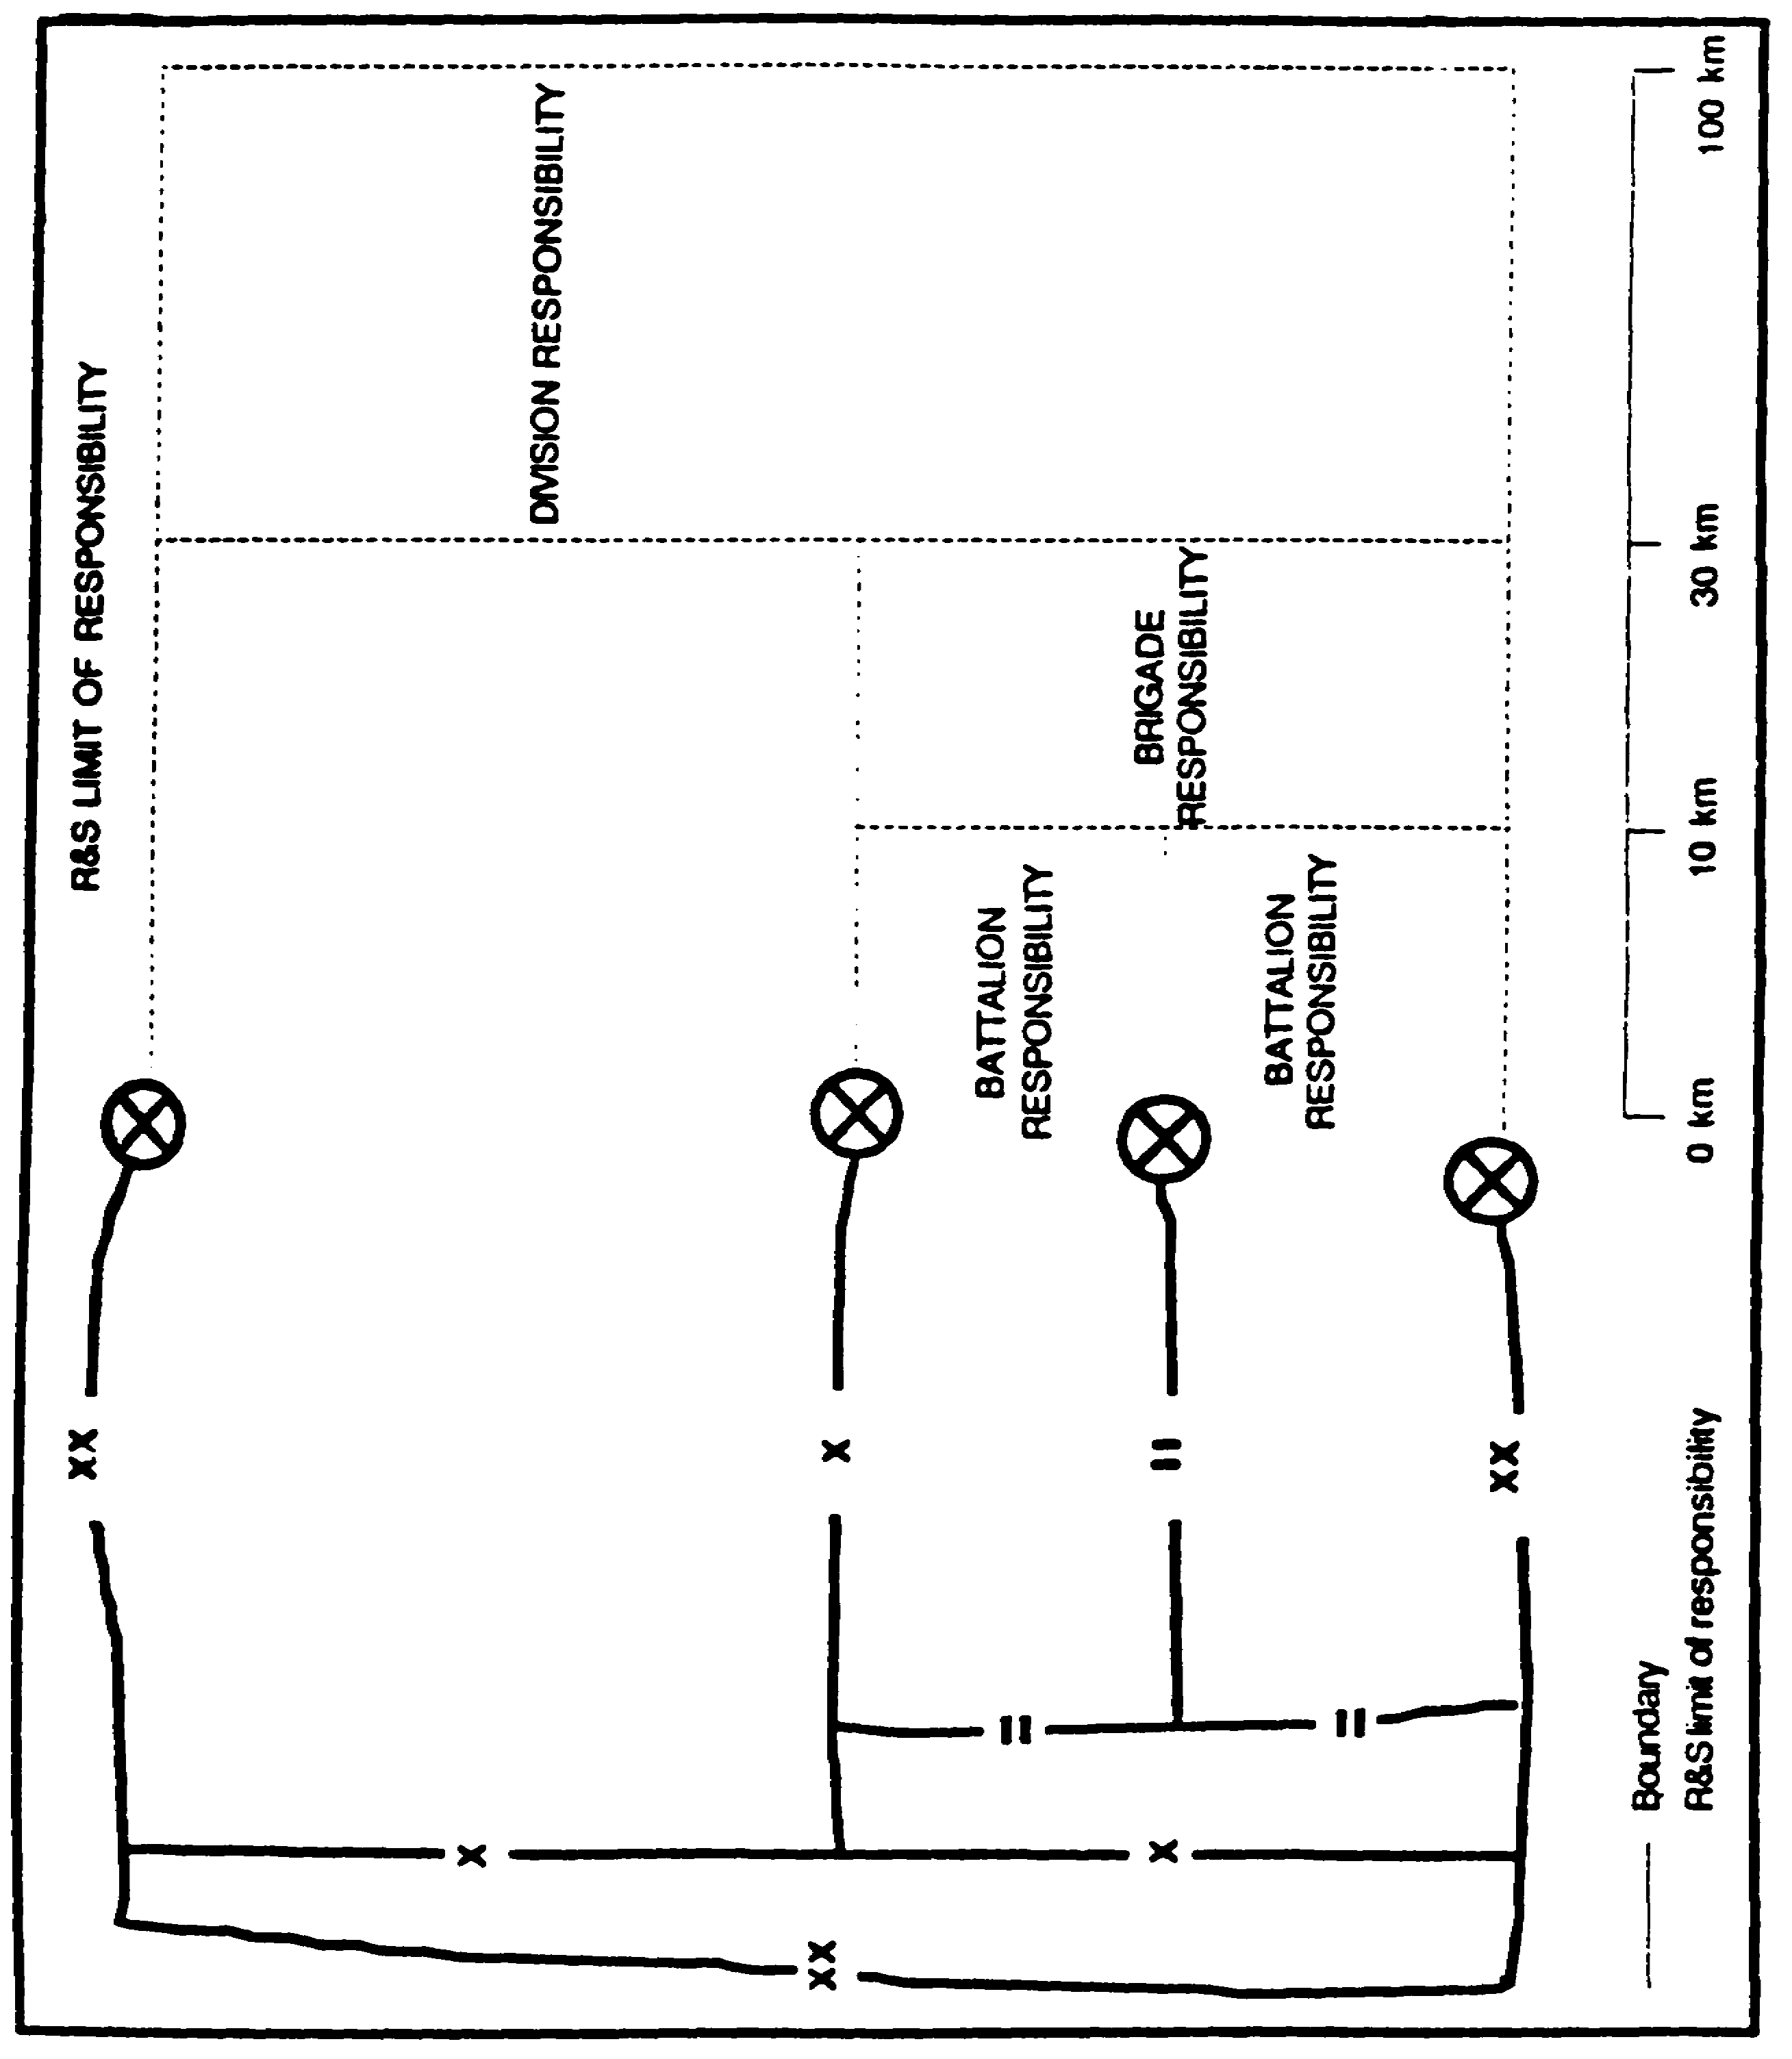

Figure 3-1. R&S Limits of Responsibility.

IT 0433 3-6

Integrate Fire Support. Involve the Fire Support Officer (FSO) in R&S planning so that indirect fire support is integrated into all phases of R&S operations.

Stress the Importance of R&S Missions. Subordinate elements tend to ignore collection taskings assigned by higher echelons; they sometimes consider these nonessential taskings. Make sure these subordinate element commanders understand the importance of their R&S missions. You must get the S3 or the commander involved to remedy this situation.

Participate in the Development of Mission Essential Tasks Lists. The battalion S2 should take an active role in the development of the scout platoon battle tasks. The only way to establish a proper working relationship is to train with the scout platoon leader in garrison as well as in the field. The result will be a scout platoon that understands what the S2 needs and an S2 that understands the capabilities and limitations of the scout platoon.

Point out Named Areas of Interest (NAI). During CR operations, point out areas throughout the battlefield where you expect enemy reconnaissance. Do not limit these NAI to areas just along the forward edge of the battle area (FEBA) or the line of departure (LD) /line of contact (LC). Company and team commanders and staffs must understand that CR operations extend throughout the depth of the battlefield. Enemy reconnaissance assets are trained to look deep and to conduct operations well into the friendly rear area.

Incorporate Flexibility. Be sure to incorporate flexibility into your R&S plan. Be ready to make modifications at any time, especially in a nuclear, biological, and chemical (NBC) environment.

Do Not Keep the Scout Platoon Leader Waiting. Do not keep the scout platoon leader at the tactical operations center (TOC) waiting for a complete OPORD. Some results are --

- The scout platoon deploys too late to sufficiently reconnoiter its assigned NAIs.

- Lack of time makes the scout platoon leader reluctant to exercise the initiative and flexibility necessary to ensure complete coverage. For example, scouts remain in their vehicles instead of dismounting.

- The scout platoon fails to follow standing operating procedures (SOPs).

3-7 IT 0433

Do Not Overly Rely on the Scout Platoon. Commanders tend to rely too much on their scout platoons. An untrained scout platoon may display weaknesses in land navigation, selecting proper R&S positions, reporting information, and calling for indirect fire. When you do use scout platoons, try to confirm its reports with information gathered from other assets. Also, do not fall into the trap of using the scout platoon as the only R&S collection asset. When using the scout platoon be sure the mission you give it is one it is capable of successfully completing.

These solutions apply to common problems occurring throughout the Army. Take note of these solutions and try to develop R&S plans reflecting the solutions, not the problems. Appendix A, provides an example of a R&S checklist. The purpose of the checklist is to ensure that complete coordination is conducted for all R&S operations. The checklist should be used in directing the planning and execution of R&S operations. It will help you in alleviating some of the problems inherent in R&S operations.

IT 0433 3-8

PART E - ASSETS AND EQUIPMENT

Before you can develop an, R&S plan you must know the characteristics of available assets and equipment. This part of the lesson will discuss the organic and supporting R&S assets and equipment available to the maneuver battalion S2. NOTE: Lesson 2 and lesson 5 of module IT 0432 address the organic and supporting assets and equipment available to the maneuver brigade and military intelligence (MI) battalion of the heavy division. FMs 34 and 71 series field manuals provide detailed information on the maneuver and intelligence and electronic warfare assets and equipment available for use in planning and executing R&S operations.

At the battalion level the commander is fighting close-in operations. To support the commander, focus the collection effort at the 1st - and 2d-echelon regiments (out to 15 kilometers). The assets available to conduct R&S missions at battalion are limited. Consequently the S2 faces a challenge when planning R&S operations. Some of the assets are scouts, patrols, observations posts (OPs), listing posts (LPs), soldiers, and equipment.

Scout Platoon. The scout platoon's primary missions in support of the battalion are reconnaissance and screening. Its primary mission is reconnaissance. The scout platoon, with fire support protection, can conduct reconnaissance missions 10 to 15 kilometers beyond the FEBA. These distances vary with the type of scout platoon and METT-T. The scout platoon is the only asset found at the maneuver battalion specifically trained to conduct reconnaissance. Other missions the scout platoon conducts are --

- Quarterly party duties.

- NBC reconnaissance, including chemical detection and radiological surveying and monitoring.

- Limited pioneer and demolition.

- Security missions.

- Reconnoiter and establish OPs and LPs.

3-9 IT 0433

Patrols (Maneuver Elements. There are two basic types of patrols: reconnaissance and combat. A patrol is a detachment sent to conduct reconnaissance, combat, or both. It consists of at least two people who may be accompanied by specially trained personnel or augmented with equipment essential to the mission. All maneuver elements conduct patrols during combat operations to provide reconnaissance, CR, security, and small-scale combat operations.

Reconnaissance patrols collect information and confirm or disprove the accuracy of previously gained information. The three types of reconnaissance patrols are route, area, and zone.

Combat patrols provide security and harass, destroy, or capture enemy personnel, equipment, and installations. The three types of combat patrols are raid, ambush, and security.

OPs/LPs (Maneuver Elements). Units establish OPs/LPs to provide security, surveillance of NAI, and early warning of enemy activities. They are in use extensively during limited visibility. Proper emplacement includes concealment and unit support by fire.

Patrols differ in training and logistic support from scout platoons and normally do not establish OPs/LPs for extended periods. If you use patrols to conduct surveillance for extended periods, you are mismanaging your R&S assets. OPs/LPs are tasked to provide surveillance for extended periods as long as they meet the requirements stated above.

Soldiers. During combat, soldiers are scattered all over the battlefield; thus, they can provide a large quantity of real-time information. You must get involved in the training to increase the timeliness and accuracy of information reported. All soldiers must know how to properly report information. Lesson 1, module IT 0431 provides guidance on directing unit intelligence training.

Equipment. Night observation devices (NODs) are either active or passive equipment designed to permit observation during darkness. Active equipment transmits infrared or white light to illuminate the target. Passive devices use either ambient light (from the stars, moon, or other low-intensity illumination) or operate by detecting the differences in heat (infrared energy) radiated by different objects. Heavy rain, snow, fog, or smoke degrades the effectiveness of these devices. You should use NODs on night patrols and OPs/LPs. Figure 3-2 shows observation equipment associated with the maneuver battalion.

IT 0433 3-10

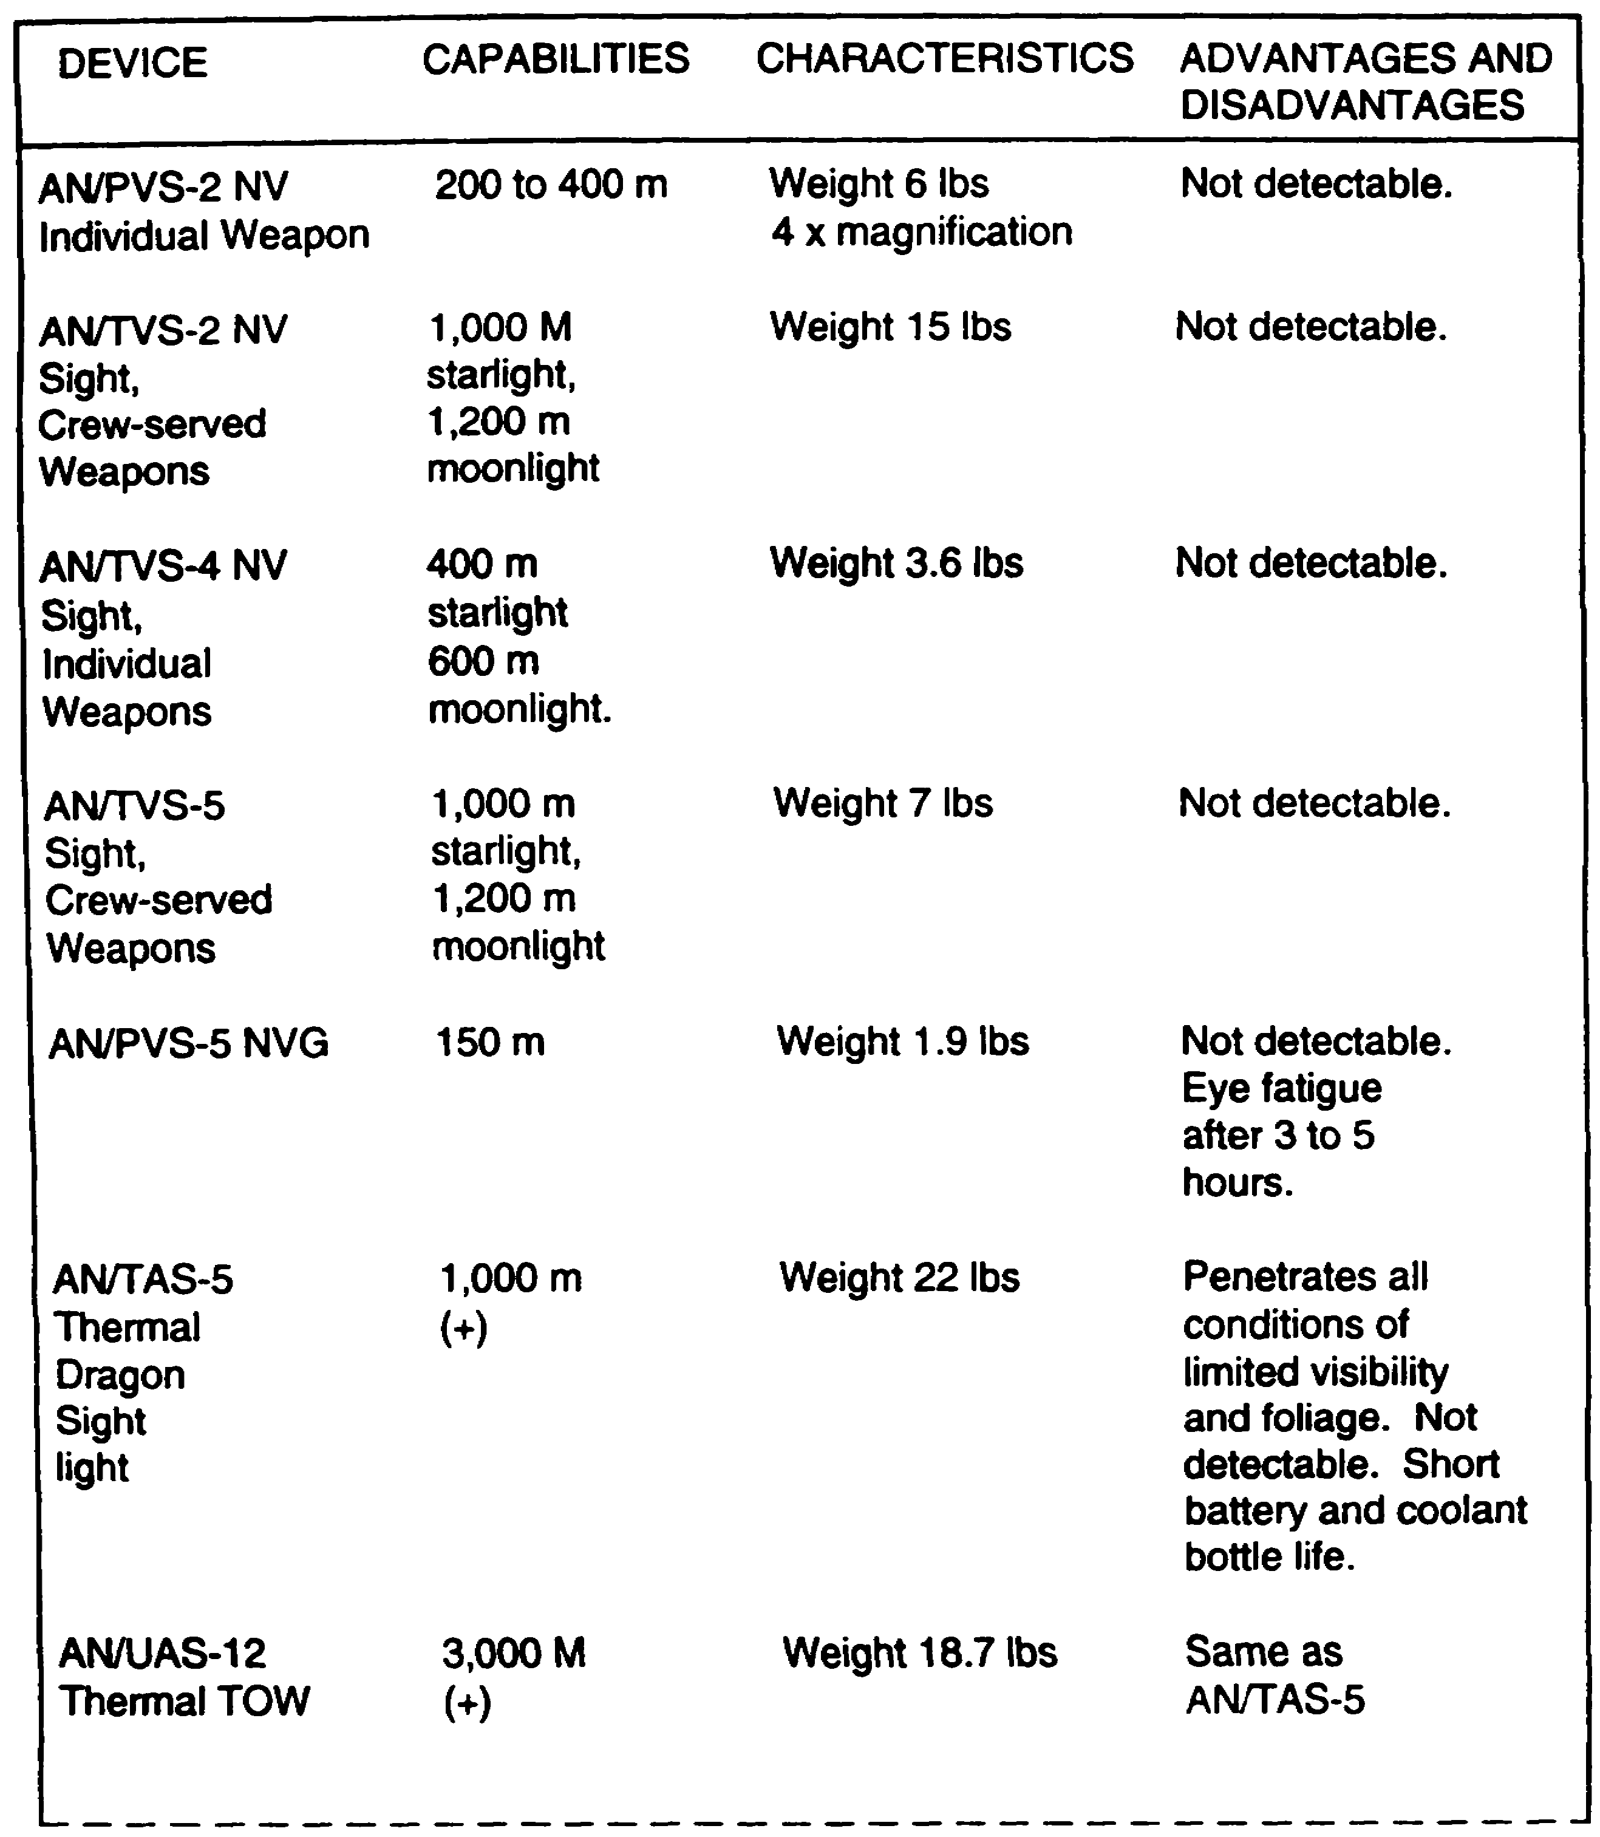

Figure 3-2. Observation Equipment - Maneuver Battalion.

3-11 IT 0433

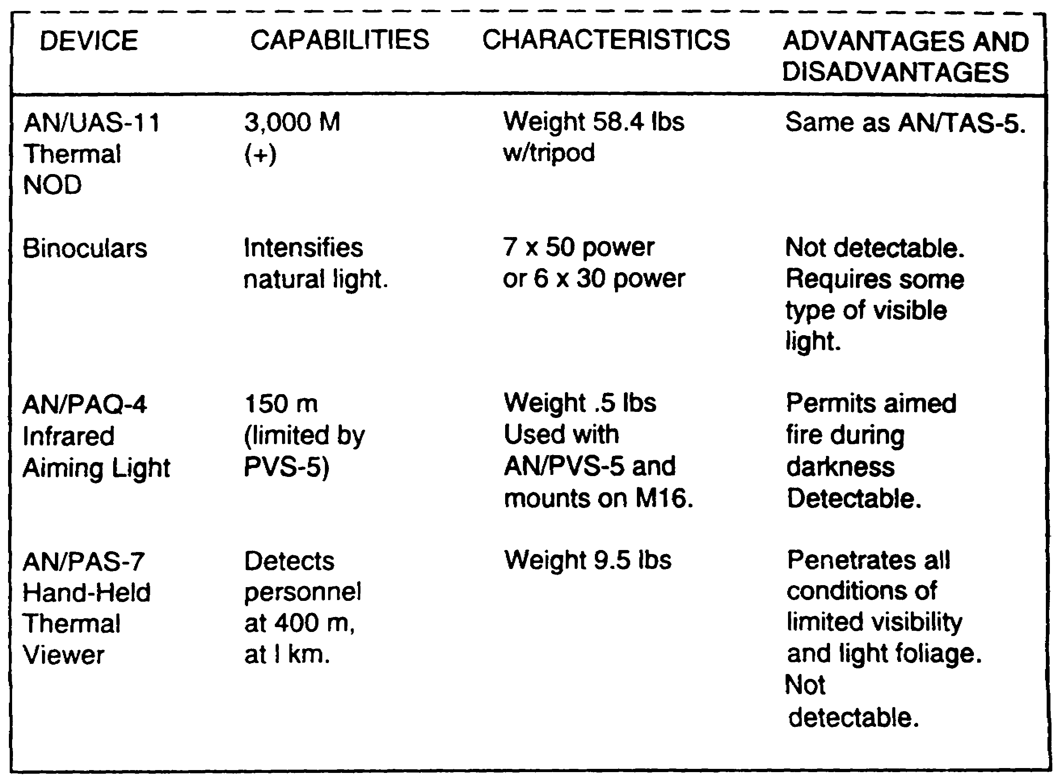

Figure 3-2. Observation Equipment - Maneuver Battalion
(Cont.)

There are a variety of additional assets and personnel that normally support the maneuver battalion. These induce ground surveillance radar (GSR), remotely monitored battlefield sensor system (REMBASS), field artillery, engineer platoon, air defense artillery platoon, and Army aviation.

Ground Surveillance Radar: provides the tactical commander with timely combat information and target acquisition data. The primary capability of the GSR is to search, detect, and locate moving objects during limited visibility. GSR is capable of accurately locating targets for rapid engagement. It provides early warning of enemy movement and assists friendly forces in movement control. GSR is used to--

IT 0433 3-12

- Detect enemy movement during limited visibility.

- Monitor NAI.

- Monitor barriers and obstacles to detect enemy breaching.

- Extend the capabilities of patrols and OPs/LPs.

- Vector patrols.

- During daylight, detect enemy obscured by haze, smoke, or fog.

- Monitor possible drop zones (DZs) or landing zones (LZs).

REMBASS: is organic to the airborne, air assault, and light division Ml battalion, Intelligence and Surveillance (I&S) company. Each MI battalion is allocated 5 REMBASS systems. REMBASS can be employed in a general support (GS) role or it can be used in a direct support (DS) role. In a DS role REMBASS provides support to the maneuver brigades, division support command, armored cavalry squadron, or maneuver battalions.

REMBASS teams hand deploy the sensors and repeaters. They also provide personnel to operate a monitoring device and monitoring set located at the supported unit's TOC. It is important to include the REMBASS team leader in planning REMBASS missions to support R&S operations.

REMBASS is an all-weather day or night surveillance system activated by magnetic, seismic-acoustic, or infrared changes from moving targets. It transmits target data by frequency modulation radio link to the monitors. With this data the operator can determine the target's--

- Direction of travel.

- Rate of speed.

- Length of column.

- Approximate number.

- Type (personnel or wheeled or tracked vehicles).

REMBASS can operate in unusual climatic conditions and on varied terrain. REMBASS has transmission ranges of 15 kilometers (ground to ground) and 100 kilometers

3-13 IT 0433

(ground to air). Because of the flexibility and wide range of REMBASS application, various sensor combinations can be selected to suit any given mission.

Field Artillery. To properly integrate field artillery assets into the R&S and CR plans, you must understand the capabilities and limitations of their equipment. A field artillery battalion is both a producer and a consumer of combat information. Field artillery battalions in DS Of brigades provide each maneuver battalion headquarters a fire support element (FSE). This element is headed by a fire support Officer (FSO). The FSE helps plan, direct, and coordinate fire support operations. The FSE also provides a fire support team (FIST) to each maneuver company.

Forward observers (FOs) from each FIST are deployed to platoons (except in armor battalions) and may accompany reconnaissance patrols or help operate OPs. FOs observe the battlefield to detect, identify, locate, and laser-designate targets for suppression, neutralization, or destruction. They report both targeting data and combat information to the maneuver battalion FSO and S2.

Engineer Platoon. The maneuver battalion receives engineer support from the engineer company normally placed in DS of the brigade. Usually, an engineer platoon supports a battalion. The mission of the engineer platoon is to provide mobility, countermobility, survivability, and general engineering support.

As the S2, you should learn to tap into this valuable resource for detailed information on natural and constructed terrain features. The S3 and the engineer support officer need to coordinate with each other to integrate engineer assets into the R&S and CR plans. The engineer support officer can provide key information about the terrain without your having to send out a reconnaissance patrol. In some cases it would prove valuable to have engineers go along with reconnaissance patrols. Engineers can provide expert terrain and obstacle analysis.

Air Defense Artillery Platoon. Short-range air defense elements normally support the maneuver battalion. These may include stinger teams or sections and Vulcan squads. The air defense artillery (ADA) platoon or section leader functions as the battalion air defense officer. The ADA leader works closely with the battalion S2, S3-air, FSO, and air liaison officer (ALO) to plan and coordinate with you to pinpoint area of enemy air and ground activity.

Army Aviation. Army aviation units provide a responsive, mobile, and extremely flexible means to find, fix, disrupt, and destroy enemy forces and their supporting command, control, and communications facilities. Some aviation assets are capable of performing limited reconnaissance missions; however, most will collect information only as part of normal aviation missions.

IT 0433 3-14

PART F - R&S PLANNING

The S2 is responsible for making recommendations in R&S operations. At brigade or battalion, you are the driving force in the R&S effort. The first step in R&S planning begins with receiving the unit's mission. You must understand the commander's intent in this particular mission. Once you understand the mission, begin to analyze the requirements placed on you as the S2. The commander should tell you the key pieces of information needed before and during the mission. This key information, called PIR, is either stated by the commander or recommended by you for the commander's approval. During this time you also start to develop initial IRs.

The PIR and IR provide the initial focus on the R&S effort. The R&S plan should answer the PIR and IR. At this point you should have a rough draft R&S plan, such as when and what areas to begin R&S operations. (This is part of the mission analysis phase of the planning process steps).

You can now begin adding some detail to the R&S plan. Integrate any requirements from higher headquarters into the plan. You have to translate the initial PIR and IR into indicators on which R&S assets can collect. Now determine the specific information requirements (SIR) and specific orders and requests (SOR) needed for the R&S plan. The SIR and SOR ensure assets are collecting specific information that answers the PIR and IR. Figure 3-3 shows examples of the PIR, indicator, SIR, and SOR. (Additional examples of indicators are in FM 34-3, Appendix C).

The event template is a product of Intelligence Preparation of the Battlefield (IPB) showing when and where the enemy could go. Compare the developed SIR to the event template. This comparison should indicate when and where to deploy friendly R&S assets. Those areas in which you expect enemy activity are labeled NAI.

Once you have a picture of the coverage required for the R&S effort, you should prioritize the SIR. Those SIR that, when answered, will provide the greatest amount of intelligence in the shortest amount of time should have the higher priority. (This is part of the Course of Action (COA) development phase of the planning process steps.)

By now you have set your SIR priorities, identified areas to deploy R&S assets, and know when to begin the R&S mission. For the next step, you must be familiar with the capabilities and limitations of all R&S assets at your particular level. Compare the SIR with available R&S assets. Close coordination between you and other staff officers should ensure that the assets are properly deployed. Development of the R&S plan should involve all staff officers. Your concern is developing IR and guiding assets to the proper areas.

3-15 IT 0433

Planning. Once you know which R&S assets are available to conduct R&S operations, you have to decide how to satisfy the SIR. To collect the greatest amount of intelligence with the fewest assets, you must know how to plan missions using basic collection management strategy such as augmenting, task organizing, cueing, and redundancy.

Augmenting. In this lesson, the term "augmenting” is used to describe using numerous assets at the same time to support the R&S plan. You task with independent or dual R&S missions to augment the R&S effort; units are not augmented.

IT 0433 3-16

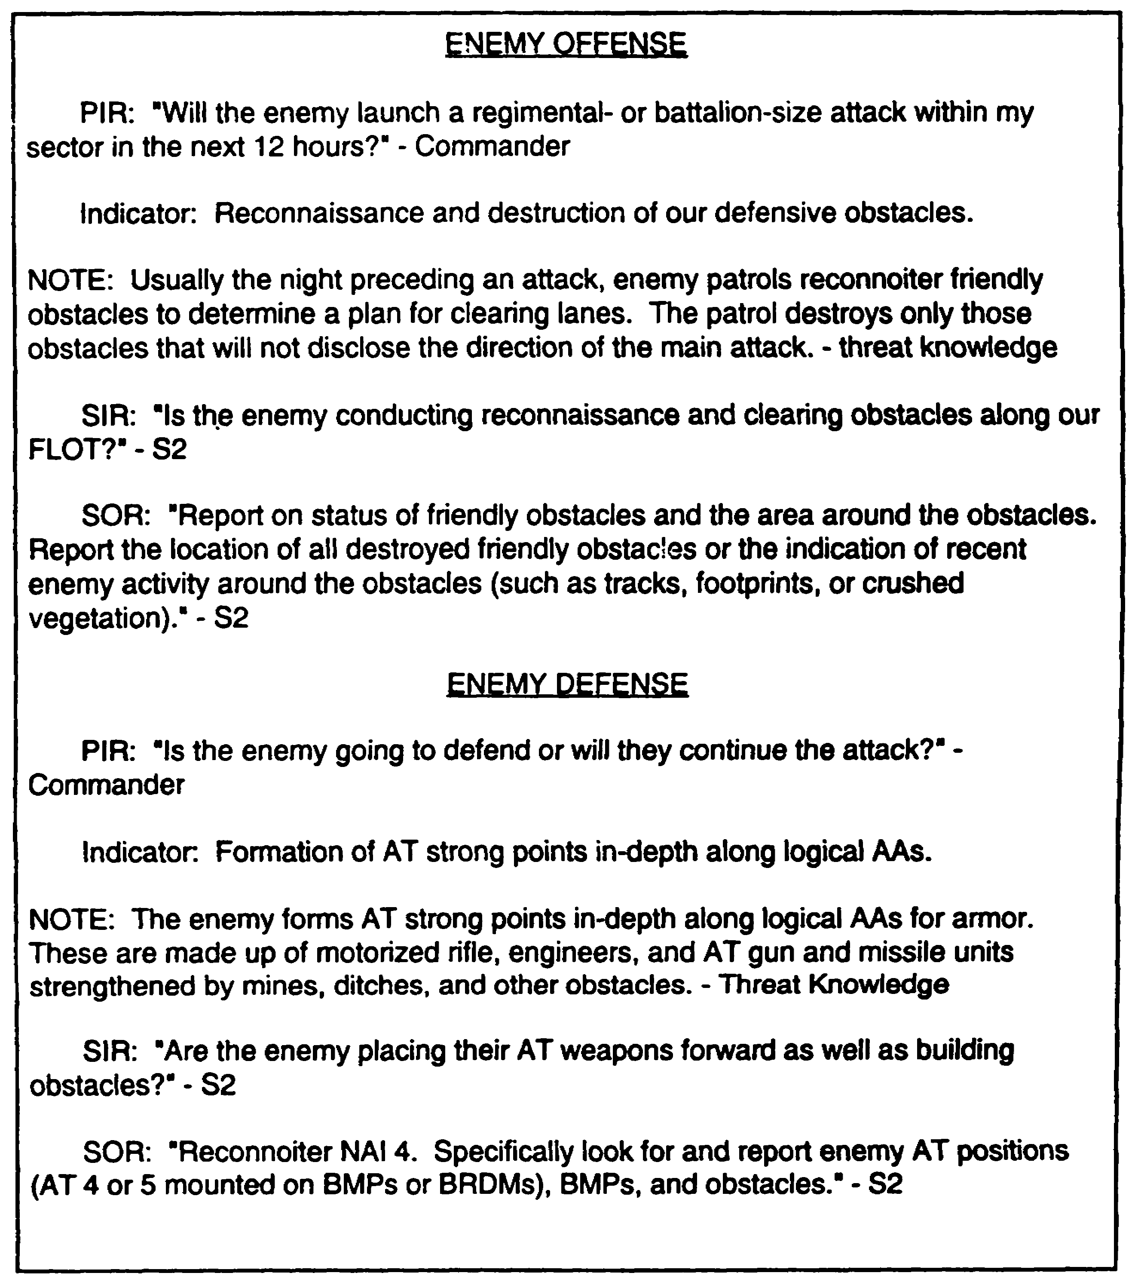

Figure 3-3. Examples of PIR, indicator, SIR and SOR.

3-17 IT 0433

Task Organizing. To collect the most information with the fewest assets in the quickest way, task organize assets. This increases their overall effectiveness in gathering information and surviving on the battlefield.

Cueing. Cueing is using limited assets to identify or verify enemy activity or using one asset to tip off or alert another asset. Use the event template to pinpoint the times and areas to collect on the enemy. Instead of the R&S assets trying to cover large areas for extended periods of time, the assets are active only when cued. The cueing can be the time you expect the enemy to be at a specific NAI, or the reaction to information reported by another asset.

Redundancy. As the S2, your primary effort is to provide R&S coverage for as many NAI as possible. Based on the priority of the SIR and the number of NAI, you have to decide which areas you want more than one asset to cover. With more than one asset covering the same NAI, a backup system is available in case one asset breaks down. Redundancy guarantees continuous area coverage.

Working with the S3, you are now ready to begin matching assets with missions. If the commander and the S3 approve the R&S plan, then give warning orders to the assets. The warning orders allow the assets enough time to conduct troop-leading procedures.

Once you issue the warning orders and refined R&S plan, prepare your portion of the mission briefing. The purpose of this briefing is to inform the collection assets of their missions and to provide them with as much information as possible. Use all available information to provide as clear a picture as possible of what you expect of them on the battlefield and what they can expect to encounter.

PART G - TASKING R&S ASSETS

The S3 is responsible for and has tasking authority over maneuver elements. The S2 makes tasking recommendations to the commander of S3. The S2 makes tasking recommendations to the commander or S3. The S2 is the primary user of the scouts and, many times, the S2 actually tasks them. In some units the S2 has tasking authority over R&S assets after the commander and the S3 approve the R&S plan. Every unit has its own SOP regarding R&S responsibilities.

Normally, you can consider the commander's approval of the R&S plan as granting tasking authority. Many times the S3 does not have enough time to prepare and publish separate R&S missions, so the S2 does it. Once the S2, after coordinating closely with the S3, has completed writing the formal plan, it is sent to the commander for approval. Once the commander signs the FRAGO or warning order (Figure 3-4), the taskings within it become missions ordered by the commander regardless of who actually wrote it.

IT 0433 3-18

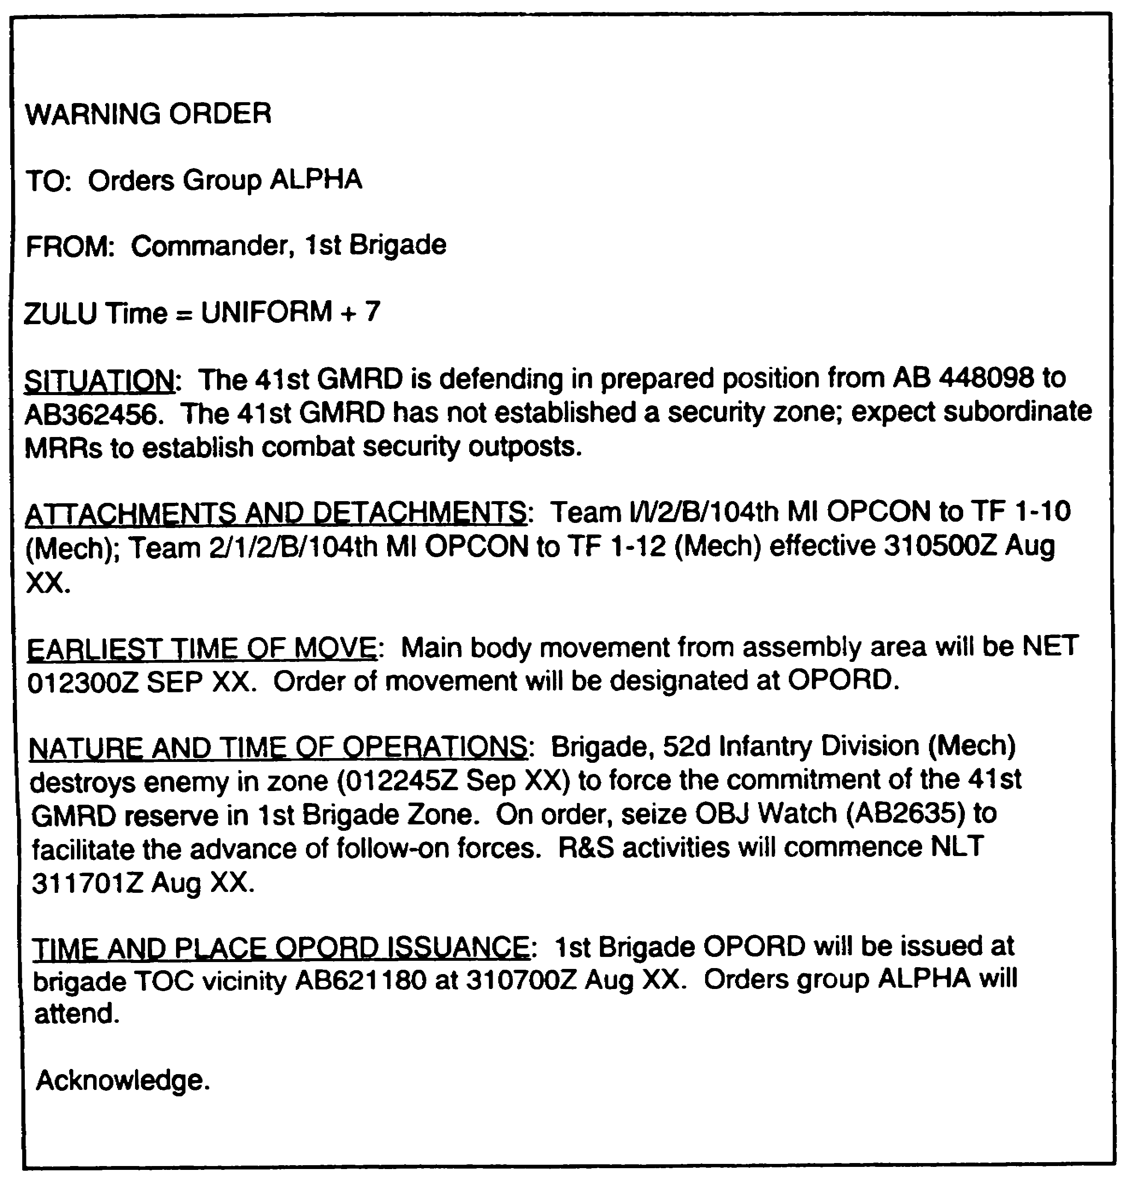

Figure 3-4. Sample Warning Order.

3-19 IT 0433

Another way to publish the missions and taskings of the R&S plan is to print it in subordinate unit instructions within the unit OPORD (Figure 3-5). While not as timely as FRAGOS or warning orders, unit instructions still let everyone know what you expect of them during the R&S operations.

A formal method of tasking assets for R&S operations is an intelligence annex to the OPROD (Figure 3-6). The intelligence annex is a formal intelligence tasking document accompanying an OPORD or an operations plan (OPLAN). Paragraph 2, Priority Intelligence Requirements, and paragraph 3, Intelligence Acquisition Tasks, inform all assets what the focus of the R&S plan is and what mission each asset is to conduct. The S2 is responsible for the intelligence annex. Again, before distribution, the S2 coordinates the intelligence annex with the commander and the S3 for their approval. At battalion and brigade levels, an intelligence annex is not usually practicable. R&S instructions are provided directly in the OPORD or reference an R&S overlay.

The R&S tasking matrix is another method of tasking R&S assets. Figures 3-7 and 3-8 provide examples of brigade and battalion level tasking matrices. Distribution can be-

- Directly to the tasked asset.

- Attached to the subordinate unit instructions of the OPORD.

- Attached to the intelligence annex.

Once tasked, the assets must understand their mission. during the mission briefing for the assets, use as many of the IPB products as possible. Each product serves a particular purpose:

- The modified combined obstacles overlay (MCOO) reveals terrain constraints.

- Photographs show terrain features.

- Enemy situation templates provide a picture of the enemy's location and probable COA.

- Event templates indicate where and when the enemy can maneuver.

- NAI on the event template show target locations.

- The Decision Support Template (DST) provides a picture of the overall friendly scheme of maneuver and warns R&S assets of any friendly fires in their vicinity.

IT 0433 3-20

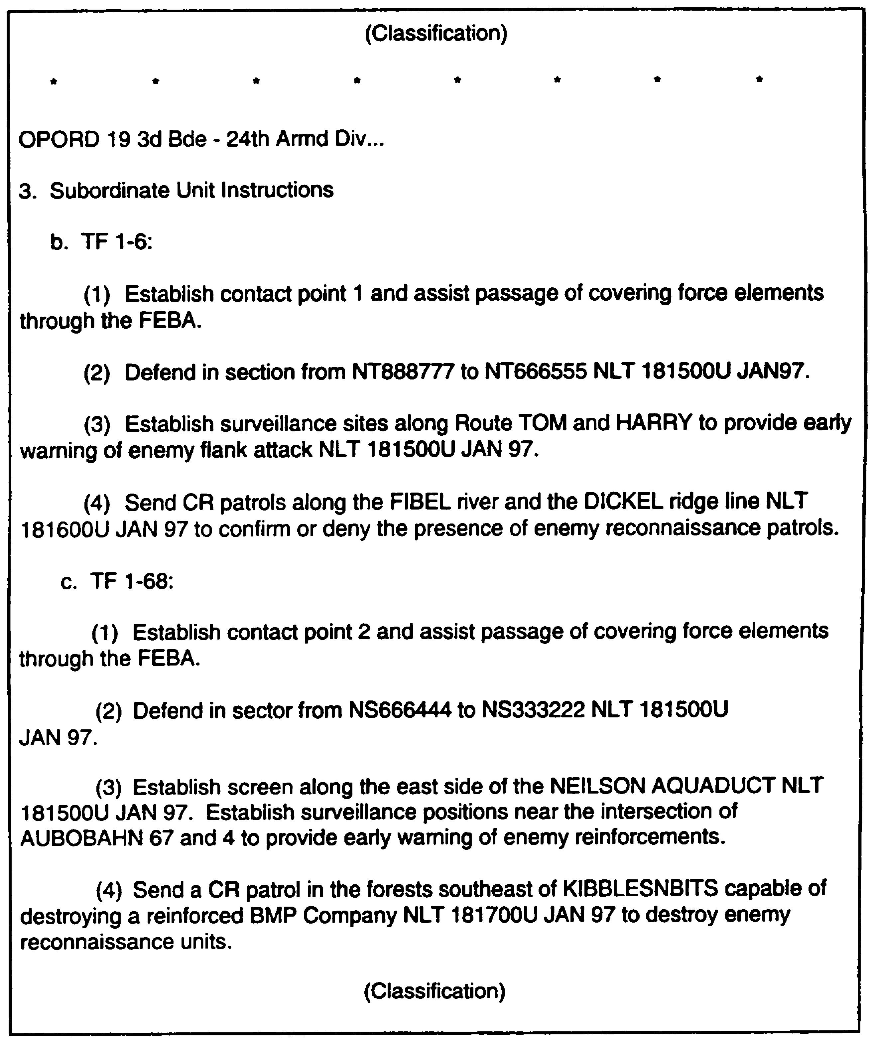

Figure 3-5. Sample R&S tasking - OPORD.

3-21 IT 0433

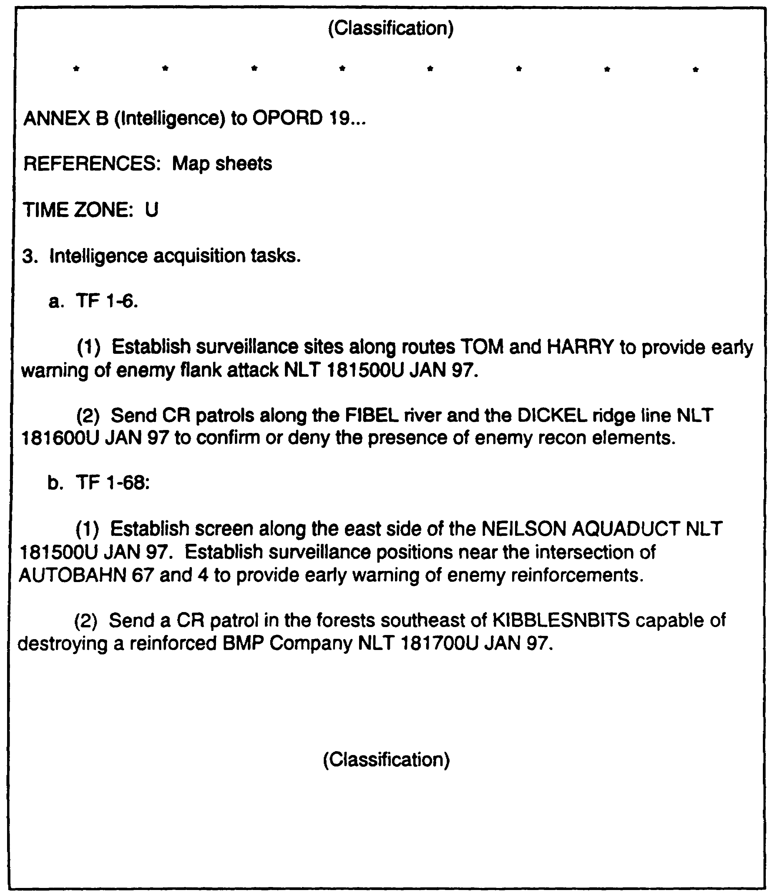

Figure 3-6. Sample R&S Tasking - Intelligence Annex.

IT 0433 3-22

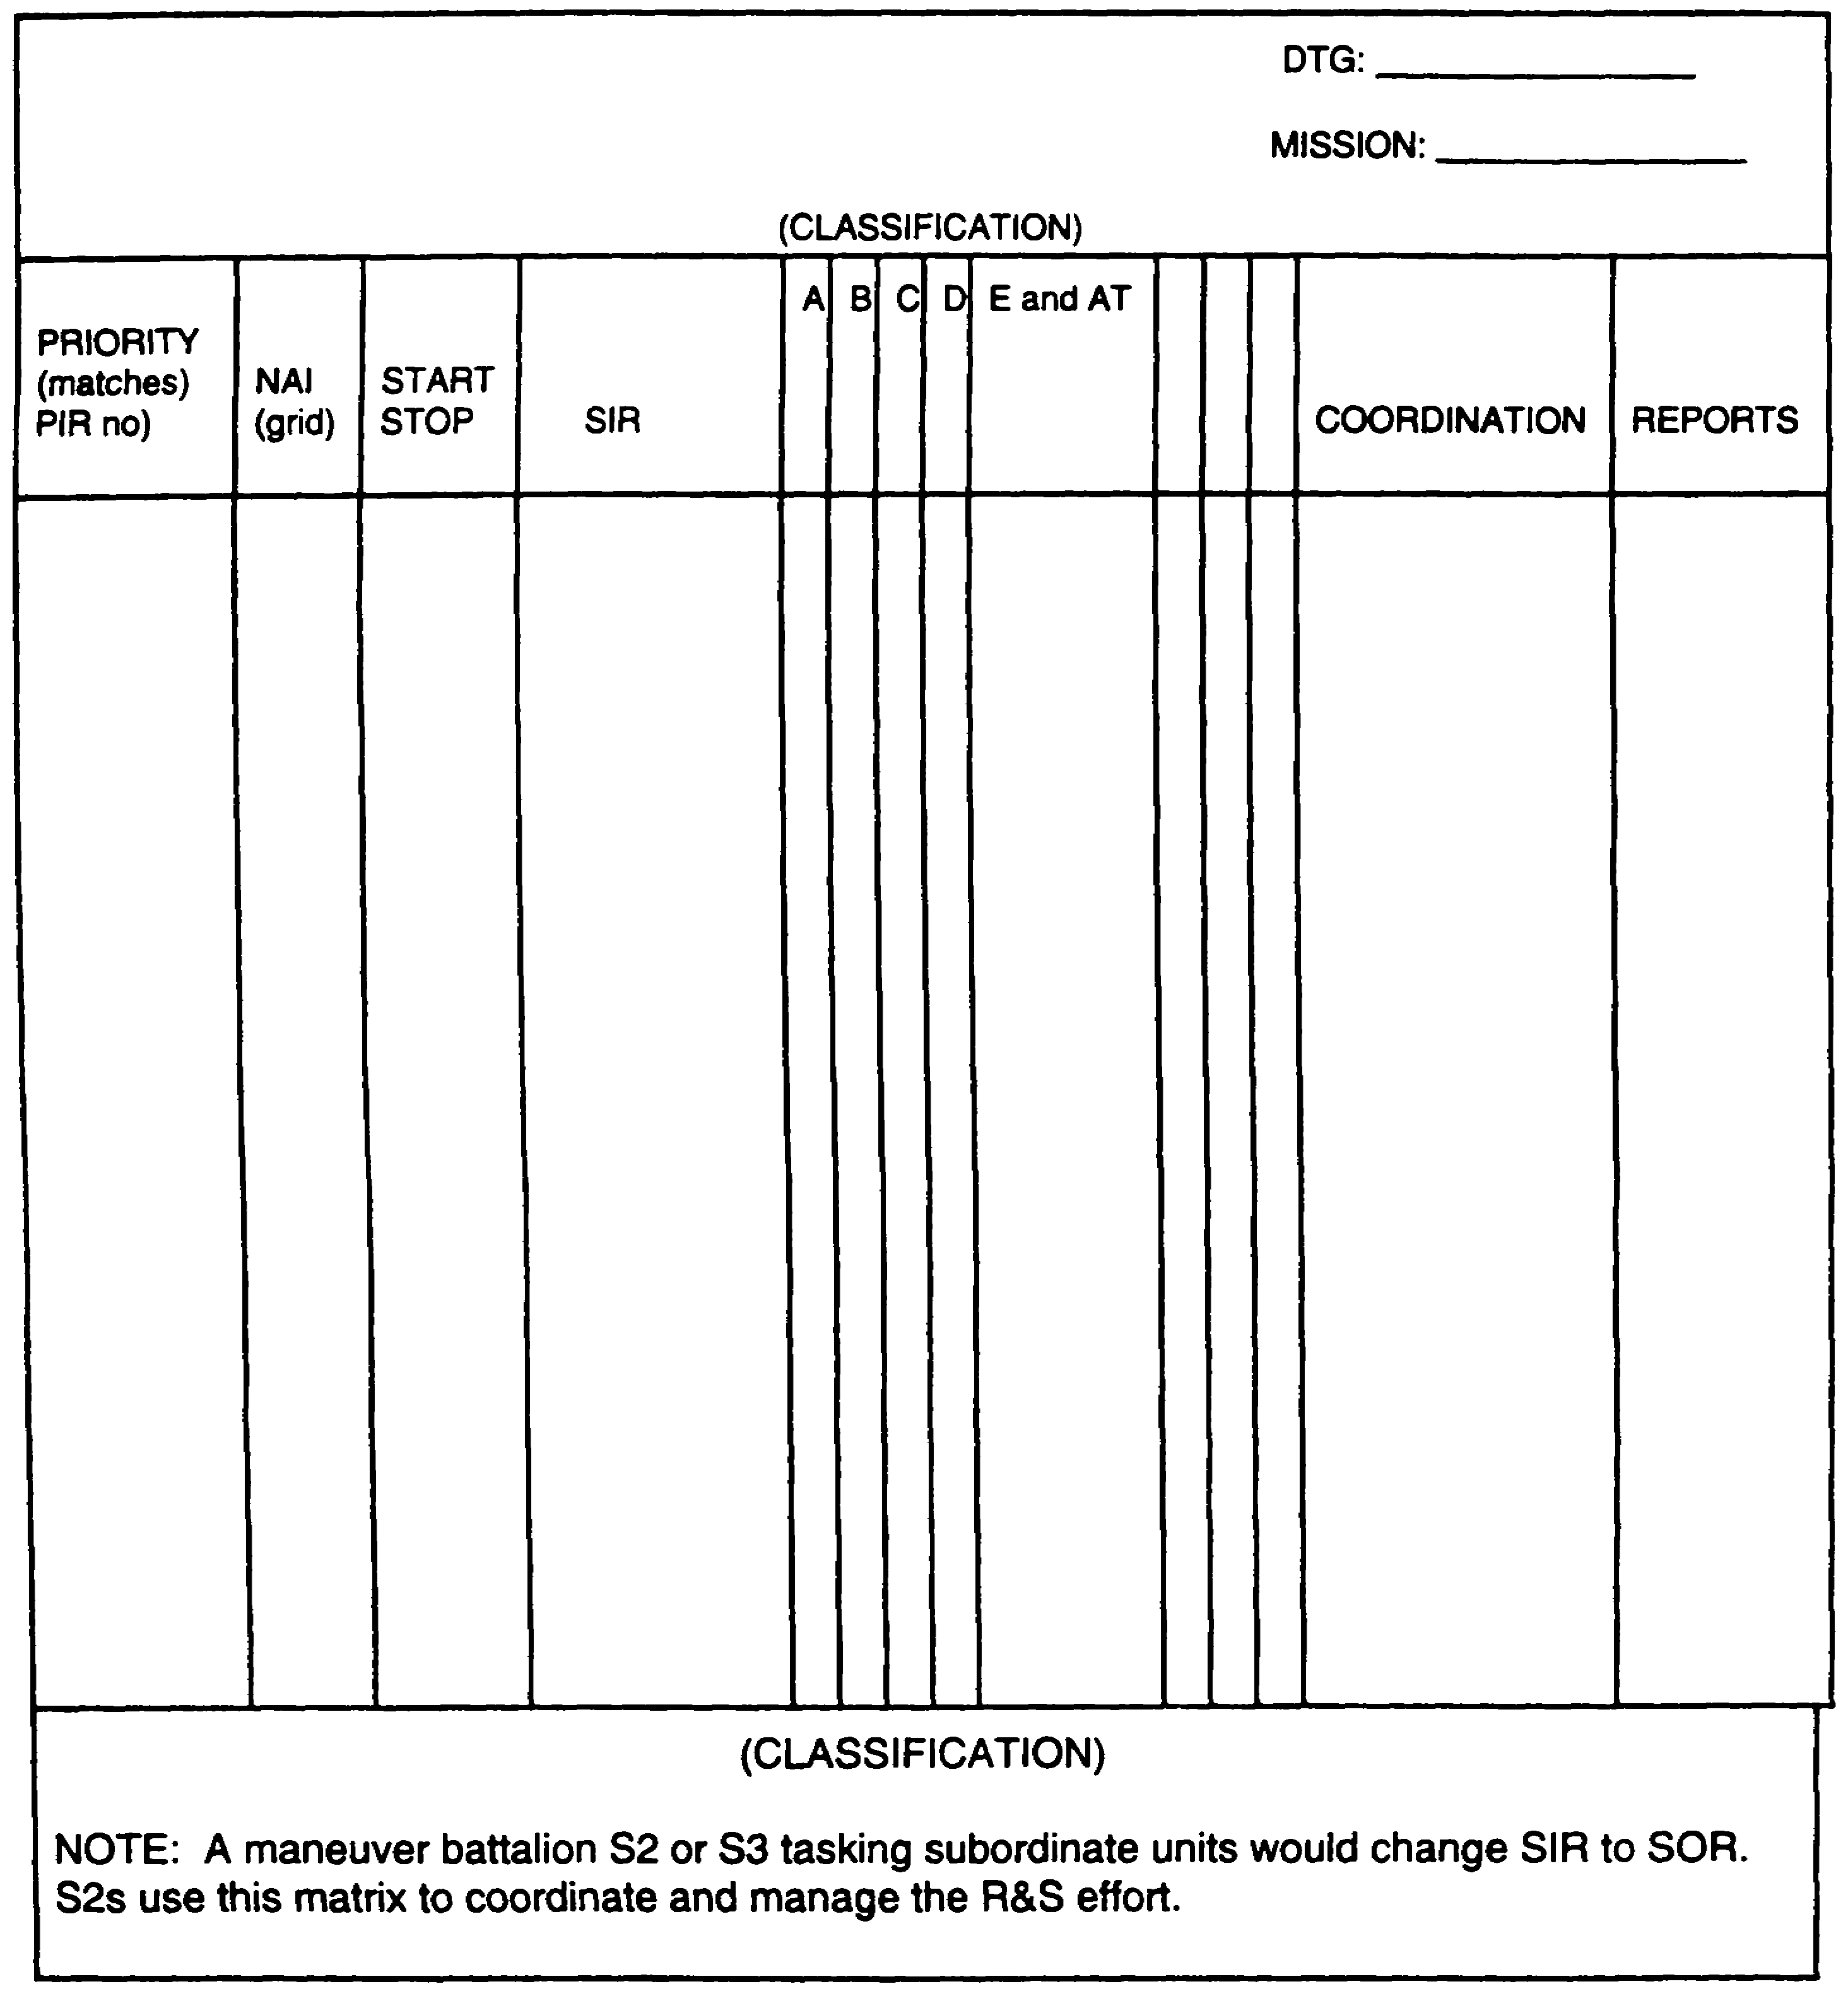

Figure 3-7. R&S Tasking Matrix.

3-23 IT 0433

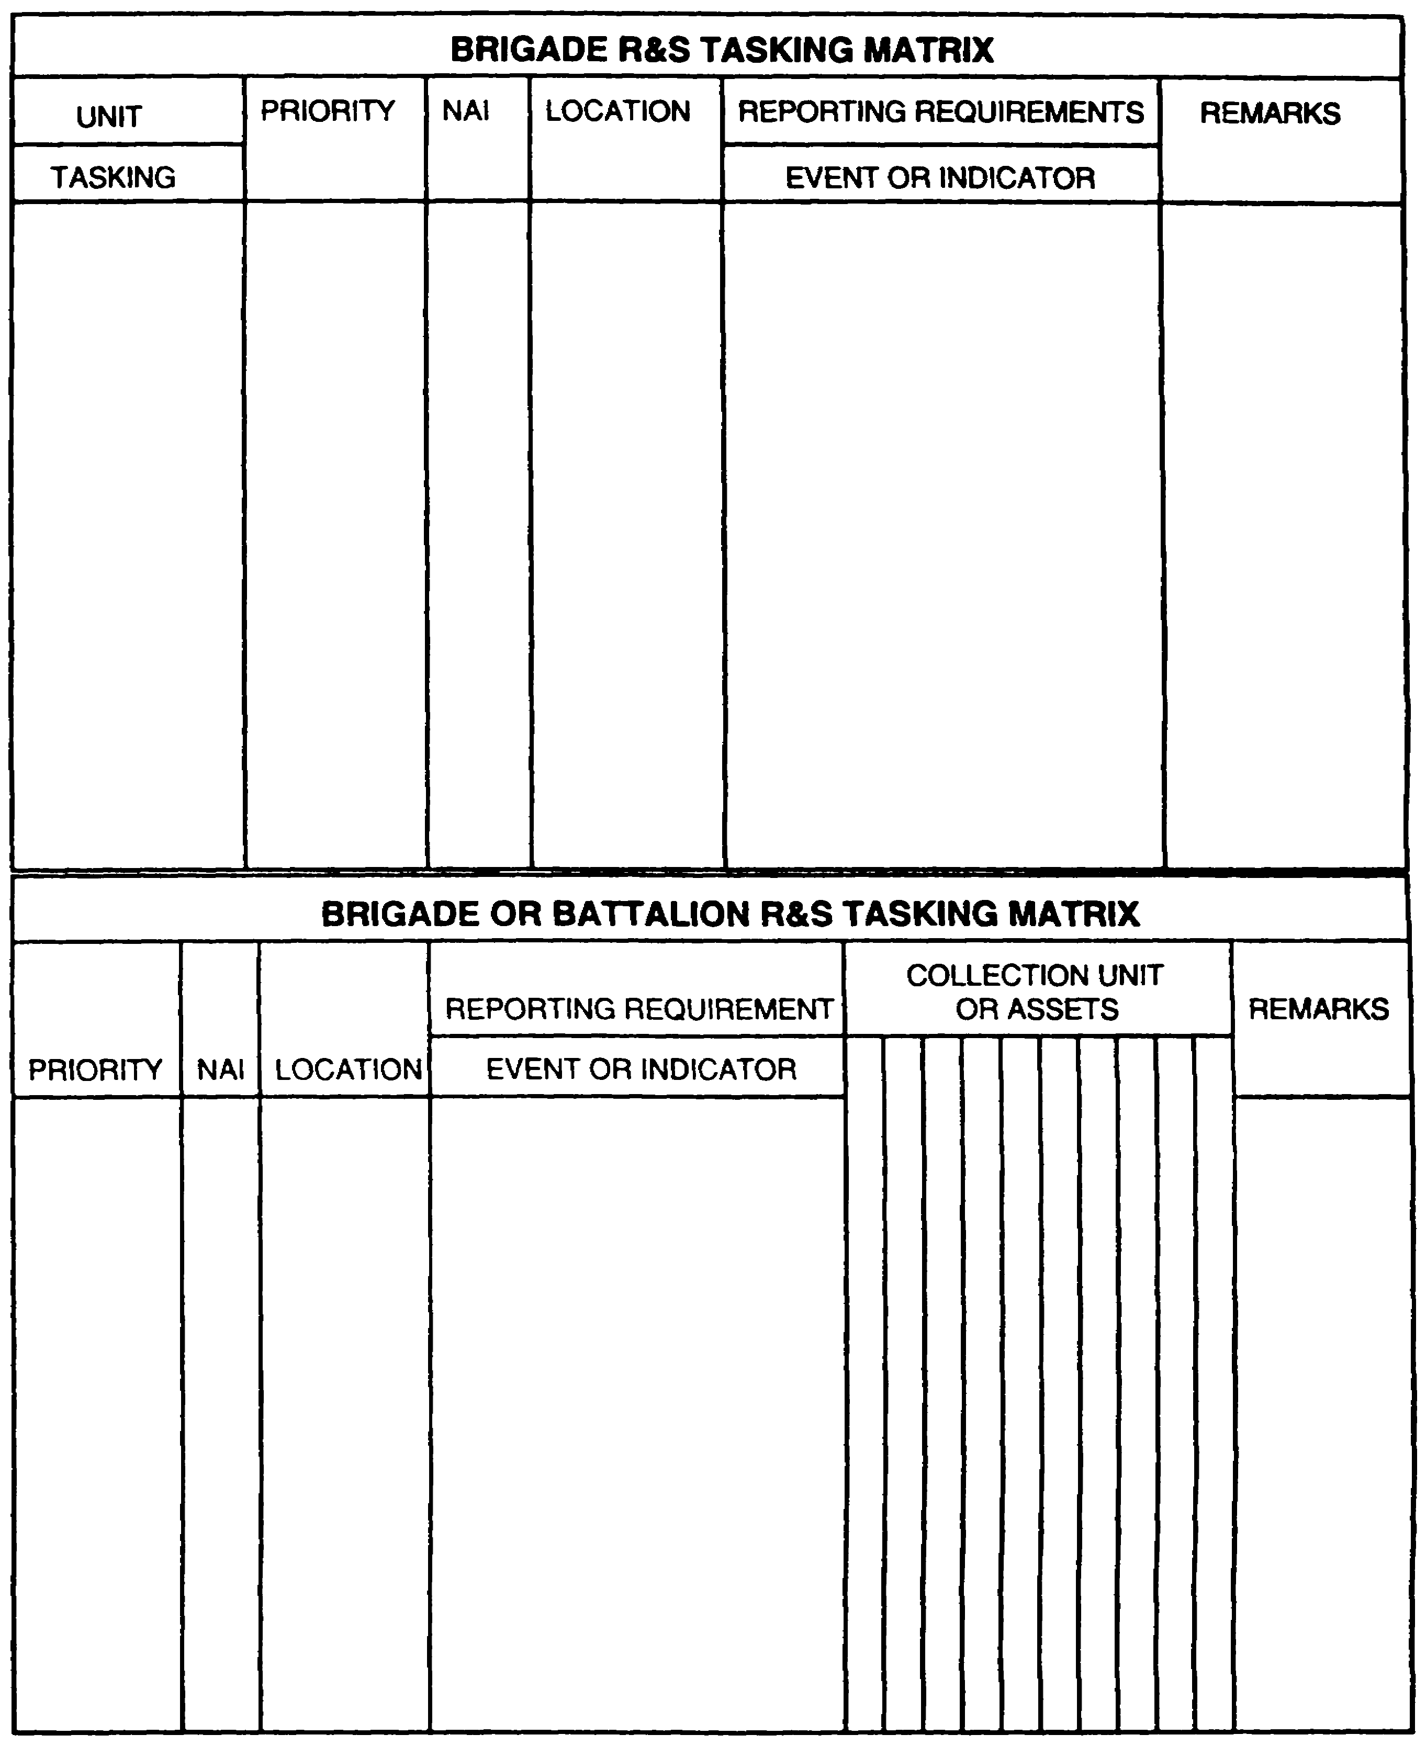

Figure 3-8. Different Versions R&S Tasking Matrix.

IT 0433 3-24

Once the assets have an understanding of the enemy and terrain, they can receive detailed mission instructions. It does not matter if you or the S3 give this briefing, just as long as the assets understand their mission. If possible, the S3, S3, and the FSO should be involved in this briefing.

Each asset should understand what the commander wants it to accomplish. Give the assets the big picture, then direct them to their specific roles and how they are to support the overall mission.

PART H - R&S OVERLAY

The R&S overlay (Figure 3-9) is the R&S plan in graphic form. The purpose of the overlay is to show the assets and the key staff officers exactly where the R&S assets are operating. There are two parts to the R&S overlay. the first part is the graphic display of deployed or planned deployment of R&S assets. The second part is the marginal data consisting of the legend, administrative data, specific instructions to each asset, and the distribution list.

The specific instructions to each asset should be as detailed as possible and should focus on-

- The required operational times. You should give each asset both a start and finish (stop) time for each mission, as applicable.

- The target. To answer the PIR, you need to look for specific indicators. Each asset should be told exactly what to look for (such as type units, equipment, and specific activity). Never give broad-based generic missions to "go out and look for and report on anything that moves.' Specific guidance will promote specific answers.

- Coordinating instructions. All assets will, at one time or another, move through or near another unit's area of operation (AO). To keep units from shooting friendly R&S assets, assets and units must coordinate with each other. It is also important that R&S assets coordinate among themselves.

- Reporting requirements. All assets should know when, how often, and what format to use when reporting. You should provide frequencies, alternate frequencies, and reaction during jamming. You must also provide the not latter than (NLT) time for specific information to be reported.

3-25 IT 0433

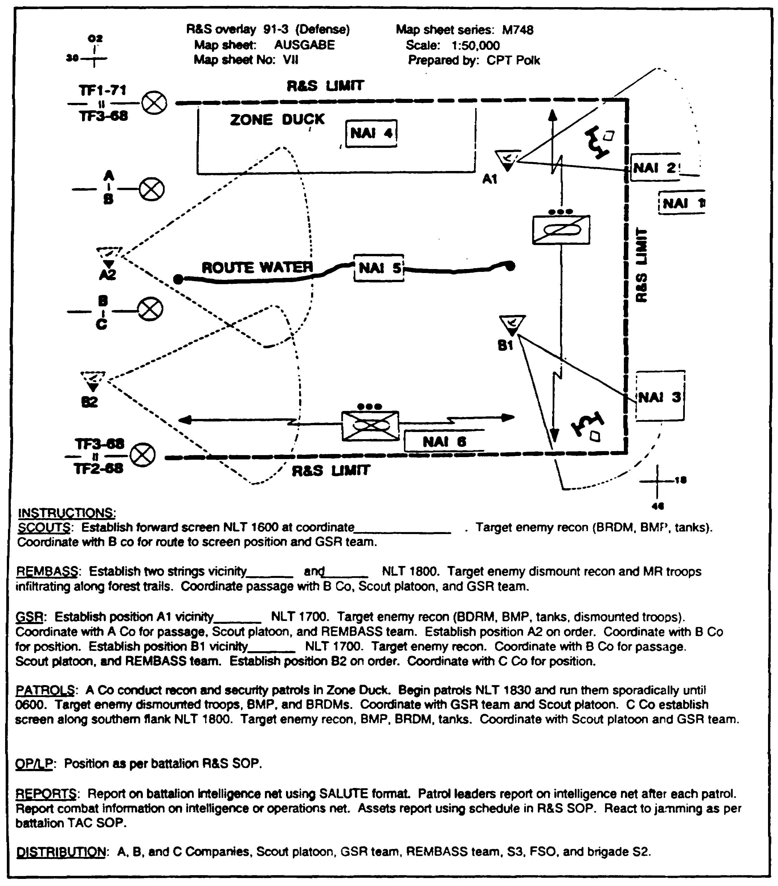

Figure 3-9. R&S Overlay with instructions.

IT 0433 3-26

Initially, the locations for assets are areas in which you recommend they deploy. After the assets have gone to these area (NAls), they report to you or the S3 the actual locations in which they can conduct their missions. You or the S3 update the graphics to show actual locations.

Certain control measures are used to control R&S operations and should be graphically portrayed. The following control measures should be considered:

- Friendly boundaries, R&S limit of responsibility, NAI, start points (SP), release points (RP), and checkpoints.

- Graphics depicting route, area, and zone reconnaissance.

- Primary, alternate, and supplementary positions.

- Sectors of scan for sensors.

Remember, it is important to include detailed written instructions for each R&S asset on the bottom of the overlay.

PART I - MONITORING THE R&S EFFORT

During the battle, your commander will probably have several PIR that need to be answered. As the S2, you will weight those PIR in some way to organize your collection effort. Remember the first principle of R&S: tell commanders what they need to know in time for them to act. This principle implies that you must monitor your collection effort at all times so you can make sure you answer your commander's PIR.

If your commander develops new PIR during the battle, you may have to modify your R&S plan to address the new PIR. Suppose a PIR becomes obsolete. For example, let's say your commander was very concerned about enemy reconnaissance locations. This PIR would be valid as your unit prepared to cross the LD/LC. However, once your unit consolidates on its objective, this particular PIR would be less important. The point is, you should constantly monitor the status of your R&S effort so you will know when to update PIR or to modify your R&S plan.

Tracking Targets and Assets. There are other reasons you must monitor your R&S or collection plan. Remember the term “high payoff target,” or HPT? These are specific enemy weapons systems, or specific enemy units which must be destroyed, degraded, or

3-27 IT 0433

suppressed for your unit to succeed in its mission. Many times, locating an HPT may be one of your commander's PIR. Other times, it might be an IR. In either case, your R&S plan must be able to identify HPTs and quickly forward their location to the S3 and FSO for action. This is especially critical for CR operations.

Another reason for monitoring your R&S operation is to keep track of your asset status and location. You will need to know which of your assets are still mission capable and which are inoperative, so you will not waste time retasking inoperable assets.

Obviously, if you need to retask or relocate assets from one location to another, you need to know where those assets are.

One technique to keep track of your assets is to have them report in a predetermined intervals based on mission, enemy, terrain, time and troops available (METT-T), critically of the area covered by the asset, or communications available. You can even show this graphically by using time phase lines (TPLs) for moving assets (Figure 3-10).

For example, let us say you have given your scouts the mission of route reconnaissance. On your event template, you have developed a series of TPLs depicting 15-minute increments. As your scouts cross a TPL, they report in to you. In this way, you can easily monitor where your scouts are on the battlefield. (Instead of TPLs, you can use existing friendly control graphics as well).

If you lose contact with your scouts, you at least have an approximate idea of where they last were. When you use TPLs, try to have recognizable features represent them. Another technique is the utilization of an asset deployment matrix (Figure 3-11). The matrix provides current information on asset location, target, personnel or equipment, and reporting criteria and channels.

Evaluating Asset Reporting. You should monitor your R&S plan to evaluate how well your assets are reporting information back to you. If your assets are not reporting quickly enough, or reporting the wrong information, you will need to make corrections.

At the brigade and battalion levels, many times you will find your assets may not always provide you with timely or complete information. There are many reasons for this. Most of the time it is difficult to discern what is happening on the battlefield. The company commander or platoon leader is preoccupied with fighting and winning the battle.

Nevertheless, do not accept incomplete information. If a spot report lacks the type of vehicle, number of vehicles, or direction of movement, get back on the radio and ask for it. If your scouts send back a report that does not make any sense to you, ask for clarification. If you have not heard from your ground surveillance radars for an unusually long time, call them and ask for a situation report.

IT 0433 3-28

You should enforce negative situation reports at predetermined intervals. Too many times in the past, S2s thought no news was good news. They were content to sit in their vehicles in silence. Be aggressive! Remember, you are trying to answer your commander's questions. You cannot, and commanders cannot do their jobs, unless incoming information is timely, accurate, and complete. Nevertheless, you must be realistic.

3-29 IT 0433

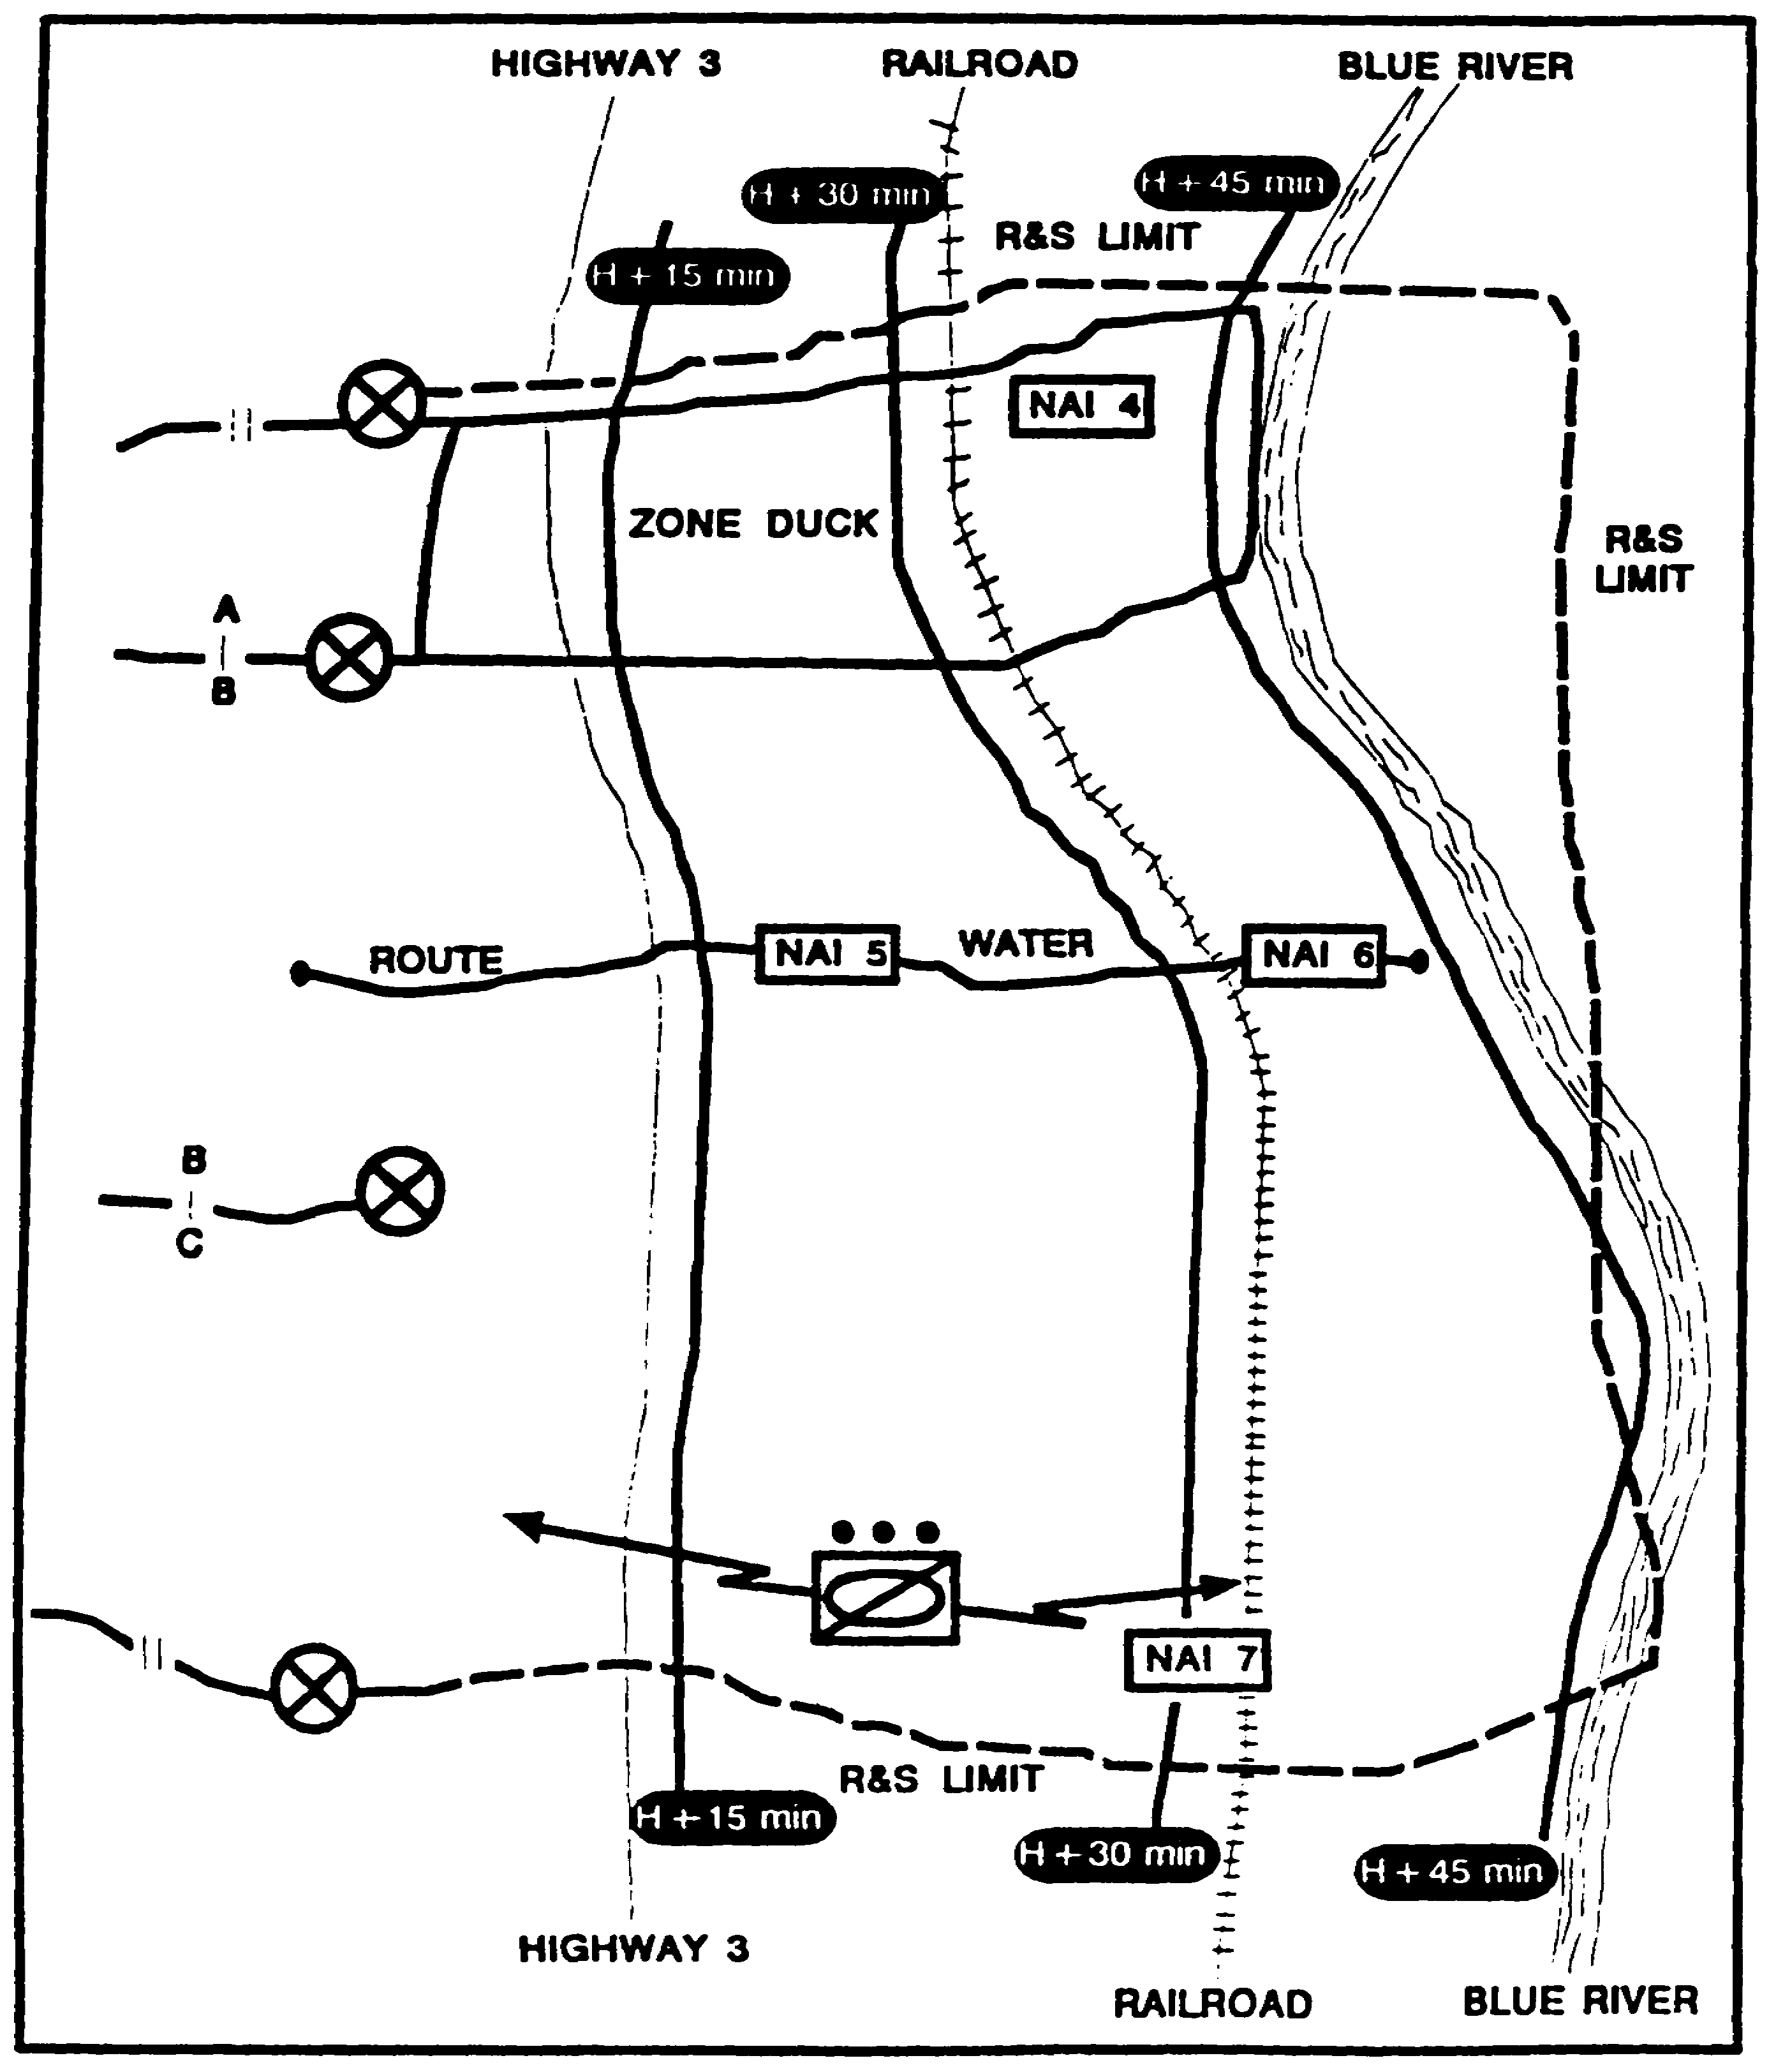

Figure 3-10. Time Phase Line Control.

IT 0433 3-30

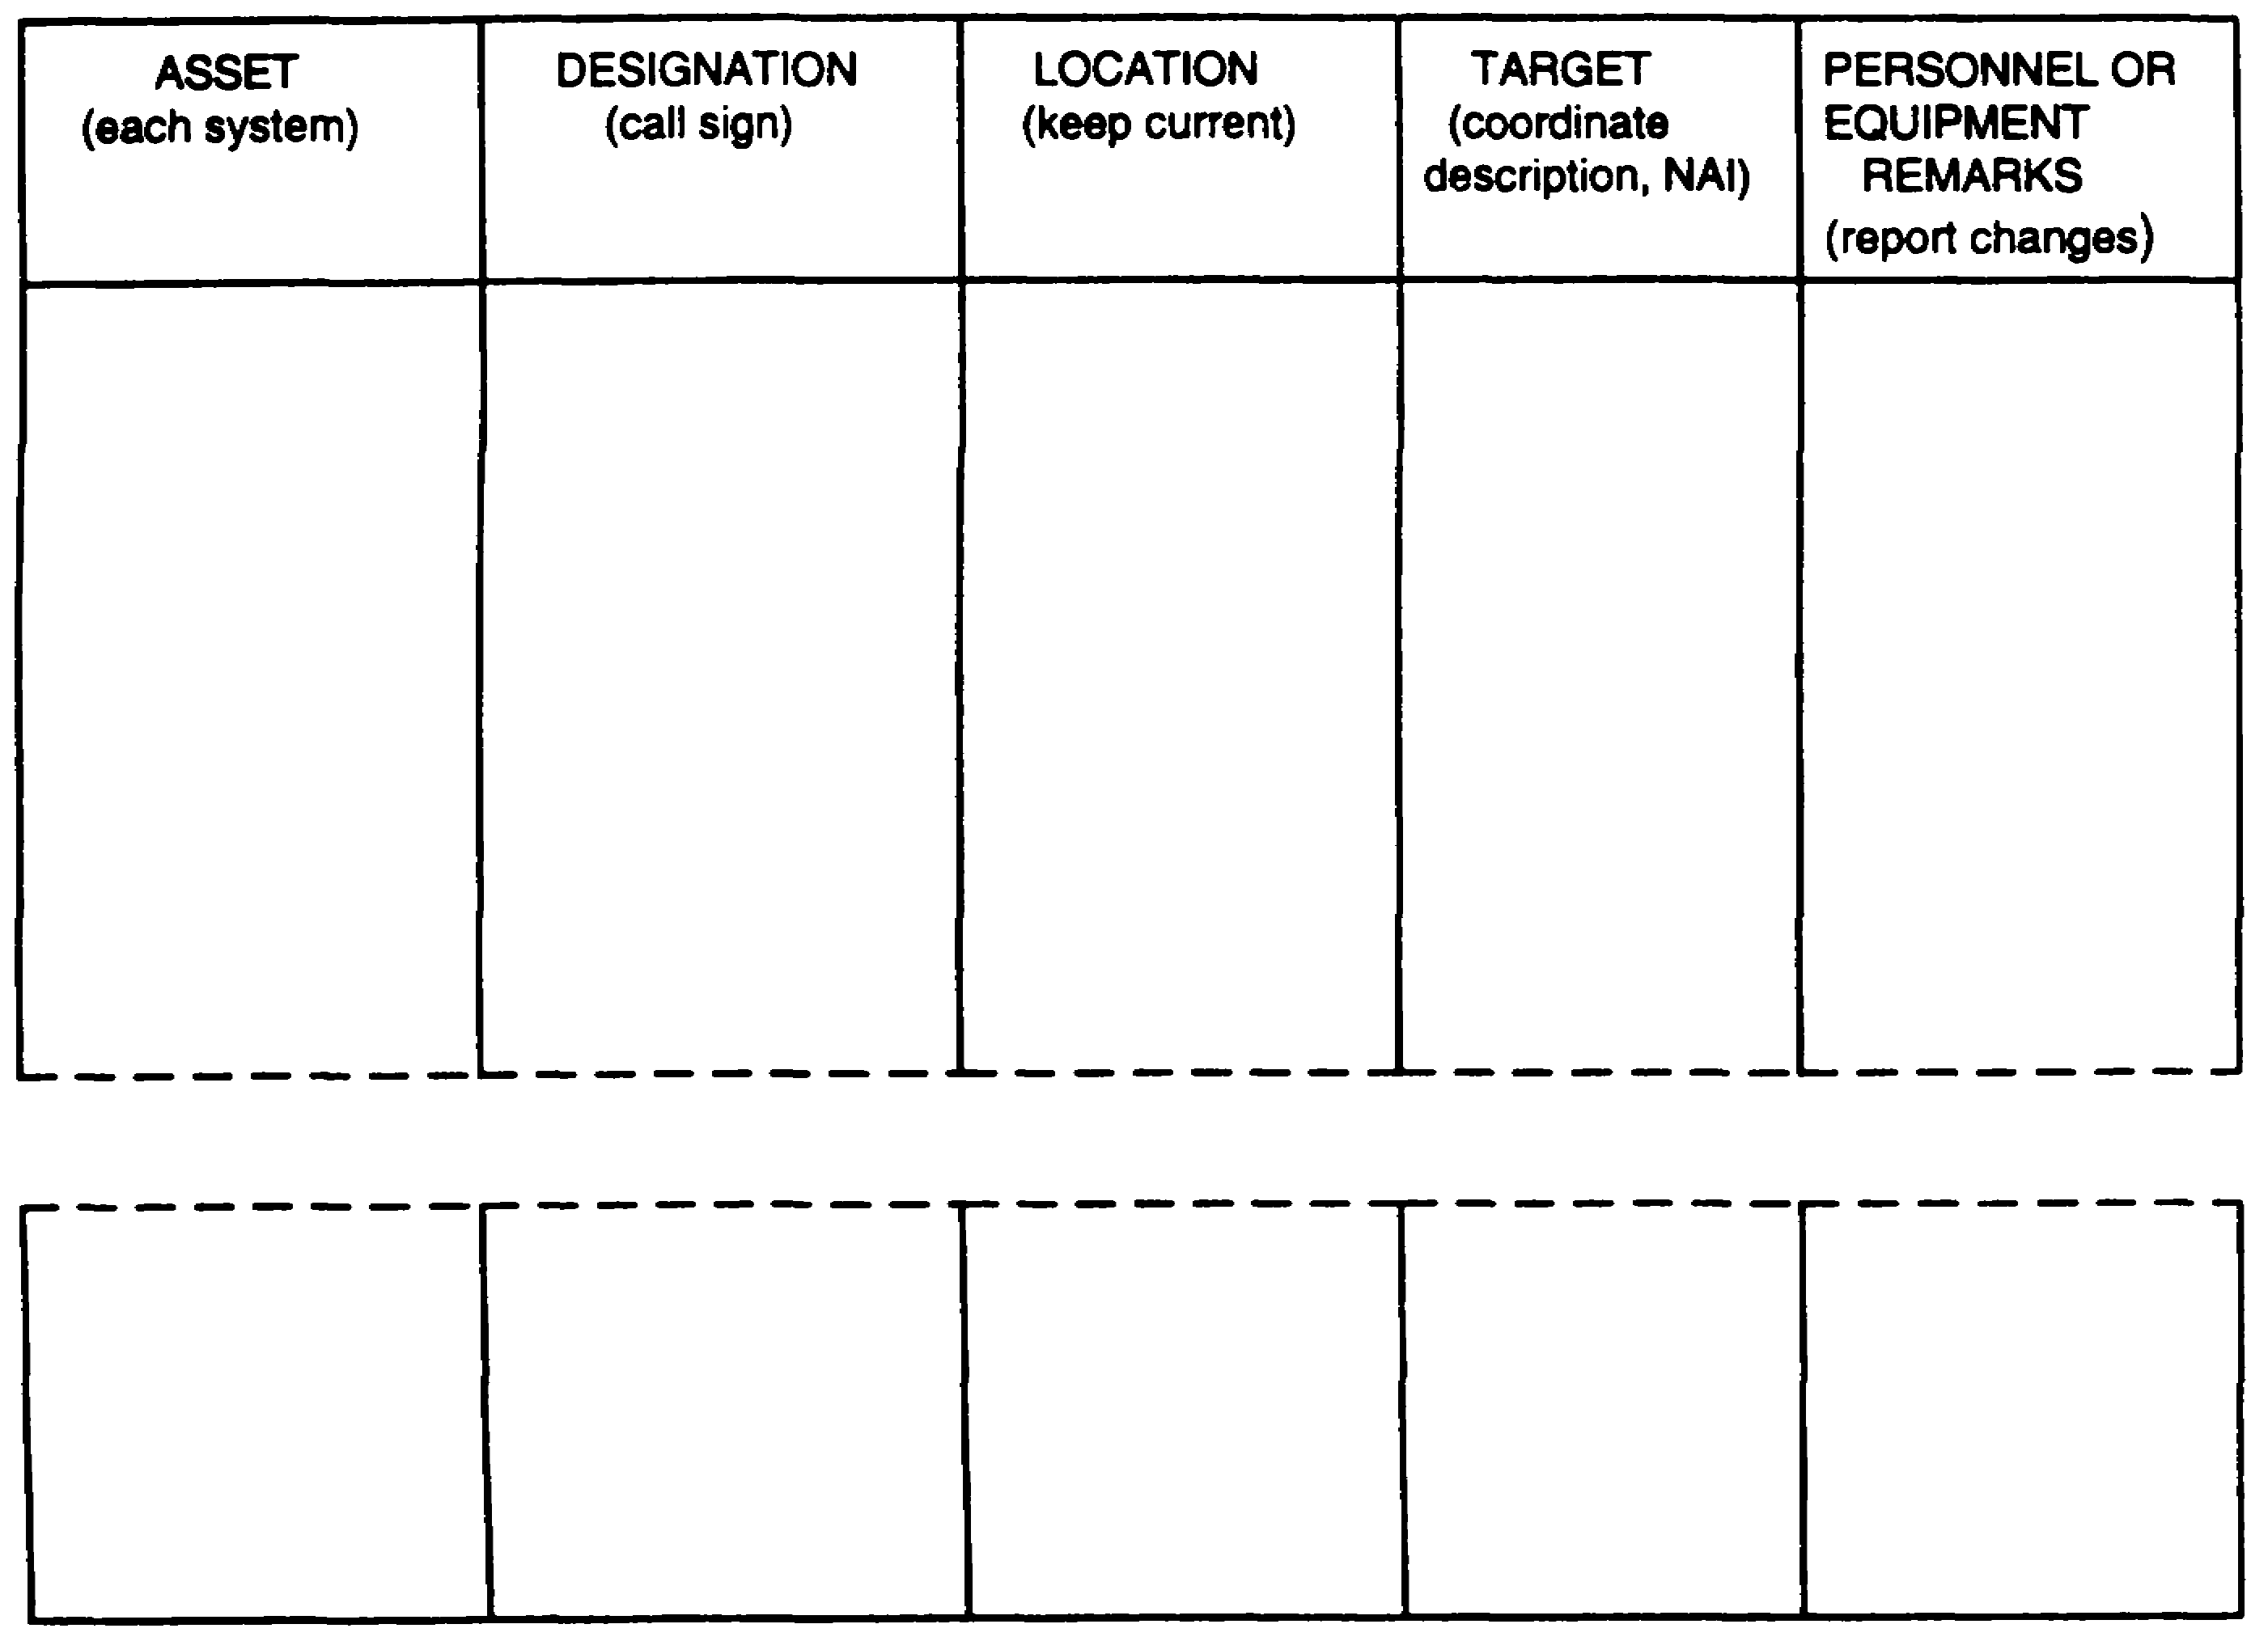

Figure 3-11. Asset Deployment Matrix.

3-31 IT 0433

LESSON 3

PRACTICE EXERCISE

The following items will test your grasp of the material covered in this lesson. There is only one correct answer for each item. When you complete the exercise, check your answer with the answer key that follows. If you answer any item incorrectly, study that part of the lesson which contains the portion involved.

1. What technique allows for the simultaneous R&S planning by all echelons?

A. Development of mission essential task lists.

B. Scheme of maneuver.

C. Limits of responsibility.

D. Nature and time of operation.

2. What R&S asset is normally used to reconnoiter and establish OPs and LPs?

A. Infantry platoon.

B. Scout platoon.

C. Engineer platoon.

D. Artillery platoon.

3. Which of the following allows the collection of the most information with the fewest assets in the quickest way?

A. Augmenting.

B. Task organizing.

C. Cueing.

D. Redundancy.

IT 0433 3-32

LESSON 3

PRACTICE EXERCISE

ANSWER KEY AND FEEDBACK

Item Correct Answer and Feedback

1. C. Limits of responsibility. Page 3-4.

2. B. Scout platoon. Page 3-9.

3. B. Task organizing. Page 3-18.

IT 0433 3-34

LESSON 4

PROCESSING AND DISSEMINATING
OF INFORMATION/INTELLIGENCE

Critical Tasks: 301-372-2250
301-372-3250
301-372-3553

OVERVIEW

LESSON DESCRIPTION:

In this lesson you will learn how to direct the processing and disseminating phases of the intelligence cycle.

TERMINAL LEARNING OBJECTIVE:

ACTIONS: Ensures that all messages have been logged and are recorded to the intelligence files, Order of Battle (OB) files, and the Situation Map (SITMAP). Ensures that all messages and reports have been evaluated for pertinency, credibility, and reliability. Ensures that all information is analyzed. Ensures that messages are disseminated to the appropriate users.

CONDITIONS: You will be given narrative information and illustrations from applicable field manuals.

STANDARDS: Ensure that all information is rated for credibility and reliability. Ensure that all information is analyzed and integrated. Establish a system to reference information from OB files, intelligence files, SITMAP, and DA FORM 1594, in accordance with FM 34-3, and local standing operation procedures (SOPs)

REFERENCES: The material contained in this lesson was derived from the following publications:
FM 34-1
FM 34-3
FM 101-5

4-1 IT 0433

INTRODUCTION

The dynamics of the modern battlefield -speed, complexity, and lethality -will require the very highest level of organization and operational efficiency within tactical operation centers (TOCs) at all levels of command. Automated and/or manual information systems must minimize the time required for administrative processing of information, ensure accurate portrayal of the tactical situation, and provide timely information to the commander and his staff.

PART A - PROCESSING

Processing is the phase of the intelligence cycle in which information becomes intelligence. It consists of three operations--

Recording. Recording is the reduction of information to writing or some other form of graphical representation and the arranging of this information into groups of related items.

Evaluating. Evaluation is the determination of the pertinence of information to the operation, reliability of the source of agency, and accuracy of the information.

Analyzing. Analysis is the determination of the significance of the information relative to the information and intelligence already known. It is drawing deductions about the probable meaning of the evaluated information.

Processing is continuous. New information is processed as it is received without waiting for additional information. Intelligence derived from fragmentary information is essential, particularly during fast-moving operations or when the information concerns a high payoff target (HPT). Complete information is seldom available. Information gaps need to be identified and information acquired to complete, confirm, or refute fragmentary information. This information must assist the commander to generate and apply combat power. It helps the commander to strike critical units or areas, and to achieve and retain the initiative.

The sequence for processing varies with the nature and urgency of the information. Information is normally recorded first; however, if it contributes to the development of urgent intelligence, it is recorded simultaneously with or after evaluation and analysis. Combat information or partially developed intelligence that is needed immediately is disseminated before it is completely processed. Information that is not of immediate value is processed before it is disseminated.

Evaluation and analysis may occur simultaneously followed by immediate dissemination. For example, information from a reliable source may indicate that the

IT 0433 4-2

enemy is about to launch a major attack. In this case, recording is of secondary importance, and the intelligence report that an attack is imminent is disseminated as soon after receipt as possible.

Reporting of information to higher and lower echelons occurs concurrently with processing. For example, to speed target execution time of HPTs, a commander orders lower headquarters to report all information concerning specified enemy units, areas, or activities before the processing cycle is complete. Lower headquarters make similar requests to higher headquarters.

PART B - RECORDING INFORMATION

There are many means at your disposal for recording information, however, the means used for recording information must-

○Be able to handle the volume of information.

○Serve the needs of those who use it.

○Permit timely dissemination.

Recording information into the data base makes evaluation and analysis easier and more accurate. It facilitates preparation of intelligence reports by conveniently drawing together all available information on a single subject. Some examples of recording devices are-

- Intelligence journal.

- Intelligence files.

- SITMAP.

- OB files.

As an intelligence officer, it will be your responsibility to supervise subordinate personnel in posting and maintaining these recording devices. Consequently, a greater understanding of these recording aids will facilitate this responsibility and ensure that the entire processing phase is completed.

Intelligence Journal.

The intelligence journal is an official, permanent, and chronological record of reports and messages that have been received or transmitted during a stated period, usually

4-3 IT 0433
24 hours. The journal also includes important events that have occurred and actions taken in response to these events. Accuracy and completeness are essential and all entries should be concise statements of events.

Figure 5-1 shows a partially completed intelligence journal. Note that the journal entries--

- Are assigned a journal number.

- Include the time of dispatch or receipt.

- Are concise statements concerning incoming/outgoing messages, reports, or events and include the originator of these messages.

- Show action taken, such as means of dissemination, staff coordination, internal recording.

- Include the initials of the individual making the entry.

- Provide a brief summary statement of important events which occurred during the period.

The journal is an important aid to the efficient conduct of operations. It provides a ready reference for the commander and staff and serves as a permanent record for training matters, operational reviews, and historical research. At brigade and lower echelons, only one journal might be maintained by the S2 and S3. This is at the discretion of the unit commander and is covered by unit SOP.

IT 0433 4-4

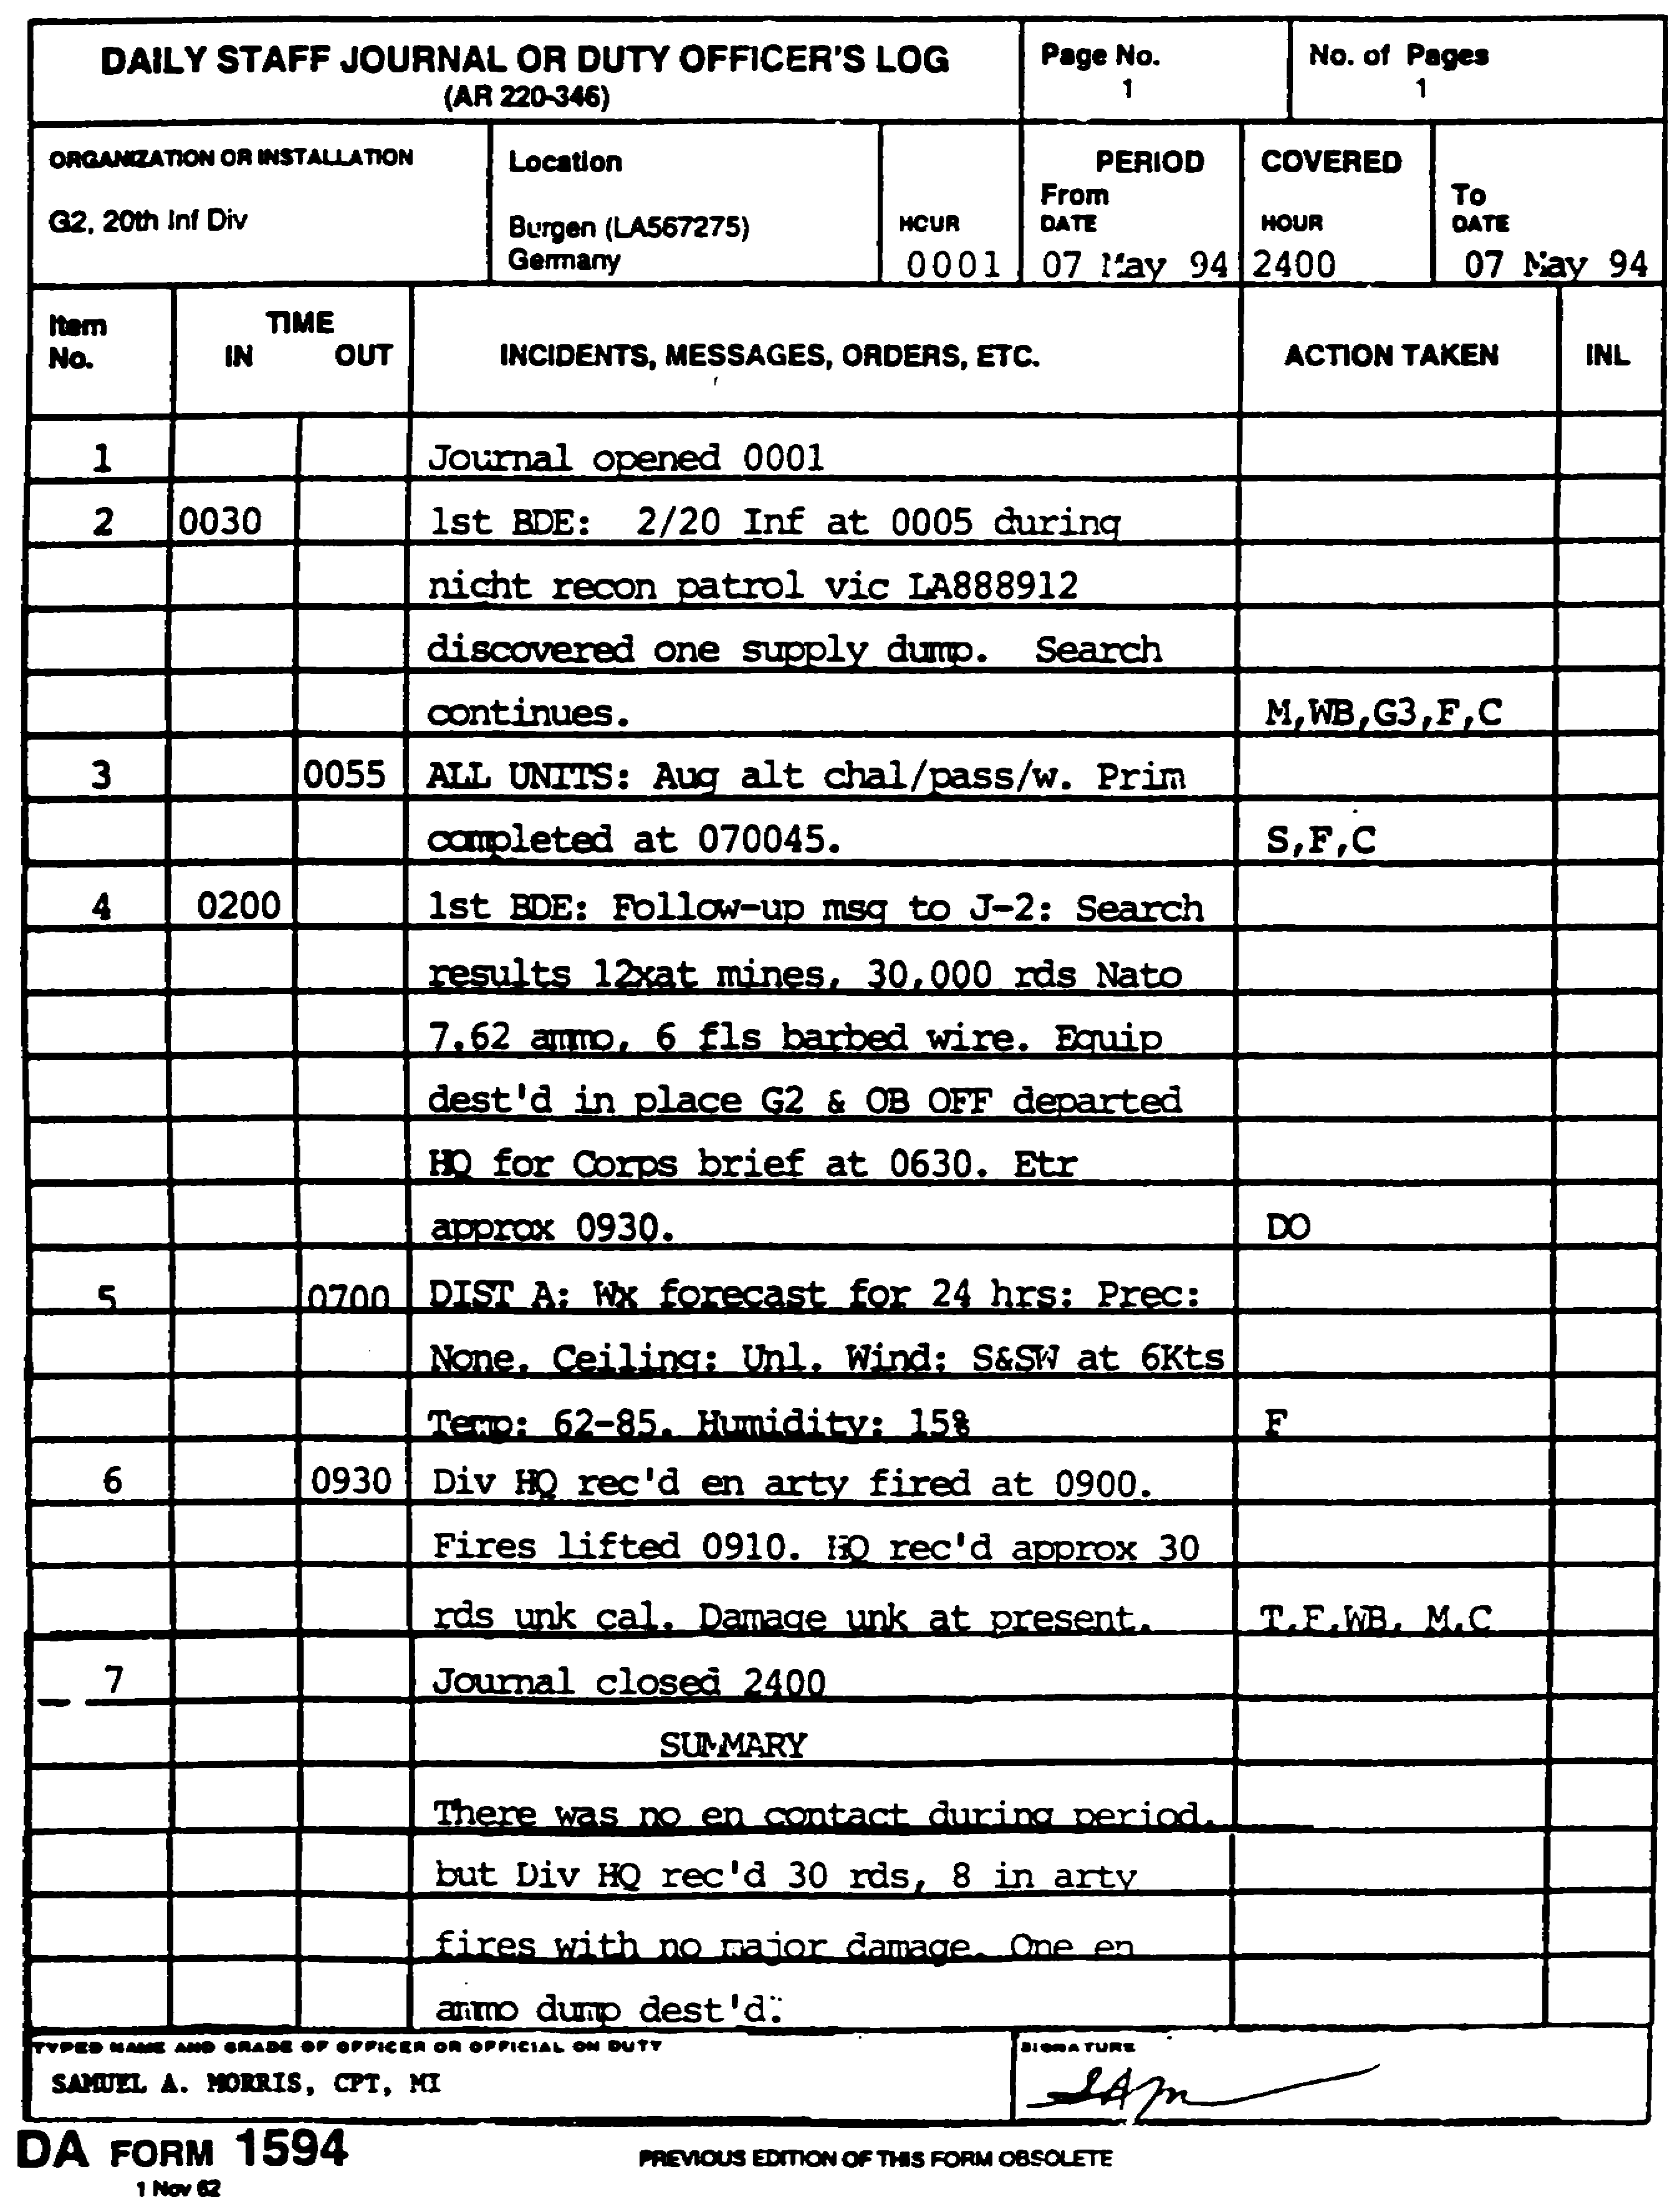

Figure 4-1. Example of Intelligence Journal.

4-5 IT 0433

Intelligence Files.

Intelligence files permit ready access to all available information. There is no exact format for establishing these files. However, they should be arranged to support the command echelon and existing situation. The files most commonly maintained are--

- Journal file.

- Reference file.

- OB file.

Journal File. The journal file contains all previously recorded journal sheets and supporting material. It contains a record copy of each message or document noted in the journal and is filed in chronological sequence. It supports the journal and is a permanent and official record.

Reference File. The reference file includes all information that is not of immediate interest but may be of future value. Information is cross-indexed to permit easy retrieval.

OB File. The OB file will be discussed later in this lesson.

Situation Map.

The working situation map is the primary analytical tool at all echelons. It is a temporary graphic display of the current dispositions and major activities of the enemy. Friendly forces information is limited. The level of detail of the SITMAP will be proportional to the echelon at which it is maintained.

The maintenance of the working SITMAP takes precedence over all other recording devices during combat operations. In a fast moving situation, particularly at the maneuver battalion level, it may by the only recording device used.

The SITMAP is used to make sound tactical decisions; its primary intelligence uses are to--

- Display the enemy disposition and situation.

- Provide a basis for comparison to determine the significance of newly received data about enemy forces. Intelligence preparation of the battlefield (IPB) situation and event templates provide a basis of comparison.

IT 0433 4-6

- Provide a background and basis for briefings and other required intelligence reports.

- Provide the basis for overlays which graphically portray the enemy situation.

- Assist in the determination of movement patterns of guerrilla or insurgent forces.

- Show possible intelligence gaps which require redirection of the collection effort.

For secondary intelligence use, the following information is posted in the margin of the SITMAP or on charts or cards nearby-

- Computation of enemy personnel and weapon strengths and weaknesses.

- Organization charts of specified enemy units.

- Summaries of weather and terrain data.

- A listing of priority intelligence requirements (PIRs) and information requirements (IRs).

- Notations about the current patrol plan.

- Movement computations.

- A listing of friendly attachments.

- A listing of unlocated enemy units believed to be in the AO.

- Probable courses of action.

- Battle damage assessment (BDA).

Order of Battle Files.

The command echelon, the situation, unit SOP, and the availability of time and personnel will influence the extent of the OB recording system. The mission is to provide the records necessary to produce intelligence, not to become bogged down in record keeping. Only those records that contribute to the accuracy and efficiency of the intelligence production effort should be maintained. OB files must be simple, accurate, and complete.

4-7 IT 0433

OB files should accomplish the following--

- Aid in cataloging and compiling current OB information.

- Provide media for cross-referencing for identification purposes.

- Provide collated data for evaluation and interpretation.

- Provide an orderly and systematic method of recording essential information.

- Provide for easy retrieval of accurate and current information.

Some common recording aids (See appendix B for examples) are--

- Unit workbook.

- OB workbook.

- OB SITMAP.

- OB card file.

- Personality file.

- Military installation file.

- Organizational worksheet.

- Strength worksheet.

Unit Workbook is used to maintain reported information on specific level organizations, such as divisions or armies. The format depends upon the structure of the foreign army being monitored. Normally records are maintained for enemy units one level above and two levels below the command's. For some special purpose units, three levels or more down are followed as well.

OB Workbook aids in sorting, evaluating, and interpreting information and in preparing intelligence reports. It has no prescribed format. It can be tabbed to conform with the OB annex to the Periodic Intelligence Report (PERINTREP) or in accordance with the nine OB factors.

IT 0433 4-8

OB SITMAP is a graphic portrayal of current Threat OB, either confirmed or unconfirmed. It shows identification and disposition of the opposing units and any other information which will assist in developing the threat OB. As a general rule, enemy units one echelon above and two echelons below are plotted. Special purpose units, guerrilla, and insurgents forces may be plotted down to squad level. A caption box is placed on the OB SITMAP to identify and explain the OB situation graphics. Although any number of caption boxes may be used, normally three types are necessary-- strength, unlocated units, and legend.

OB Card Files are used to maintain accurate and complete data on enemy units. The format of the card is standardized within the North Atlantic Treaty Organization (NATO) to facilitate the exchange of information and intelligence among allied forces. Normally, one card will be maintained on each enemy unit within the friendly Al that could affect current operations.

Personality Files record personality data on key military figures, staff officers and other categories of key personnel. This file provides reference material used in the development of other OB intelligence, such as: unit identification, tactics, and combat effectiveness. The file is kept in alphabetical order.

Military Installation Files are normally maintained during peacetime by higher echelons to facilitate preparation of installation handbooks.

Organizational Worksheets provide a convenient method of showing types of units within an armed force. These worksheets depict the complete breakdown of all units from the highest type headquarters to the lowest unit. They include information on personnel and major weapons strengths.

Strength Worksheets are used to maintain a running numerical tabulation of the enemy's personnel and equipment strengths (losses and known gains). This information is recorded on committed units, fire support units, and reinforcements.

PART C - EVALUATING INFORMATION

As an intelligence officer within an intelligence section/center, your duties will include receiving all incoming information/intelligence. It will be your responsibility to review these messages for.

- Pertinence.

- Reliability.

- Credibility.

4-9 IT 0433

Evaluation of information at lower echelons is a simple process compared to the procedures employed at higher echelons. From the viewpoint of the brigade or battalion S2, information which relates to the unit's area of operations (AO) and area of interest (Al) is pertinent. Information relating to areas outside the Al may or may not be pertinent. The brigade or battalion S2 may not be able to judge the reliability of a source, because the S2 may not have repetitive contact with that source.

This difference between higher and lower echelons is because information received from higher headquarters normally has been processed, evaluated, and interpreted. Information collected by organic agencies at lower echelons is acquired by direct observation or actual contact with the enemy.

Pertinence is the examination of information to determine whether or not the information is--

- Pertinent with regard to the enemy or battlefield area. (Information that relates to a unit's AO/AI normally is pertinent).

- Needed immediately, and if so, by whom.

- Of present or future value, and if so, by whom.

- Of no apparent value.

Reliability. When you screen a message for reliability, you must consider the source of the information and the agency reporting the information. Both are evaluated for reliability. The principle basis for judging the reliability of a source or agency, other than troop units, is previous experience. The headquarters closest to the source or agency is ordinarily the best judge of its reliability. Consequently, a higher headquarters normally accepts the reliability evaluation performed by a reporting headquarters. It does, however, consider the reliability of the reporting headquarters itself.

The evaluation rating of each item of information is indicated by a standard system. The lowest headquarters possible assigns the evaluation rating. Reliability of a source and agency is shown by a letter--

A - completely reliable.

B - usually reliable.

C - fairly reliable.

D - not usually reliable.

IT 0433 4-10

E - unreliable.

F - reliability cannot be judged.

A rating of "A" is assigned only under the most unusual circumstances. For example, this evaluation is given when it is known that the source has long experience and extensive background with the type of information reported. A rating of "B” indicates a source of known integrity. Assign an “F” evaluation when there is no adequate basis for estimating the reliability of the source.

Agencies ordinarily are rated A, B, or C. However, when the source and the collecting-reporting agency. are evaluated differently, only the lower degree of reliability is indicated.

Credibility relates to determining the probable truth of the information provided by the source or agency. Judgement of credibility is based on the following--

- Is it possible for the reported fact or event to have taken place?

- Is the report consistent within itself?

- Is the report confirmed or corroborated by information from other sources?

- Does the report agree or disagree with other information, which one is more likely to be true?

The most reliable method of judging the accuracy of a report is by comparing it with similar information that may already be available in the intelligence data base. When possible, obtain confirming or refuting information through different agencies and from other sources.

Marked differences in credibility evaluations may occur between higher and lower echelons. Higher echelons have more sources of information and a greater opportunity to confirm, corroborate, or refute the accuracy of reported data. Regardless of the source, the accuracy of incoming information and intelligence is reevaluated at each echelon. Accuracy is shown by a numerical rating--

1 - confirmed by other sources.

2 - probably true.

3 - possibly true.

4-11 IT 0433

4 - doubtfully true.

5- improbable.

6 - truth cannot be judged.

The statement 'truth cannot be judged' is always preferred over the inaccurate use of ratings 1 to 5. If there is no sound basis for a rating of 1 to 5, then the accuracy of the information must be rated 6. The scale of 1 to 6 does not represent progressive degrees of accuracy. They are guidelines by which to evaluate information.

Although both letters and numerals are used to indicate the evaluation of an item of information, they are independent of each other. For example, a source known to be unreliable may provide raw information that is accepted as accurate information, when confirmed by reliable sources. In this case, a report is evaluated E-1. Reports disseminated to higher, lower, and adjacent units should contain an evaluation fro each item of information.

Example: You are working in the brigade's battlefield information coordination center (BICC) and you receive the following message: “The enemy is reinforcing its first echelon divisions with second echelon forces (D-4)." At first glance, the message appears to be important and pertinent. However, after reviewing the evaluation rating you decide that the message has lost most of its urgency. The source is rated “not usually reliable” and the accuracy of the information is rated as “doubtfully true.” Although this message carries a D-4 rating, it does not mean that the information is not true, but rather, that you do not have any other sources of information to confirm or deny the report.

The evaluation and interpretation of information at the brigade and battalion is a simplified mental process; thus, the standard evaluation rating has little if any application. This system assists the G2 or S2 in processing information received from other headquarters and in evaluating information disseminated to other headquarters.

PART D - ANALYZING INFORMATION

The processing of information continues with analysis, which consists of three steps: assessment, integration, and deduction. It is during this phase of the intelligence cycle that information becomes intelligence.

Assessment is the shifting and sorting of evaluated information to update significant elements with respect to the mission and operations of the command. The first and most important step towards proper assessment is a clear understanding of the unit's mission and the commander's intent. all information gathered is viewed in relation to

IT 0433 4-12

what the commander wants to accomplish. Assessment also requires judgement and a thorough knowledge of military principles, the characteristics of the AO, and the enemy situation, to include enemy doctrine, tactics, and past practices. Regardless of the level of command, individuals who assess information must relate their efforts to the unit's mission to avoid wasted time and effort.

Integration is the process of combining significant elements of information (assessment) with other known information. It forms a logical picture or hypotheses of enemy activities or the influence of the operational area characteristics on friendly course of actions (COAs). In the process, more than one hypotheses may be formulated based on existing intelligence.

Integration, particularly the development of hypotheses, requires the same good judgement and thorough knowledge essential to making a good assessment. In formulating hypotheses, the intelligence officer needs to avoid preconceived opinions and hypotheses based solely on personal experience, preference, or biases. Attempt to adopt the role of the enemy commander in the development of these hypotheses.

All hypotheses are analyzed and tested. Analysis includes determining the indications that should exist if the hypotheses are valid. Testing includes verifying the existence or nonexistence of these indications within the limitations of available time and means. Testing can be accomplished by comparing the hypotheses with a list of enemy indicators similar to those outlined in Appendix C, FM 34-3. It can also be tested by discussing the hypotheses within your work section. This approach can accomplish the following:

- Surfacing varying views and bits of information you might have overlooked.

- Developing a sense of accomplishment in subordinates who have tedious posting and recording responsibilities.

- Increasing the problem-solving capability of your section, thus enabling personnel to operate more effectively.

Deduction is the last step in the analysis of information. Deducing the enemy's actions will be a direct result of the integration process and is designed to answer the question: "What does this information mean in relation to the AO, enemy situation, and commander's intent?" The resulting answer provides a useful conclusion which can serve as a basis for determining future enemy COAs and for keeping the intelligence estimate current. Deduction should also answer the question: "What does this information mean in relation to the enemy's use of tactical deception or counterdeception?" The resulting answer reduces friendly vulnerability to being deceived and the false belief that battlefield deception operations are being believed by

4-13 IT 0433

the enemy. NOTE: The counterintelligence HUMINT analysis cell (part of the ACE) at division and higher can assist in the area of deception and counterdeception. Lesson 6 of module IT 0431 provides information on the functions and products of the counterintelligence HUMINT analyst cell.

The following example shows how the analysis phase works:

At 121010Z Jul 95, your receive a message stating that the enemy has been digging in extensive artillery positions, including the preparation of alternate artillery positions. At 121335Z Jul 95, a long range surveillance unit (LRSU) reports that large tank units are being formed in the enemy division's rear area. By utilizing the process of assessment, integration, and deduction it can be deduced that the enemy is conducting defensive operations and preparing defensive positions.

PART E - DETERMINATIONS

During the processing phase, a determination needs to be made if further action is required. While not all incoming messages will be affected, typical follow-up action might include--

- Coordinating with other staff elements.

- Contacting original message sender for clarification or missing information.

- Disseminating information/intelligence to higher, lower or adjacent units.

PART F - DISSEMINATION

Intelligence dissemination is the final critical phase of the intelligence cycle. Emphasis must be placed on disseminating needed intelligence at the right time. A fast moving battle dictates the use of the quickest means of getting the information to the user. Electrical messages, secure voice radio, and telephone are the mainstay of intelligence dissemination. Unformatted, fragmentary messages and standardized report formats carry the bulk of intelligence and are transmitted as soon as possible to keep pace with the constantly changing situation.

Information and intelligence are placed in the hands of the user in time to permit his evaluation and interpretation, formulation of plans, and initiation of actions. If the information is of such value that time does not permit complete processing then the user should be made aware of this fact. An update with additional intelligence on the same subject should be transmitted as soon as it is available or relevant to the situation. Intelligence is of little to no value on the battlefield when it is merely a historical report.

IT 0433 4-14

Some examples of intelligence reports commonly used are-

- Spot Report

- Intelligence Report (INTREP).

- Supplementary Intelligence Report (SUPINTREP).

- Intelligence Report (INTREP).

- Supplementary Intelligence Report (SUPINTREP).

- Intelligence Summary (INTSUM).

- Periodic Intelligence Report (PERINTREP).

- Bomb Report (BOMREP).

- Shell Report (SHELREP).

- Mortar Report (MORTREP).

- Nuclear, Biological, Chemical (NBC) Report.

- Intelligence Estimate.

- Intelligence Annex.

- Imagery Reports.

- Signals Intelligence Tactical Reports.

- Weather Report/Forecasts.

Figure 4-2, shows a chart depicting some of the intelligence reports and summaries used at echelons corps and below (ECB). It also depicts the types of information or intelligence reported in each. This chart may be used to help determine which reports or summaries to select when reporting the types of information indicated in the left column of the chart.

Most of the formats and reporting criteria applicable to these reports/summaries are governed by International Standardization Agreements with the exception of Signals Intelligence (SIGINT) reports which are governed by US SIGINT Directives (USSID).

4-15 IT 0433

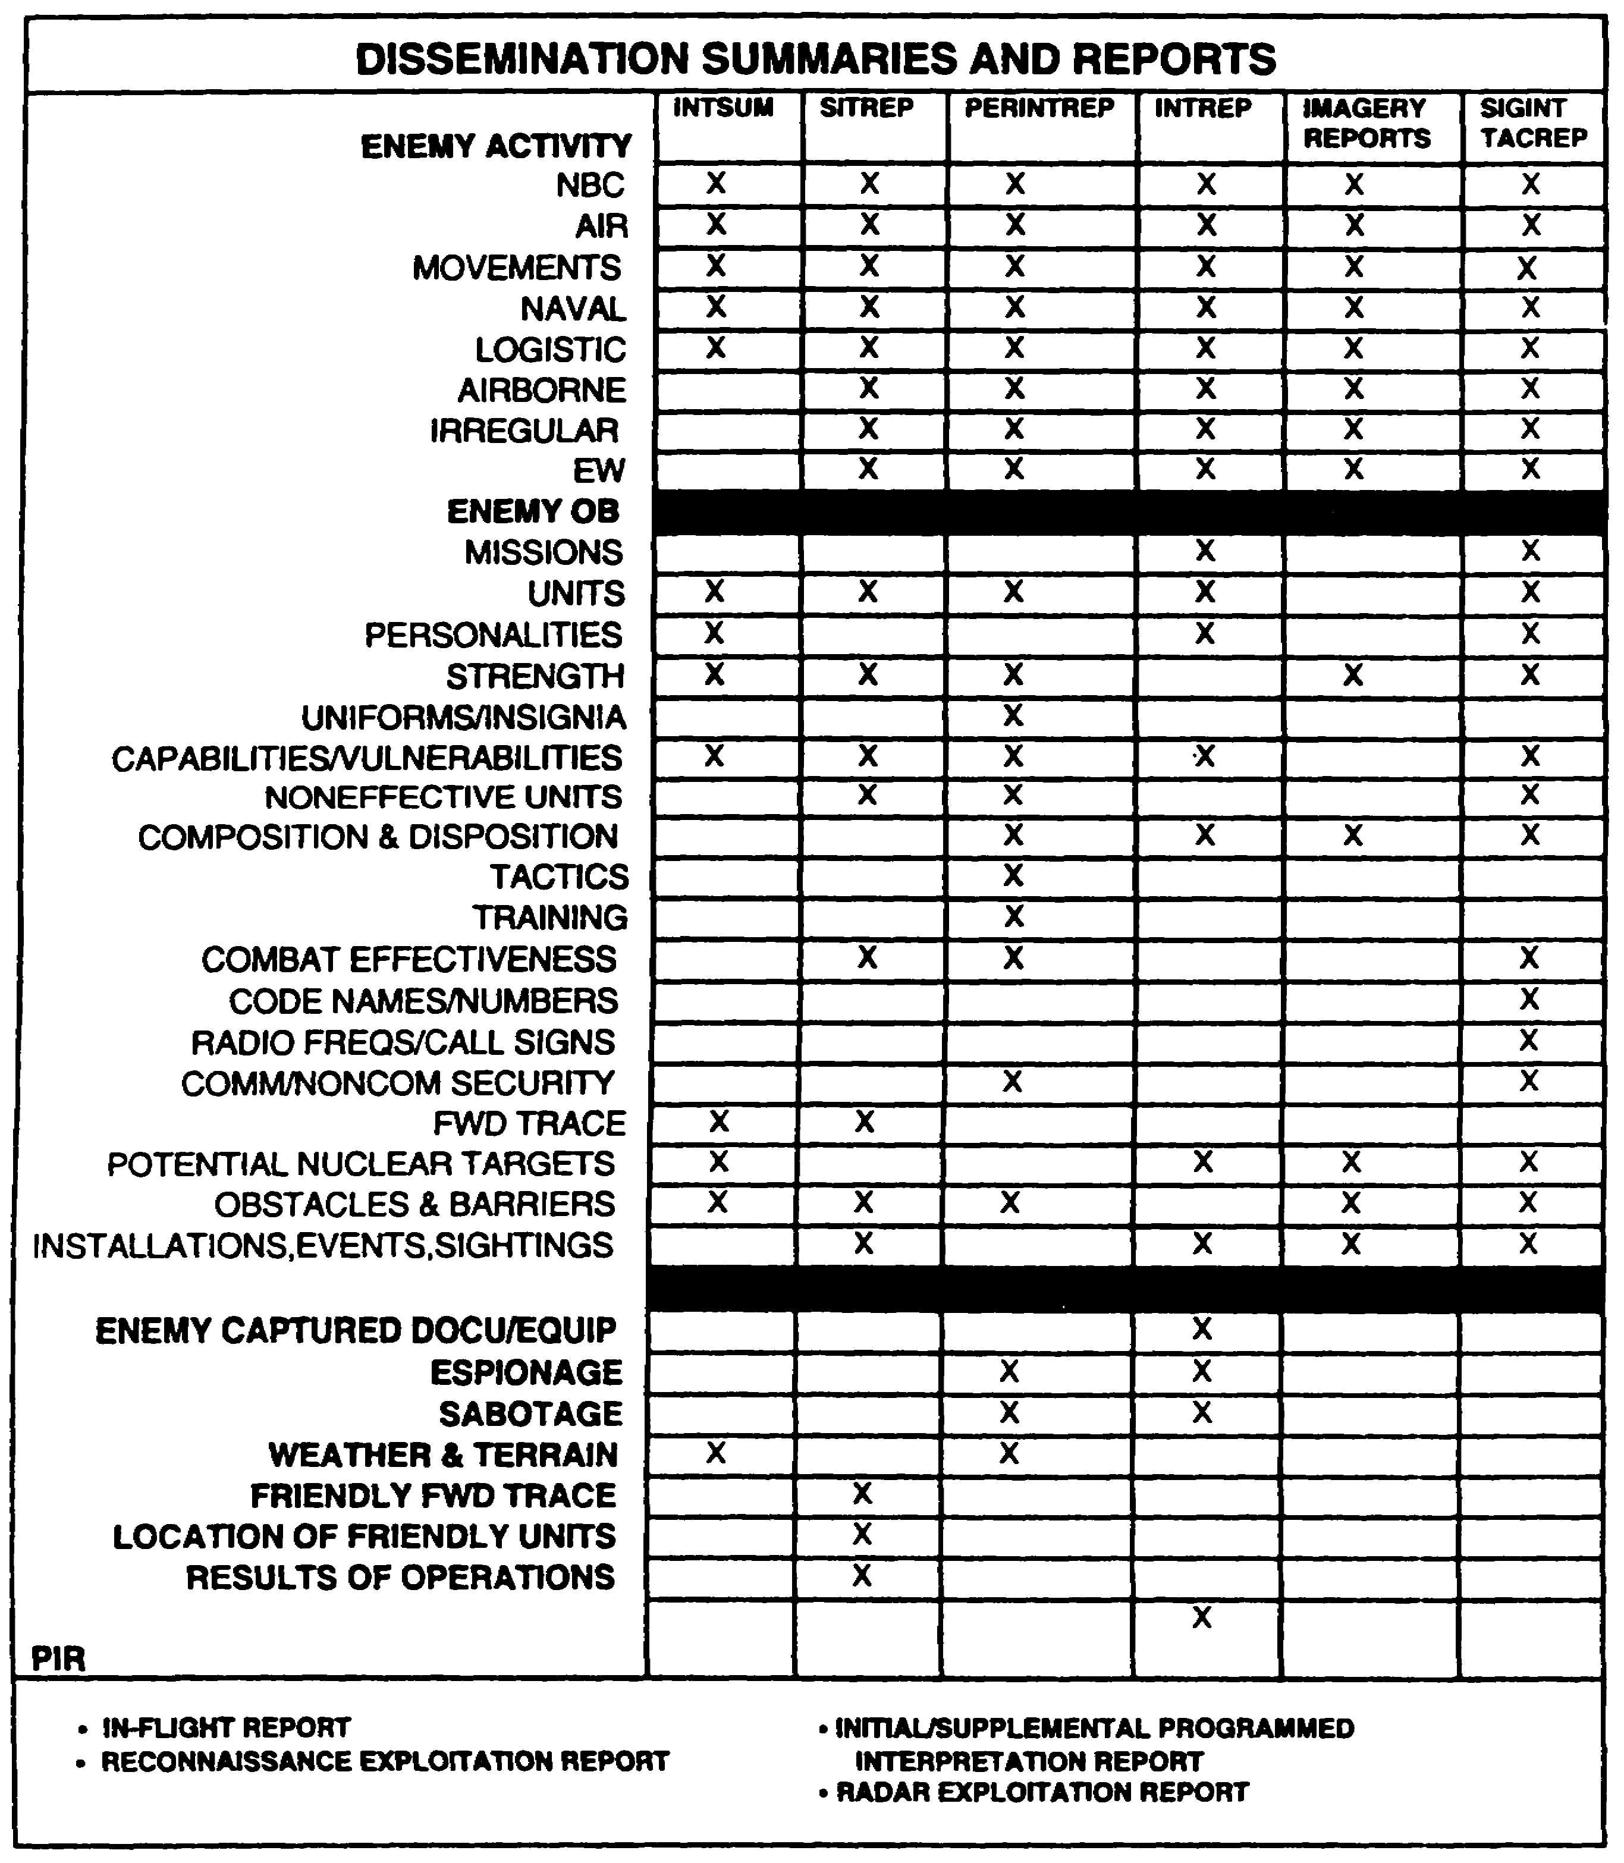

Figure 4-2. Dissemination Summaries and Reports.

IT 0433 4-16

LESSON 4

PRACTICE EXERCISE

The following items will test your grasp of the material covered in this lesson. There is only once correct answer for each item. When you complete the exercise, check your answer with the answer key that follows. If you answer any item incorrectly, study that part of the lesson which contains the portion involved.

1. In what order would information in the journal file be kept?

A. Categorical.

B. Alphabetical.

C. Chronological.

D. Organizational

2. What is generally the most reliable method of judging the accuracy of a report?

A. Base it on the reliability of the source and agency.

B. Compare it with similar information already available.

C. Base it on the opinion of the intelligence analyst.

D. Consult with other staff officers and elements.

3. What are the three steps in evaluating information?

A. Timeliness, pertinency, accuracy.

B. Disposition, composition, pertinency.

C. Classification, location, pertinency.

D. Reliability, credibility, pertinency.

4-17 IT 0433

LESSON 4

PRACTICE EXERCISE

ANSWER KEY AND FEEDBACK

Item Correct Answer and Feedback

1. C. Chronological. Page 4-6.

2. B. Compare it with similar information already available. Page 4-11.

3. D. Reliability, credibility, pertinency. Page 4-9 and page 4-10.

IT 0433 4-18

LESSON 5

PRODUCE FINISHED INTELLIGENCE PRODUCTS
FROM ALL-SOURCE INFORMATION

CRITICAL TASKs: 301-372-2151
301-372-2152
301-372-2204
301-372-3150
301-372-3202
301-372-3254

OVERVIEW

LESSON DESCRIPTION:

In this lesson you will learn how to produce finished intelligence products from all-source information.

TERMINAL LEARNING OBJECTIVE:

ACTIONS: Identify the procedures used to develop and produce an intelligence estimate, an intelligence annex, and an intelligence summary (INTSUM). Ensure that the finished intelligence products are disseminated in accordance with (IAW) unit standing operating procedures (SOP).

CONDITIONS: You will be given narrative information and illustrations from applicable field manuals.

STANDARDS: Write an intelligence estimate, an intelligence annex, and an INTSUM in accordance with FMs 34-3 and 101-5; and disseminate IAW local unit SOP.

REFERENCES: The material contained in this lesson was derived from the following publications:

FM 34-1
FM 34-3
FM 101-5

5-1 IT 0433

INTRODUCTION
In order for commanders to fully exploit enemy forces on the battlefield they must be provided with an accurate assessment of intelligence factors affecting both friendly and enemy courses of action (COAs). Commanders at all echelons need continuous all-source intelligence information for planning and executing friendly operations. This intelligence is provided through the development of intelligence preparation of the battlefield (IPB) products and the collection of all-source information. Pertinent intelligence information is normally disseminated via intelligence estimates and intelligence summaries. The intelligence annex to the operations plan (OPLAN) or operations order (OPORD) is used to disseminate priority intelligence requirements (PIRs), information requirements (IRs), and acquisition tasks to support intelligence collection. As intelligence officers, you will be responsible for generating and presenting these intelligence products. Consequently you must fully understand the procedures for developing, completing, and presenting them.

PART A - INTELLIGENCE ESTIMATE

The intelligence estimate is a basis for planning operations and disseminating intelligence factors affecting mission accomplishment. Its main purpose is to determine the COAs open to the enemy commander and their probable order of adoption. The estimate is generally written at division and higher headquarters and briefed down to battalion. In a contingency operation, it may be written at the brigade level. The intelligence estimate provides-

- An analysis of the area of operation (AO) based on IPB.

- An estimate of enemy strengths, capabilities, and limitations.

- Conclusions about the total effects of the AO on friendly COAs.

- The COAs most likely to be adopted by the enemy.

- The effects of exploitable enemy vulnerabilities.

The intelligence estimate is a basis for planning operations and disseminating intelligence. Figure 5-1 provides an example of an intelligence estimate in outline format. Appendix B, provides an example of a completed division level intelligence estimate.

Mission. This section contains the restated mission as determined by the commander.

IT 0433 5-2

Area of Operation. This paragraph discuses the influence of the battlefield environment (AO) in arriving at conclusions. It is based on the facts and conclusions of step 2 of the IPB process and, if one has been prepared, an analysis of the AO. It may reference an analysis of the AO, if an adequate amount of coverage and discussion are included. If an analysis of the AO is not available, then this paragraph must contain enough information to support the conclusions.

Weather. In the subparagraph discussing the weather conditions, include the existing situation, and the weather effects on both enemy and friendly COAs.

Existing Situation. In the existing situation, include light data and either a weather forecast or climatic information, as appropriate. For detailed information use appendices.

Effect on Enemy Course of Action. In this section describe the effects of weather on each broad enemy COA, for example, an attack or defense. Conclude each statement with a description if the weather favors the enemy COA. For each COA, include the use of chemical agents, nuclear weapons, and special methods, techniques, and equipment procedures, or forces. In other words, what effect would the weather have on the enemy's use of these weapons of action?

Effect on Own Course of Action. For this section, describe the effects on the weather on our own COAs as described previously for enemy COAs. The weather may affect us differently. If, for example, the enemy is defending and we are attacking, low visibility might be an asset to us and a hindrance to the enemy. The weather might also affect us differently due to a difference in types and quantities of equipment.

5-3 IT 0433

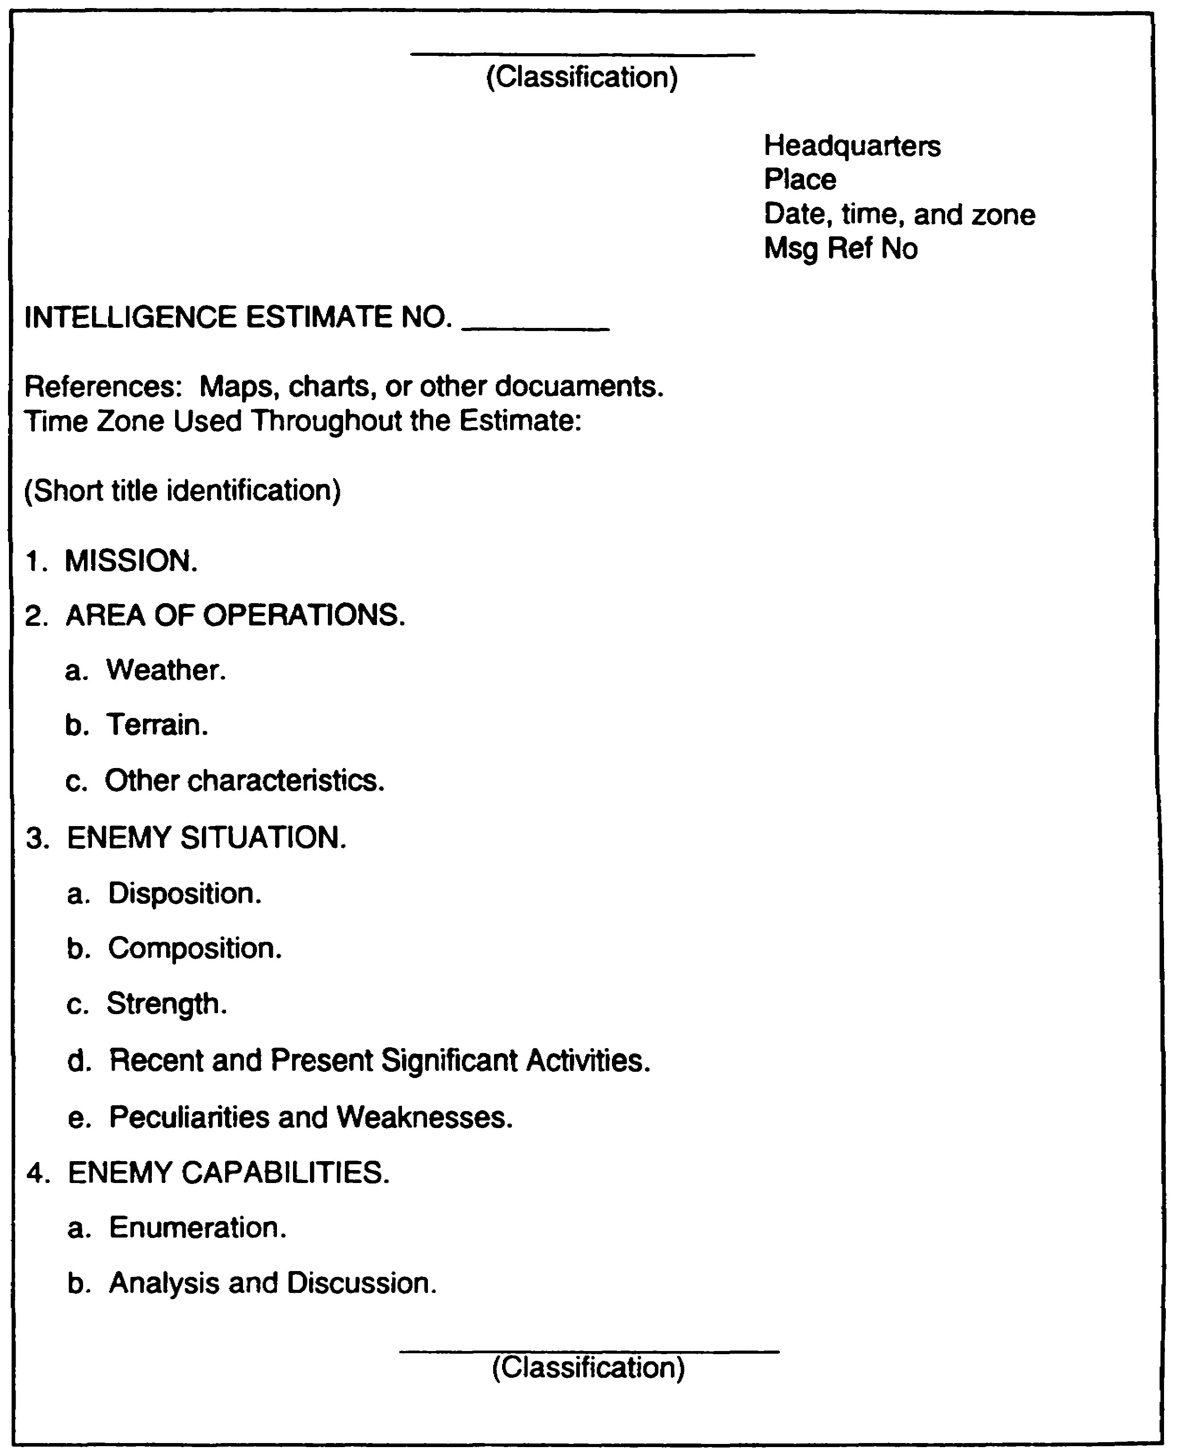

Figure 5-1. Intelligence Estimate Outline Format.

IT 0433 5-4

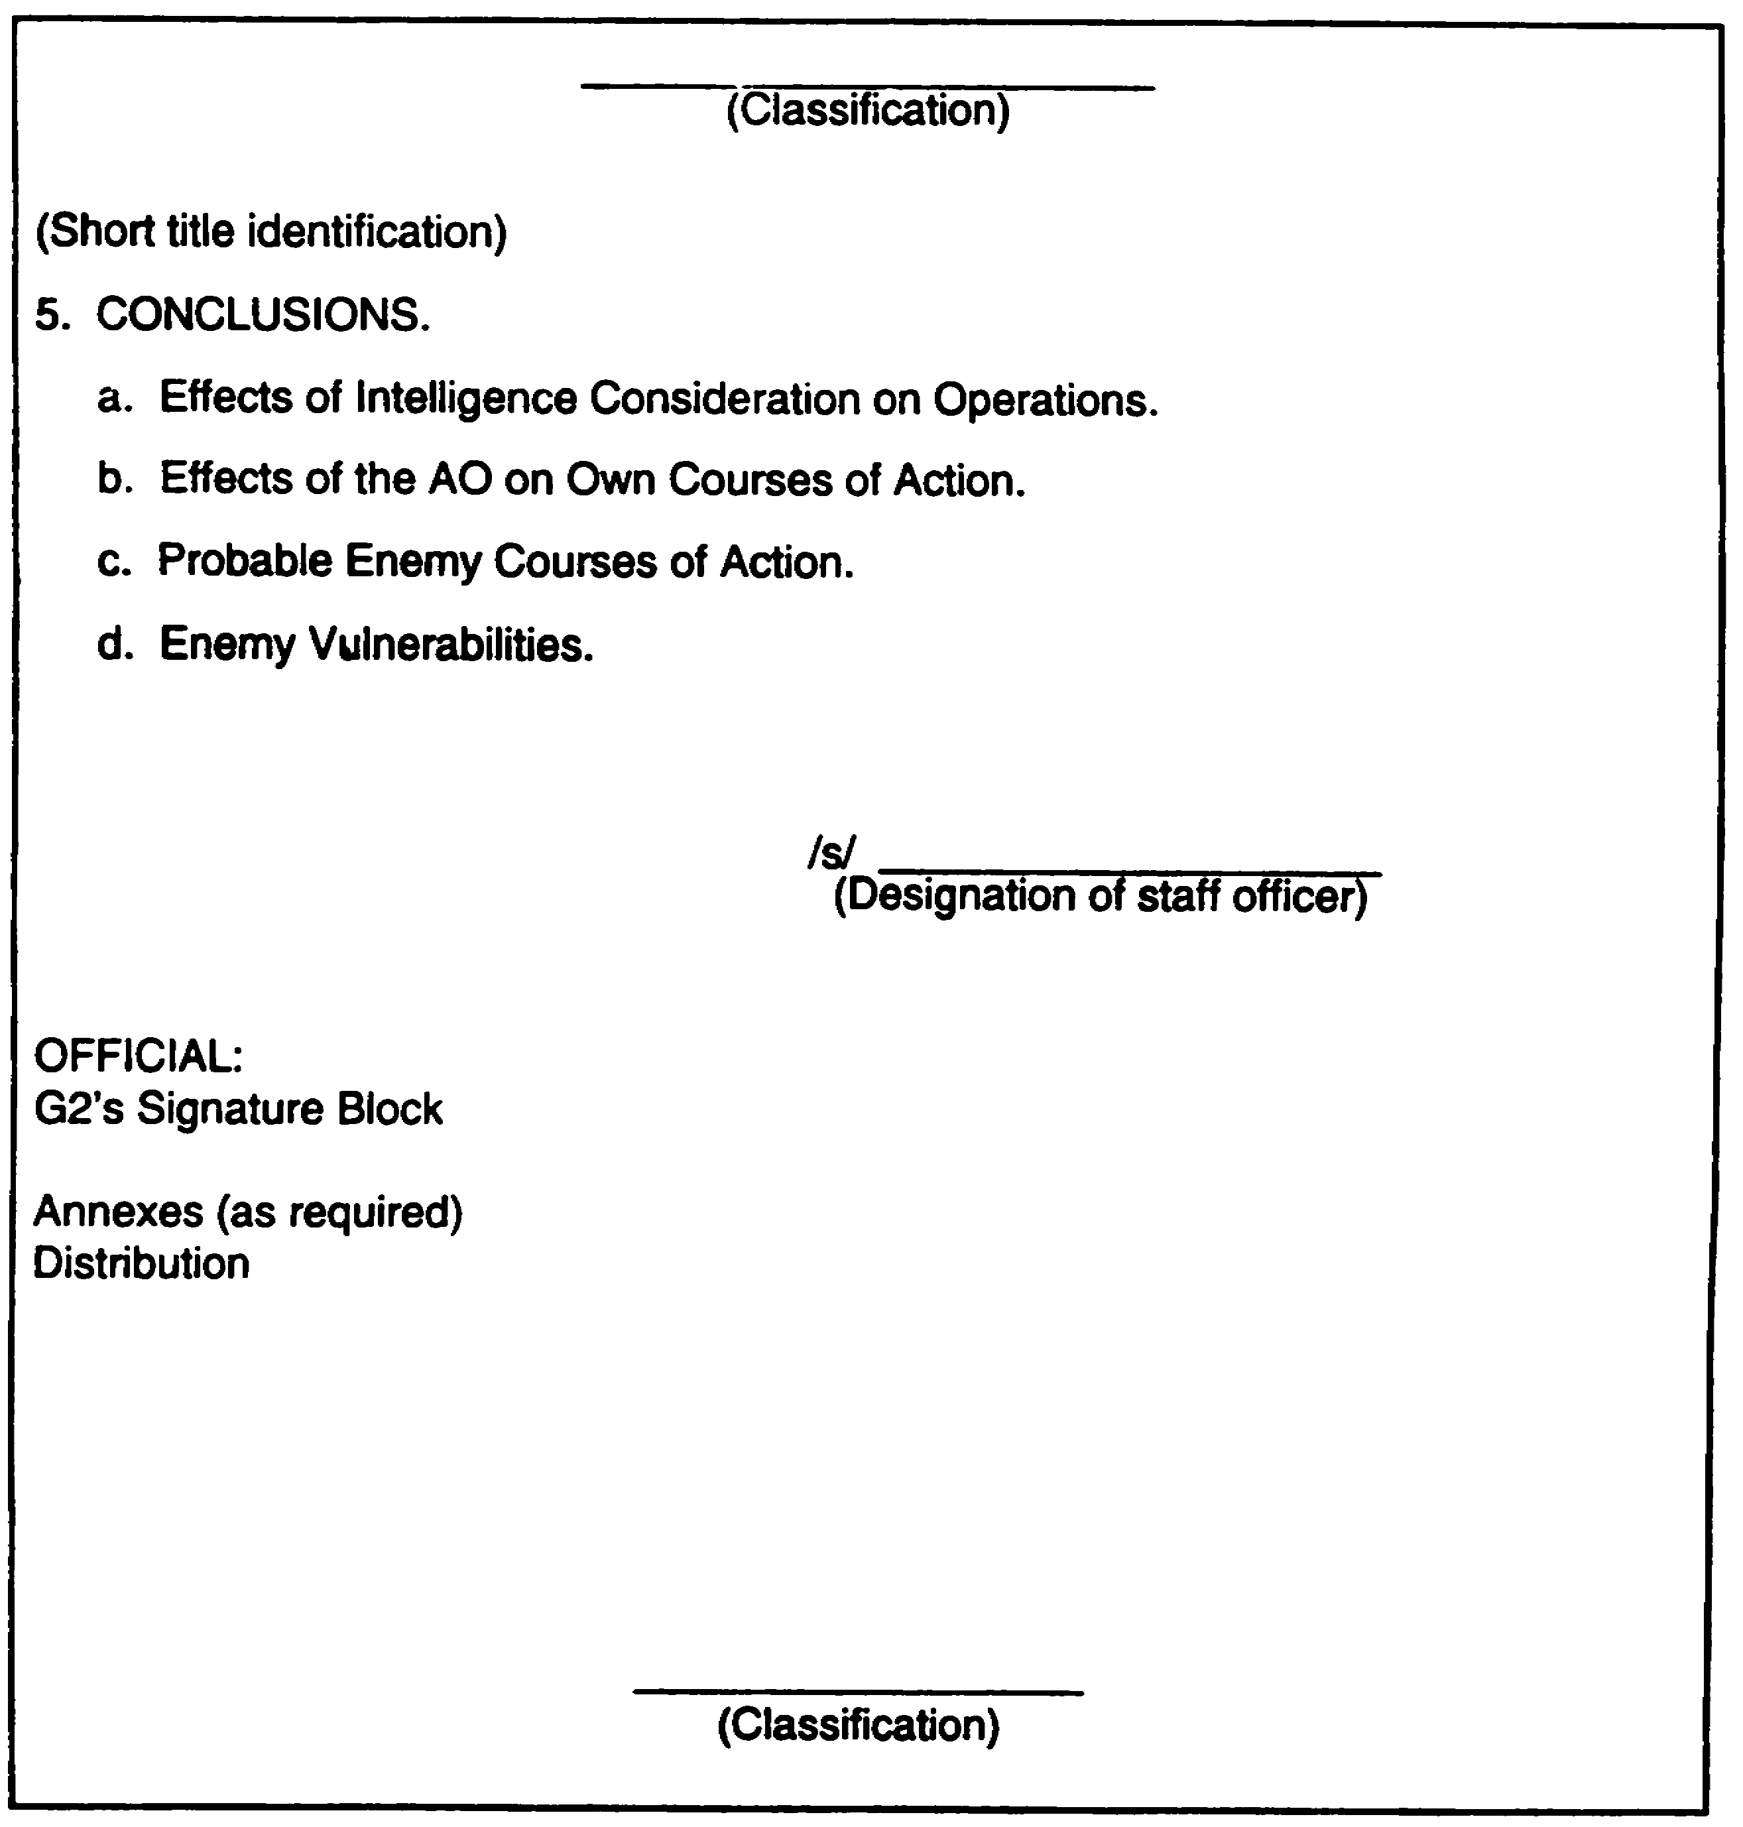

Figure 5-1. Intelligence Estimate Outline Format
Continued.

5-5 IT 0433

Terrain. The subparagraph discussing terrain includes the existing situation, and the terrain effects on both enemy and friendly COAs.

Existing Situation. To report on the existing situation use graphic representations such as IPB templates, where possible. Use annexes for detailed material. Include as much information as necessary for an understanding of the military aspects of terrain. Include as much information as necessary for an understanding of the military aspects of terrain. Include the effects of nuclear fires, enemy biological and chemical agents, and any pertinent considerations on each of these factors.

Effect on Enemy Course of Action. For this section, describe the terrain's effect on the enemy COAs in the same manner you described the weather's effect. For defensive COAs, state the best defensive areas and the best avenues of approach (AAs) leading to it. For attack COAs, state the best AAs.

Effect on Own Course of Action. Describe the effects of the terrain on your own COAs in the same manner as the effects of the weather.

Other Characteristics. If there are additional characteristics you consider pertinent, include them in separate subparagraphs. Possible topics might include-

- Sociology.
- Politics.
- Economics.
- Psychology.
- Science and technology.
- Material.
- Transportation.
- Manpower.
- Hydrography.

Analyze these factors using the same subheadings as weather and terrain.

Enemy Situation. In this paragraph you provide information on the enemy which will permit later development of enemy capabilities, vulnerabilities, and COAs. NOTE: This paragraph is derived from step 3 of the IPB process.

Disposition. In this section you describe the disposition of enemy forces. Reference may be made to overlays, enemy situation maps, or previously published documents.

Composition. You summarize enemy order of battle that can influence mission accomplishment. Make special mention of units capable of electronic warfare (EW),

IT 0433 5-6

low-intensity or special operations. Reference may be made to previously published documents.

Strength. Information on enemy strength is listed in the following categories--

- Committed forces.
- Reinforcements.
- Air assets.
- Nuclear weapons.
- Chemical and biological agents.

These listings will assist in developing enemy capabilities and vulnerabilities for use in selecting COAs. Factors to be considered include: unit mission, enemy location, doctrine, and the level of command.

Committed Forces. When describing the committed forces, list enemy ground maneuver units with which imminent contact can be expected regardless of the specific friendly COA implemented. Designate enemy forces as committed based on disposition, location, controlling headquarters, and doctrine.

If you have a doubt as to whether a unit is a committed force or a reinforcement, consider it a reinforcement. This allows you to assume the enemy has the maximum capability to reinforce forces to oppose a given friendly COA.

Reinforcements. When describing enemy reinforcements, include designation and location. Reinforcements are those maneuver units that may or may not be employed against us, depending on our choice of a specific COA and enemy plan. Subject to time and distance considerations, they also include enemy units not committed in our out of the friendly sector, but which can react to the friendly COA in time to influence mission accomplishment. In determining which enemy forces are reinforcements, consider disposition, location, level of control, or other factors.

Air. When describing the enemy air situation, list the number of enemy aircraft by type within the operational radius of the command. Also, if known, include the number of possible sorties per day by type of aircraft.

Nuclear Weapons and Chemical and Biological Agents. For this section, as appropriate, estimate the number, type, yield, and delivery means of enemy nuclear weapons and chemical and biological munitions or agents available to the enemy.

Recent and Present Significant Activities. List selected items of information to provide a basis for determining relative probability of adoption of specific enemy COAs and

5-7 IT 0433

vulnerabilities. Enemy failure to take expected actions are listed, as well as positive information.

Peculiarities and Weaknesses. List enemy peculiarities and weaknesses and a brief description of each. Indicate the extent to which they may be vulnerable to friendly actions, and how they influence possible friendly COAs. Base the list on your knowledge of enemy tactical doctrine, practices, the principles of war, the AO, and the enemy situation previously described and discussed. List them, as appropriate, in the following categories--

- Personnel.
- Intelligence.
- Operations.
- Logistics.
- Civil-military operations.
- Personalities.

Personnel. An estimate of strength is usually included if less than 80 percent of authorized strength.

Intelligence. An estimate of enemy intelligence success, ineffectiveness, and susceptibility to deception and detection is usually included. If appropriate, reference multidiscipline counterintelligence (MDCI) annex.

Operations. An estimate of combat effectiveness is usually included if less than excellent.

Logistics. An estimate of the enemy's capability to support their forces logistically is included if there are apparent weaknesses.

Civil-military Operations. An estimate of the attitudes of the enemy and the civilian populace and the status of food supply, medical facilities, communications, and other critical resources is usually included.

Personalities. An estimate of the capabilities and weaknesses of the enemy commander and principal staff officers usually is included.

Enemy Capabilities. Based on previous information and analysis, develop and list enemy capabilities. The listing provides a basis for analyzing all available information to determine probable enemy COAs.

Enumeration. State what, when, where, and in what strength for each capability.

IT 0433 5-8

Analysis and Discussion. This subparagraph is for analyzing and discussing each enemy capability separately. Consideration of enemy deception measures is also included. All the pertinent previous information and conclusions are tabulated as either supporting or rejecting the adoption of the capability.

After listing all the indicators, each capability is judged from the enemy view point – is the adoption of that capability advantageous to them. Such judgments need not be made if the conclusion is obvious or if there is no evidence that the enemy will adopt the capability. An exception is when the capability is one that will make the accomplishment of the friendly mission highly doubtful or impossible. This exception is to focus attention on dangerous Threat COAs. NOTE: The Threat COAs identified should exactly correspond with the situation templates developed during step 4 of the IPB process.

Conclusions. Based on all previous information and analysis, state your conclusions concerning-

- Total effects of the AO on friendly COAs.

- Probable enemy COAs.

- Enemy vulnerabilities that can be exploited.

These conditions assist in the selection of a friendly COA.

Effects of Intelligence Considerations on Operations. Indicate whether the previously stated mission can be supported from the intelligence standpoint. Also indicate which course(s) of action can be supported.

Effects of the AO on Own Courses of Action. Indicate the best avenues of approach for attack courses of action. For defensive courses of action, indicate the best avenues of approach leading to and into the defense area.

Probable Enemy Courses of Action. List courses of action in order of relative probability of adoption. A listed COA may include several subordinate COAs that can be executed concurrently. Usually, no more than two or three COAs, in order of probability of adoption, can be justified by the available evidence.

Enemy Vulnerabilities. List the effects of peculiarities and weaknesses that result in vulnerabilities that are exploitable at own, higher, or lower levels of command. The order in listing these vulnerabilities has no significance.

5-9 IT 0433

PART B - INTELLIGENCE ANNEX

The intelligence annex disseminates information about enemy forces which is essential to the conduct of operation and to give any necessary intelligence orders or guidance for the operation(s) in question. It also serves as a medium for instructing subordinate commanders to acquire information necessary for the planning and execution of tactical operations. The intelligence annex is not a substitute for an intelligence collection plan, rather it is a way to communicate the taskings and requests of the collection plan.

The intelligence annex is a formal intelligence tasking document that accompanies an OPLAN or OPORD. It should be as brief as possible consistent with clarity. It confirms the orders and requests for information that have been made in fragmentary form and are still current when the annex is prepared. Figure 6-2 provides an example of an intelligence annex in outline format. Appendix B, provides an example of a completed division level intelligence annex.

Summary of Enemy Situation. Provide information about enemy forces which is essential in implementing the OPLAN or OPORD. When the amount of detail makes it appropriate, provide a brief summary and reference an intelligence document or appendix to the annex. Reference to documents not available to all annex recipients, should not be included in the annex.

Intelligence Requirements. List each PIR in priority order, if applicable, with a separate subparagraph for each PIR. List IRs, if any, in a final subparagraph. If an intelligence annex is not prepared or is distributed separately from the basic order, PIR should be listed in the coordinating instructions of the OPORD.

Intelligence Acquisition Tasks. Discuss issues relating to the intelligence collection. Provide collection tasks and named areas of interest (NAls) of concern to the issuing headquarters.

Orders to Subordinate and Attached Units. List, by unit, the detailed instructions for reports required by the issuing headquarters. List each unit's instructions in a separate numbered subparagraph. You list units in the same order as they appear in the OPORD.

Requests to Higher, Adjacent, and Cooperating Units. In a separate numbered subparagraph, list requests for information from units not organic or attached.

Measures for Handling Personnel, Documents, and Material. Include instructions pertaining to the operation that are not contained in unit SOP or that modify or amplify the SOP. Examples include:

IT 0433 5-10

- Personnel. Include special handling and segregation instructions for the following persons--

- Enemy Prisoners of War (EPWs)
- Deserters.
- Repatriates.
- Local Inhabitants.
- Other Persons of special interest.

- Captured Documents. Provide instructions for handling and processing captured documents from time of capture to receipt by specified intelligence personnel.

- Captured Material. Provide designation of items or categories of enemy material for examination, and specific instructions for their processing and disposition.

- Documents or Equipment Required. List, in each category, the conditions under which certain documents or equipment required by or allocated to units can be obtained or requested. Items may include air photographs and maps.

5-11 IT 0433

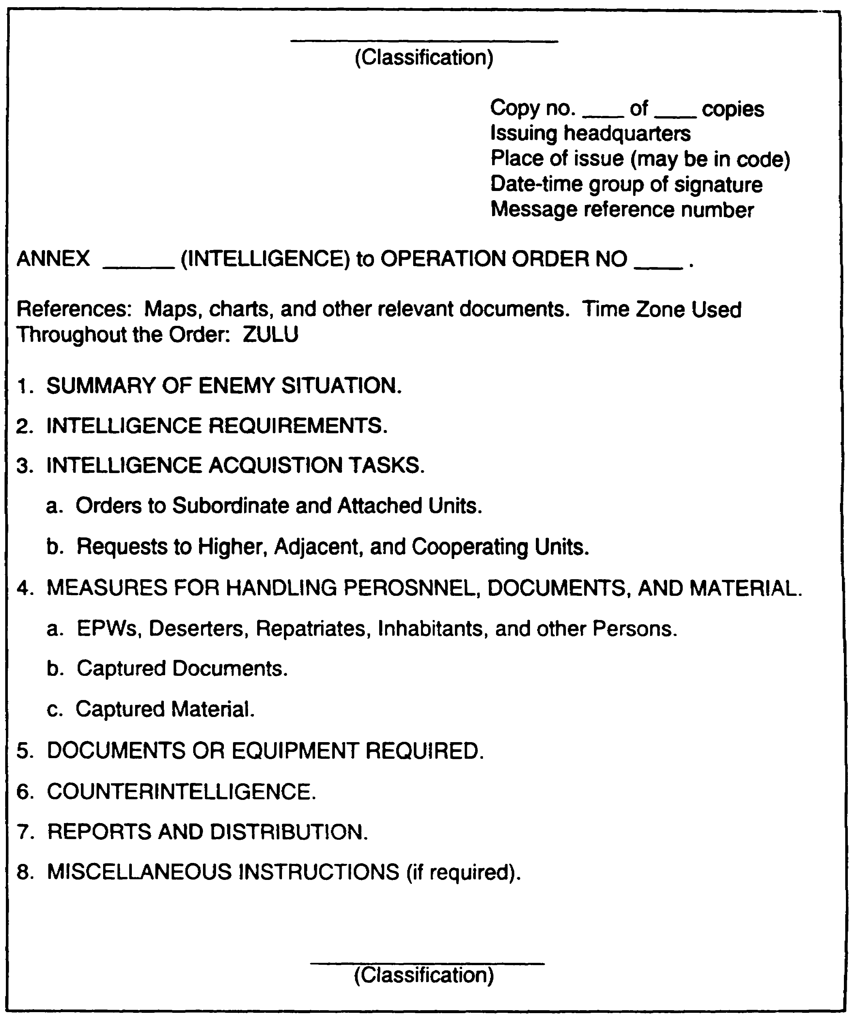

Figure 5-2. Intelligence Annex Outline Format (Continued).

IT 0433 5-12

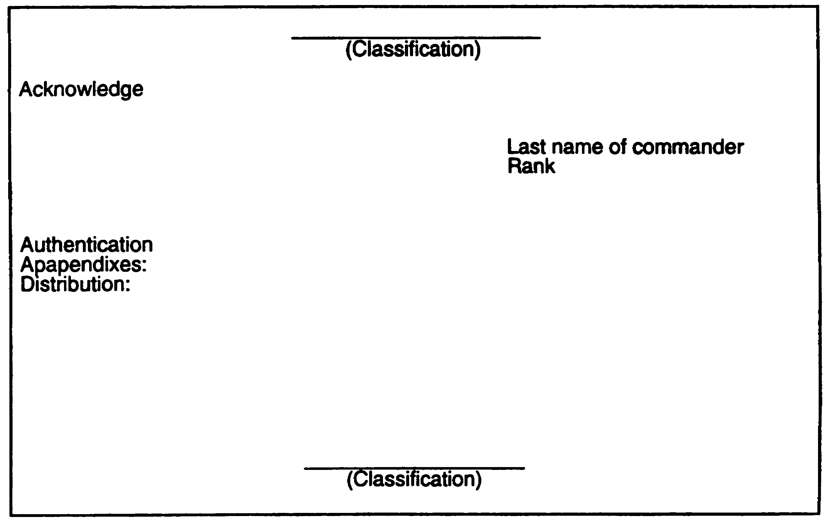

Figure 5-2. Intelligence Annex Outline Format (Concluded).

5-13 IT 0433

Counterintelligence (CI). This paragraph is covered largely by SOP. Many of the special operational instructions having Cl aspects are listed in the OPORD, in other annexes, or in the MDCI appendix to the intelligence annex.

Reports
This paragraph may be covered largely by SOP. It stipulates the conditions (for example, dates, number of copies) regulating the issue of intelligence reports to the originating command for the duration of the operation. Any or all of the following items may be covered in this paragraph--

- Period to be covered by routine reports and distribution.

- Routine and special reports that differ from SOP required from subordinate units.

- Periodic or special conferences of intelligence officers.

- Distribution of special intelligence studies, such as defense oerprints, imagery intelligence reports, and OB overlays.

- Special intelligence liaison, when required.

Miscellaneous Instructions (if required). List, under separate subparagraphs, necessary items that are not covered above or in SOPs. Also include any actions that are different than those detailed in the unit SOP.

PART C - INTELLIGENCE SUMMARY

The INTSUM is used to provide a brief summary of information of intelligence interest covering a specific period of time. It provides a summary of the enemy situation in forward and rear area, enemy operations and capabilities, and weather and terrain characteristics. The INTSUM reflects the intelligence officer's interpretation and conclusions as to enemy capabilities and probable courses of action. There is no specified format for the INTSUM, except for joint service operations. Figure 6-3 provides a format and sample of an intelligence summary. The majority of the items contained in the INTSUM can be omitted if they are not applicable to the current tactical situation. The exceptions to this include--

- Issuing unit.
- Time and date of issue.
- Brief discussion of capabilities and vulnerabilities.
- Conclusions.

IT 0433 5-14

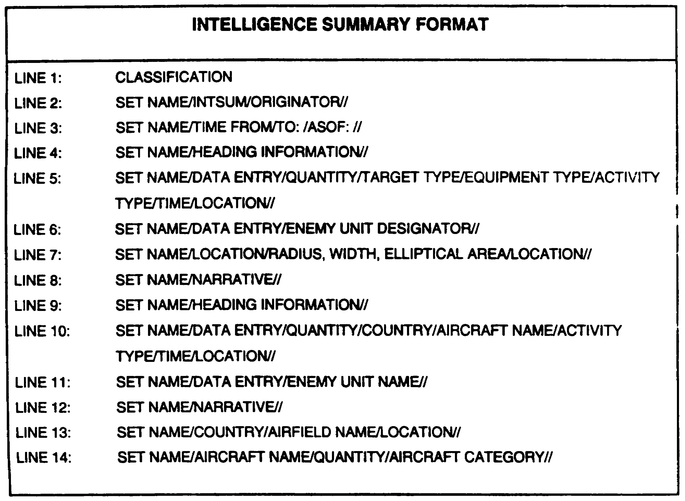

Figure 5-3. Format and Sample Intelligence Summary.

5-15 IT 0433

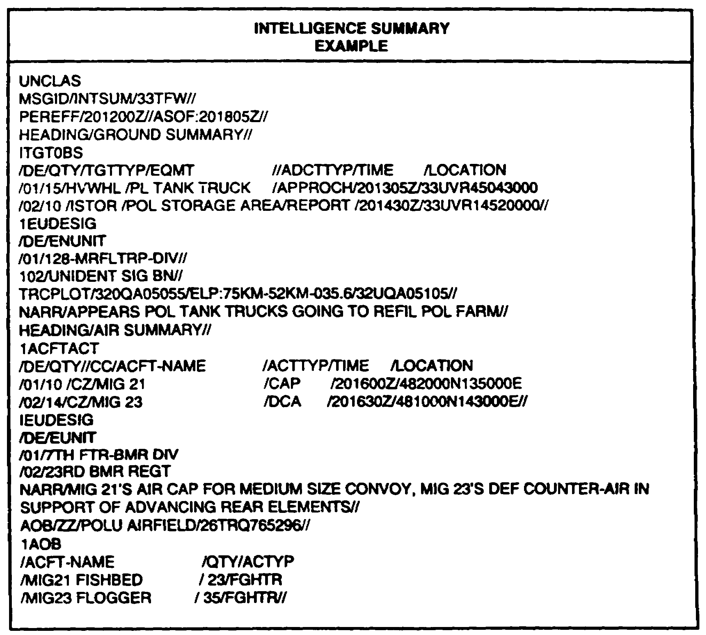

Figure 5-3. Format and Sample Intelligence Summary
Continued.

Summary of Enemy Activity for Period. Provides a summary of major or significant enemy activity that occurred during the reporting period.

Ground Activity. Summarize major movements and activities of enemy ground forces. Indicate estimated strength, composition, disposition, and any other items of significance.

Trace of Forward Elements. Show the most forward location of main location of the enemy forces as a pinpoint position, area boundary, or a series of connected points. NOTE: The universal transverse mecator (UTM) system will be used to the maximum extent practicable.

Potential Targets for Nuclear Weapons. List all potential nuclear targets, such as concentrations of troops or equipment observed during the period. Include location, date, and time (ZULU) of observation.

IT 0433 5-16

Nuclear Activity. List enemy use of, or capability to use, nuclear weapons during the reporting period. Include any changes to previously reported activity and capabilities. Indicate location, date, and time (ZULU) of observation of artillery, missile, or air nuclear capability or activity.

Chemical and Biological (CB) Activity. Indicate CB weapons (agents) employed or capability by type, location, date, and time of occurrence.

Air Activity. Summarize all enemy air activity that has occurred during the reporting period. Include, as appropriate, close air support (CAS), air interdiction, and aerial reconnaissance affecting friendly operations. Include location, date, time, and type of aircraft involved.

Other. Summarize new tactics observed and enemy CI measures of significance, including active and passive measures. Also include any other item not previously covered or reported.

Enemy Personnel and Equipment Losses. Provide a summary of enemy personnel and equipment losses that occurred during the reporting period.

Personnel Killed in Action (KIA). List in separate categories: confirmed KIA, estimated KIA, and estimated wounded in action (WIA).

EPW. List the number of EPWs captured during the reporting period.

Equipment Destroyed or Captured. List by number and type the enemy equipment and material losses during the period. Include damaged enemy equipment separately.

New Obstacles and Barriers. List those identified during the period by type and location.

Administrative Activities. Summarize enemy activities pertaining to personnel replacements, supply buildup, or unusual logistic activity. Do not include information or intelligence reported elsewhere in the INTSUM.

New Identifications. List all newly identified units and individuals of importance that may have a significant impact on enemy operations.

Units. List new units identified during the period. Include location, date, time, and unit making the identification.

Personalities. List significant individuals identified by name, rank or title, and organization.

5-17 IT 0433

Enemy Movements. Summarize significant enemy movements by type, activity, location, and unit designation, if known.

Estimate Number and Types of Vehicles. Summarize by type the estimated number of vehicles available to the enemy. Include aircraft and ships if appropriate.

Weather and Terrain Conditions. Provide a summary of the weather and terrain conditions during the period that would have an effect on subsequent operations.

Conclusions. State courses of action which the enemy will most probably adopt.

IT 0433 5-18

LESSON 5

PRACTICE EXERCISE

The following items will test your grasp of the material covered in this lesson. There is only once correct answer for each item. When you complete the exercise, check your answer with the answer key that follows. If you answer any item incorrectly, study that part of the lesson which contains the portion involved.

1. Your unit is planning to conduct an offensive operation and your commander has requested information on the AO, and enemy strengths, capabilities and vulnerabilities. To provide him with this information, which intelligence product is developed?

A. Intelligence Annex.

B. Intelligence Report.

C. Intelligence Estimate.

D. Intelligence Summary.

2. Which of the following intelligence products provides a brief summary of information of intelligence interest covering a specific period of time?

A. Intelligence Annex.

B. Intelligence Report.

C. Intelligence Estimate.

D. Intelligence Summary.

3. Which of the following serves as a medium for instructing organic and attached assets to acquire intelligence information?

A. Intelligence Annex.

B. Intelligence Report.

C. Intelligence Estimate.

D. Intelligence Summary.

5-19 IT 0433

LESSON 5

PRACTICE EXERCISE

ANSWER KEY AND FEEDBACK

Item Correct Answer and Feedback

1. C. Intelligence Estimate. Page 5-2.

2. D. Intelligence Summary. Page 5-14.

3. A. Intelligence Annex. Page 5-9.

IT 0433 5-20

